Giacinto Libertini

______________

Evolutionary Arguments
on
Aging, Disease, and Other Topics
______________

Azinet Press

Evolutionary Arguments on Aging, Disease and Other Topics

Giacinto Libertini

Copyright © 2011 Azinet LLC

ISBN-13 978-0-9788709-2-8
ISBN-10 0-9788709-2-1

Azinet Press
Box 239 Crownsville MD 21032
(410) 923-4745
books@azinet.com

This book was originally published in Italian as
Ragionamenti Evoluzionistici
by
Società Editrice Napoletana
La Buona Stampa s.p.a., Ercolano
1983

Contents

Introduction to the reprint 5
Introduction 10
Chapter I — Evolution 11
1) Evolutionism 11
2) Four observations implicit in the concept of evolution 12
3) Extension of the formal definition of gene 21
4) The postulare of potentiality 23
Chapter II - Senescence 25
1) Definitions 25
2) Evolutionary advantage of a lesser longevity. 27
3) Evolutionary steadiness of character senescence 33
4) Other selective pressures affecting longevity 41
5) The Methuselah effect 42
6) Theories about the “how” of senescence 46
7) Theories of hindered senescence and of programmed senescence 52
8) Researcher and senescence 53
9) Reformulation of the four observations 54
INTERLUDE: Built-in obsolescence 55
Chapter III — Parasitism 56
1) Limitation of the effectiveness of the defences of the parasited organism 56
2) Hypothesis of the greater evolutionary potential of the host 61
3) Ways in which the antibody defence acts 64
4) The interferon 67
5) Possible errors of interpretation of the epidemiological data 67
6) From parasitism to symbiosis 69
Chapter IV — Antigenic polymorphism 71
1) Antigenic mimicry 71
2) Antigenic polymorphism 71
3) Antigenic polymorphism in immunology 79
4) Parts of the organism subject to antigenic polymorphism 80
5) Defence consequent to the differentiation of the host species 80
Chapter V — Evolutionism and Pathology 83
1) Topic 83
2) The starting point 84
3) Diseases deriving from alterations of the genotype 84
4) Diseases deriving from alterations of the ecological niche 86
5) Diseases deriving from the relations with other living beings 89
6) Diseases deriving from ‘excesses of the ecological niche’ 89
7) Disease and senescence 90
8) Diseases deriving from several causes. The epidemic 91
9) Evolutionary definition of ‘disease’ 92
10) Conclusions. Eugenics 93
REFERENCES 95
Appendix 1) Markers of biological individuality 99
Appendix 2) Excerpt from: Eredità Evoluzione Società 99
Appendix 3) The causes of the biological variety 99
Appendix 4) Method used for the mathematical models 100
Appendix 5) The natural trend toward disorder increase 111

Introduction to the reprint

Reasons for reissue

“Ragionamenti Evoluzionistici” (Evolutionary Arguments) was published in 1983 by Società Editrice Napoletana, with coverage of the editorial costs at my expense. The publisher never informed me about the number of copies sold but I fear that it was irrelevant. Moreover, of the many academics to whom I sent a copy of the book, no one deemed it opportune to reply to me or offer an opinion.
In short, the book should be considered a complete failure in every respect.
Why, then, after so many years to reprint electronically the book in the Italian version and, besides, to propose it in English?
The reasons are many:
1) The subject of Chapter II, the evolutionary cause of senescence, was transformed into a scientific paper and published in 1988 in a prestigious journal (Libertini G., An Adaptive Theory of the Increasing Mortality with Increasing Chronological Age in Populations in the Wild. J. Theor. Biol. 1988, 132, 145-62). But the article too was practically ignored by the academic world, perhaps because the theses put forward were too contrary to established ideas and ahead of their time. In 1998, however, a distinguished naturalist trying to confirm the current theories on ageing, documented an effect that ran contrary to what they had expected but which was in total agreement with that which I had predicted 15 years earlier and confirmed in my subsequent scientific article, namely what I had called "Methuselah effect" (Ricklefs R. E., Evolutionary theories of aging: confirmation of a fundamental prediction, with implications for the genetic basis and evolution of life span. Am. Nat. 1998, 152, 24-44).
I found out about these sensational results in 2001 and this led me to rekindle my interest in studies on aging with publications that confirmed and deepened what I had already maintained and, moreover, expanded upon it with precise and documented hypotheses about the mechanisms of aging, a subject which was not discussed at all in my aforementioned previous works.
2) The subject of Chapter V, disease phenomenon framed in evolutionary terms, was addressed by Williams and Nesse in a famous 1991 article that marks the official birth of Evolutionary Medicine (Williams G. C. and Nesse R. M., The dawn of Darwinian medicine. Quart. Rev. Biol. 1991, 66, 1-22). I recently returned to this discipline, which is gaining increasing importance and which I think is absolutely central to any health policy, with my contribution to a book (Libertini G. Prospects of a Longer Life Span beyond the Beneficial Effects of a Healthy Lifestyle, in Handbook on Longevity: Genetics, Diet & Disease, eds. J.V. Bentely and M.A. Keller, Nova Science Publishers Inc., 2009, New York).
3) The discussions of Chapter III, Parasitism, and IV, Antigen Mimicry, are more relevant than ever and today have some interesting confirmations, such as: a) the abuse and irrational use of antibiotics and the selection of bacterial strains resistant to almost all antibiotics (Stearns S. C. and Koella J. C. eds, Evolution in Health and Disease, 2nd ed. Oxford University Press, 2008, New York); b) the existence of mechanisms for removal of the foetus in cases in which it is too antigenically homogenous (ibidem).
The arguments expressed in the first two points would already be enough to have my 1983 book defined as a work that anticipated subjects which are, today, considered of primary importance and at the forefront of scientific studies. The arguments in the third point have strengthened my conviction and I have, therefore, decided to go ahead and reprint the work electronically, and to translate and publish it in English, making it available on the Internet to anyone who is interested.

Annotations about the reprint

The transcription is as faithful as possible to the original print but there are some significant differences that need to be pointed out:

1) The writing of formulas has been improved upon and an identifying label for each formula has been added. For example:

C_{n+1} = C_{n} (1 + S) = C_{n} (1 + S) (I-4)
C_{n} (1 + S) (1 - C_{n}) 1 + C_{n} S

instead of:

Cn+1 = Cn · (1 + S) = Cn · (1 + S)
Cn · (1 + S) (1 - Cn) 1 + Cn·S

and:

A_{h,e} = S_{p,b} + U_{p,a} - U_{p,b} (IV-5)
S_{p,a} + S_{p,b}

instead of:

Ahe = Spb + Upa - Upb
Spa + Spb

2) The formulas and the text of Chapter I, par. 3, which contained a number of copying errors and even errors of layout have been corrected, as has figure I 3-1.
For example:

C_{n+1} = C_{n} + 2 C_{n} (1 - C_{n}) S + C_{n}² S’ - C_{n} U + C’_{n} V (I-20)
T

instead of:

Cn+1 = Cn + Cn · (1 - Cn) · S + Cn² · S’ - Cn · U + C’n · V
T

3) The term "habitat", where specifically understood in a broad sense that includes the meaning of "ecological niche", has been substituted with the term "ecological niche" having the aforesaid broader sense.

4) Errors of orthography and punctuation have been corrected, together with some other minor faults.

I wish to thank the friend James Stunell for its careful correction of the English translation.

Software

The source code of the programs used for the models is found in Appendix 4-D. A modern version of them, in Microsoft VisualBasic 6.0, is in the file Evol_Arg.zip (source code and executive file), available at the internet address http://www.r-site.org/ageing. Other material, Italian version of the text included, is available at the same address.
To Silvana

GIACINTO LIBERTINI

Evolutionary Arguments

Research on the teleonomic meaning
(or finalism in a deterministic sense)
of senescence and of antigenic polymorphism.
Organization in evolutionary terms
of parasited organism-parasite relations
and of the phenomenon ‘disease’

First Italian edition by S o c i e t à E d i t r i c e N a p o l e t a n a
Printed in September 1983,
La Buona Stampa s.p.a., Ercolano
Italian electronic reprint and English Edition: April 2011
I wish to thank those scholars who, for the previous drafts and this final version of the work, have been of help and stimulus to me with criticism, advice and encouragement, putting up with a great deal, not least of all my ignorance that has been, and perhaps still is, a tenacious veil over all that is true in the following pages.
I hope I will be forgiven for the difficulties that this writing causes the reader, difficulties that I consider unavoidable given the general and theoretical nature of the topics.

Giacinto Libertini
Via Cavour 13, 80023 Caivano (Napoli)
[giacinto.libertini@tin.it]

Introduction
- When there is a physiological response, we ask: “How?” and “Why?”. The first question is physiological and means: “What are the mechanisms responsible for this response? What is the sequence of events between stimulus and response?” The second question is not strictly physiological, but teleological; it is, in fact, a request for the finalistic interpretation, which, if rightly understood, can be extremely useful. - (Wright, S., 1967)
As for the correct meaning that should be given to the term finalism:
- In determinism, the effect follows the cause, the present is conditioned by the past. In finalism (wrongly understood; Author's note), on the other hand, a phenomenon would be fulfilled with a view to an end, the cause follows the effect, the present would be conditioned by the future; yet, we must recognize a finalism in all vital phenomena, in all functions and structures of a certain complexity. The teeth are made for chewing, and the whole digestive system is meant to digest: the heart is said to work as a pump, namely as a man-made tool with a view to an end. But this finalism does not clash with determinism when one looks at the evolutionary history that the organisms have behind them, an evolutionary history during which natural selection has acted incessantly since the dawn of life.
Morphologists and physiologists must acknowledge the functional meaning, namely the finalism, of each structure of a certain complexity, but they must also always bear in mind the fact that this means looking back over the evolutionary course. - (Padoa, E., 1966)
Today, to avoid misunderstandings referring to a deterministically understood finalism, the use of the term “teleonomy” is largely prevalent: this because too often the word “teleology” has been used to refer to a finalism which is not deterministically understood.

* * *

This work is, among other things, an attempt to give, or contribute to, an answer to teleonomic questions about the following topics:
Chapter II - Senescence
Chapter IV - Antigenic polymorphism
The fifth chapter is an attempt to set out in evolutionary terms the phenomenon “disease”.
As support and formalization of the arguments expressed in the work and to define the main arguments, some ideal models which are suitable for mathematical treatment are illustrated.
Clearly, a model in itself has value only as a logical expression - if it is coherent and correct - and can achieve scientific validity exclusively when confirmed in the empirical reality.
Each model is illustrated with one or more pictures obtained with the help of a computer. For the hardware used and the source code of the programs, I refer the reader to Appendix 4.
According to the author, the validity of the answers given should be assessed:
1) both with a careful verification of the possible logical consistency and sufficiency of the arguments put forward;
2) with possible confirmation in data deriving from natural observations and in experiments already carried out or to be performed.

Chapter I — Evolution

1) Evolutionism
- For several decades, evolutionary theses have become so rooted in the minds of biologists that there is no subject concerning living beings that has not, according to them, been dealt with. Not only does the scholar of systematics that looks into the affinities, and therefore the relationships among living beings, have recourse to evolutionism, but also the biochemist who is interested in metabolism, the naturalist who debates the distribution of animals and plants over the surface of Earth, the geologist who studies the fossils that characterize this or that period. The voices of dissent, which were very loud sixty years ago, are becoming increasingly rare, and now, rather than bringing about controversy, simply produce surprise: why - the interlocutor asks himself – does this man reject the use of a guide for orienting himself within the multitude of the natural phenomena? Why does he refuse to consider the events of life in their historical perspective? - (Omodeo, P., 1979)
The knowledge of the evolutionary processes is, therefore, of fundamental importance for a correct interpretation of that set of phenomena which constitute life. Correct thinking in evolutionary terms is certainly a great help for a unified vision of the astonishing multiplicity of morphological, physiological, etc., phenomena of the innumerable living species. For the sake of brevity, I will use the term “evolutionism” when referring to this way of looking at life.

* * *

Evolution can be defined in various ways. A purely descriptive definition is as follows:
Evolution is the development and the differentiation of structures able to exist and propagate autonomously (= living beings) starting from non-living matter.
From a speculative point of view, I think that evolution can be defined as:
a complex phenomenon that is predictable to an extent proportional to the available data on the basis of probabilistic arguments.
This definition is, in itself, enough to attract a criticism that I wish to draw the reader’s attention to on purpose. One could, indeed, argue that to predict this or that step of the evolution of a species is as an attempt to predict the future. Natural selection, it could be said, acts on mutations, which are events outside our abilities of prediction.
This is true if such events are assessed one by one. But here I give the term “predict” the meaning of studying which, among the innumerable possible mutations, are those whose phenotypical expression entails a greater aptitude for survival or propagation (or for other features that favour gene persistence). As a rough, partial and non-rigorous example: if a mammal passes, over a very large number of generations, from a terrestrial to an aquatic habitat, on the basis of hydrodynamic laws and of Darwinian observation of the survival of the fittest, it is, perhaps, correct to predict the diffusion within the species of mutations that entail, as a phenotypical expression, the gradual transformation of the limbs into pinnas, modifications of skin and adnexa, so that the frictional resistance to motion decreases, a greater ability to withstand periods of apnea, etc. Such examples are not enough to prove the validity that I attribute to the definition expressed. Yet, the question is of fundamental interest because, as will be observed hereafter, this work is based on the assumption of the “predictability” of evolution, which should, however, be interpreted, not in the sense of wanting to know the future shape and physiology of a species, but in finding, within the limits of available data, why a species has come to possess such characteristics, a kind of "backward prediction" therefore. I must now emphasize the fact that evolution, if considered an unpredictable event, does indeed end any answer on the subject. On the other hand, ascertaining the predictability of the evolutionary process, within the limits, naturally, of the available data, and the verification in said data from natural observation and experiments, opens a wide range of possibilities. In this work I have followed this path: perhaps the findings and the procedures are wrong and perhaps even the main assumption is false, but I am comforted by the thought that I am not alone in going in this direction (see among others: Omodeo, P., 1979 and Wilson, E. O., 1975).

2) Four observations implicit in the concept of evolution
In order to use a correct knowledge of the evolutionary mechanisms in the discussions found in the following chapters, we need, I think, a schematization, which will be obtained by expressing what could be imprecisely defined as laws of evolution, but which I will more accurately call “observations” about evolution. They are, in fact, expressions for clarifying phenomena that are implicit in the same concept of evolution by natural selection. A careful analysis will reveal that the ‘observations’ are tautological expressions which, in themselves, prove nothing new, as formulas and mathematical demonstrations that, without revealing anything new, explicit what is derivable from basic mathematical concepts. This by no means implies that evolution is - or is reduced to - a deductive theory, such as the theories of the pre-scientific age. The theories based on natural observation and experimentation - and evolutionary theory is one of these - lead to the formulation of general ‘laws’ from which it is possible to deduce particular ‘laws’, seeking their confirmation in empirical reality (see theories of electromagnetism, gravitation, relativity, quantum mechanics, etc.). I wish to make my deductions only and exclusively within this empirical attitude.

* * *

First observation:
Those living beings that have characters which render them more suited to persistence within their ecological niche have greater probabilities of persistence (= the fittest persists).
Some definitions and specifications follow. “To persist” means “to continue to exist”. For a species to persist and not become extinct, it is necessary, first and foremost, for its components to be able to survive and propagate. The term “character” means any feature of a living being, such as, for example, the presence or non-presence of an enzyme, the function of a cell type, the form of an organ, the way of reacting to a particular type of offence, etc. The term “ecological niche” means both the physical environment in which the living being persists, but also the modus vivendi and the different and variable relations with other species and other individuals of the same species. Major factors of selection and, therefore of species evolution, are found simply in that species’ greater ability to prevail over other living beings and defend itself from them, or in the interlacing of reciprocally advantageous relations. It also has to be observed that the concept of ecological niche is entirely relative - to a single species, single population, single individual or a limited temporal period -, and is well distinct from that of the only physical environment. For example, a species that, in its evolution, passes from a terrestrial to an aquatic life, has greatly modified its ecological niche, but, in doing so, has not transformed the dry land into ocean. I must stress that, although my definition of ecological niche may be wider or different from that given or implied by other authors, I will use it exclusively in this work. Note also that, when I discuss selection or selective pressure or analogous expressions, I by no means wish to imply that something external acts on the living beings, but that from the individual-ecological niche interaction, a differential spreading of the various genes follows. Thus, to speak of selection is only an abbreviated form of expression and should not be understood literally. It is worth stressing, then, that fitness is completely relative to the single individual-ecological niche interaction - or, to generalize where this is possible, to the species-ecological niche interaction -, and that what is fit in one case may be unfit in another case.
Finally, I stress that selection in favour of the individuals of a species that have a particular advantageous character, also exists when the greater fitness due to the character is minimal. But, the transformation will be slower when the advantage due to the character is lesser (see theoretical model of Fig. I 2-1) and there will be no transformation if the mutations altering the character act more quickly than the selection (see Fig. I 2-2 and Fig. I 2-3). A continuation along the same line of reasoning leads to the Second observation:
A character that, because of changes of the ecological niche, becomes unimportant for the aptitude to persist, is lost by the species (= superfluous gets lost).
In fact, selection in favour of those individuals that have such a character vanishes and it is known - see also Appendix 5 - that the mutations altering a character are much more numerous than the few that improve it or that cancel the alterations, thereby restoring the integrity of the character. An ever-increasing number of alterations of the genes defining the character, causes, therefore, the complete elimination of said character (see model of Fig. I 2-4). Now, it must be noted that the more complex a character, that is, by rough definition, the greater the number of genes defining it, the greater the number of harmful mutations arising at each generation will be. Consequently, in order that it is minimal, or at least not great, the percentage of individuals that, in equilibrium conditions, have the character altered by harmful mutations, the selection must be quicker in proportion: this can happen only if the advantage held by having the character is proportional to its complexity (see model of Fig. I 2-5, for the definition of “equilibrium condition” too).

Third observation:
The species evolves through a series of relatively probable, and therefore mostly minimal, character modifications, rather than completely improbable modifications (= evolution does not make leaps).
The great differences among the species are due to the gradual accumulation of many advantageous mutations of one or very few genes at a time, and not by means of the contemporaneous favourable mutation of many genes, a highly unlikely event. In fact, if the onset probability of a mutation y is P_{y}, the contemporaneous onset of n mutations is equal to P₁ P₂ ... P_{n}, and if P_{x} is very small (see experimental data), this number falls greatly for each unitary increase of n. For example, if P_{x} on average is equal to 10⁻⁴, the probability of 2 contemporaneous mutations is: P₁ P₂ = 10⁻⁸, of 3 mutations: P₁ P₂ P₃ = 10⁻¹², etc. Note also that the probable event, in addition to a mutation, may be also a chromosome modification (duplication, deletion, inversion, etc.), and in this case the character modification would not be minimal at all, although probable, as proven by the very fact that it has happened. It is necessary to stress that the term “leap” indicates the concept “improbable event” and not that of “considerable modification of the characters of the living being”, although in most cases the two concepts coincide.
It is now opportune to emphasize the fact that the aim of a mutation is by no means to prepare the way for subsequent evolutionary developments of a species. Each mutation arises by chance in a small fraction of individuals and there is, necessarily, a specific greater aptitude for persistence so that the mutation, favouring those who have it, spreads within a species. Such a tendency to consider the evolution of a species, from an erroneously finalistic point of view, is contrasted by that which is expressed in the Fourth observation:
Each character of a species, and the species itself as a whole, tends to be, in any evolutionary stage, the result of the actions of all selective pressures in the ecological niche.
A species is forced by the selective pressures - by definition - to an ever-increasing adaptation to the whole of the ecological niche in which it lives, an ecological niche that is modified incessantly often by the effect of the evolution of the characters and, therefore, of the modus vivendi, of the same species. Note that, for the most part, a species is a whole series of partially separate populations and it is more correct to speak of whole series of ecological niches instead of a single ecological niche. Clearly, therefore, species and ecological niche are only an abbreviated form of expression.
Each stage of the evolution of a species and any character thereof, has its decisive causes in the contingent selective pressures in the ecological niche and does not have a subsequent form as its purpose. For example, the ancestor species of man did not evolve from an arboreal to a terrestrial life form with the goal of becoming intelligent, but rather as a consequence of strictly contingent selective pressures. Then, the new ecological niche perhaps favoured the increasingly intelligent mutants as a result of the fact that they now had free limbs capable of grabbing, and this gradually led to man. The selective pressures in the ecological niche shaped the evolutionary development along a phylogenetic line that is finalistic only in terms of an “a posteriori” superficial examination.
As we proceed with the final observations, we notice that the living being, which depends on all the factors of the ecological niche, is also influenced by the lesser or greater variation of the latter. The more stable the ecological niche, the more a species adapts itself to it, but at the same time, the aptitude towards a different ecological niche decreases. That is, if a species is not subjected to the selective pressures deriving from a variable ecological niche, it tends to lose those characters that make it suitable for living in an ecological niche different from its usual one. It is consequential that a sudden variation of the ecological niche for a species that is well adapted to a stable ecological niche, can prove fatal for said species, an event for which palaeontologists and ecologists give numerous examples.

* * *

The four observations will be reformulated at the end of Chapter II, in light of the extraordinary contributions of Maynard Smith, Haldane, Hamilton, Trivers, Wilson and others, and after an examination of senescence phenomenon.
These formulations, which express a classical point of view, are centred on the individual as the object of the selection, while the object of the formulations in Chapter II will, more correctly, be the gene.
The development of the arguments of the next chapter will inevitably lead to a reformulation that expresses the - I think revolutionary - pivotal idea of the modern sociobiology.

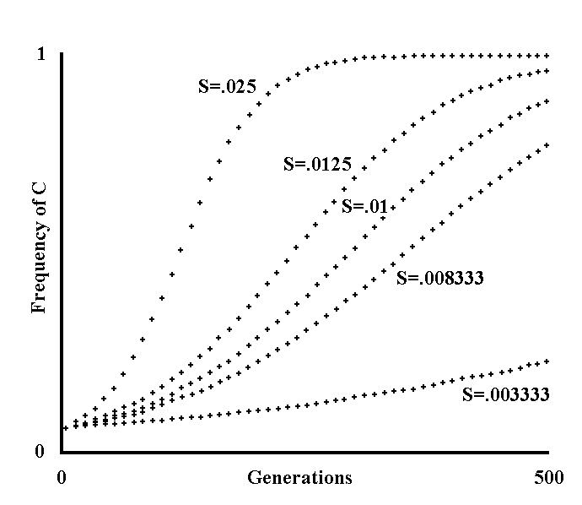
Fig. I 2-1 - Spreading within a species of a gene with advantage S (Theoretical model).

“Gene” is defined in the model as something that is passed on from the individual, or from the parental individuals, to a child individual as an exact copy, with the exception of unpredictable events defined as “mutations”. A changed gene is passed on with equal accuracy. By the term generation I mean the time needed for there to be N deaths within a population made up of a constant number N of individuals, thereby bringing about renewal of the entire population (albeit not necessarily during the same period for all individuals).
In each individual, we have either gene C, with constant phenotypical expression that includes advantage S, or as the only alternative C’, which is inactive. Using terminology that comes from genetics, C and C’ are defined as alleles.
As regards advantage S, the definition is as follows:
In our hypothetical population, which has a constant number of individuals, writing at the nth generation the frequency of C and C’ with C_{n} and C’_{n}, respectively, let us assume that:

C_{n+1} = C_{n} (1 + S) (I-1)
C_{n} (1 + S) + C’_{n}

C’_{n+1} = C’_{n} (I-2)
C_{n} (1 + S) + C’_{n}

The denominator, which is given by the sum of the two numerators, maintains the sum of the frequencies constant:

C_{y} + C’_{y} = 1 (I-3)

an equation given by excluding those alleles that are different from C and C’.
In the above figure, the number of generations is on the abscissas (10 from one cross to the next for a total of 500 generations). The fraction of the population that has gene C is on the ordinates. The fraction is obtained by the iterative use of the first of the two formulas thus modified:

C_{n+1} = C_{n} (1 + S) = C_{n} (1 + S) (I-4)
C_{n} (1 + S) (1 - C_{n}) 1 + C_{n} S

C’ is neither calculated nor illustrated, being immediately obtainable using the formula:

C’_{y} = 1 - C_{y} (I-5)

Going from top to bottom, the values of S for the various curves are:

.025 ; .0125 ; .01 ; .008333; .003333.

Moreover, in all curves:

C_{o} = 0.05

The curves show that the reduction of S lowers but does not eliminate the success of the advantageous character within the population.
In this first model, largely simplified, the mutations are disregarded. Unless otherwise specified, definitions and conventions are the same for the subsequent models too.

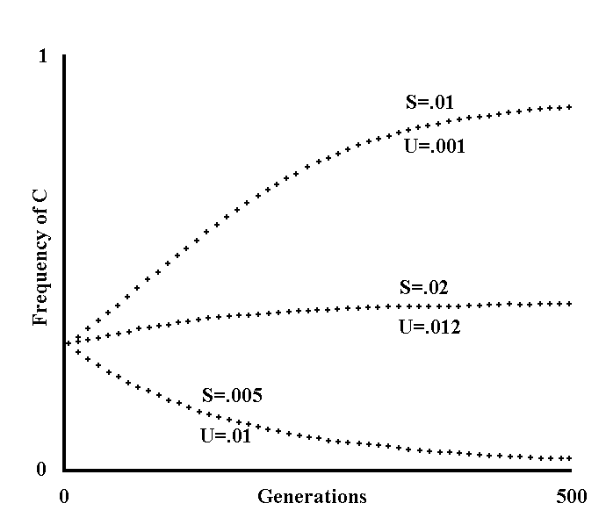
Fig. I 2-2 - Curves of frequency for a gene with advantage S and decay U (Theoretical model).

Now, using the same conventions as in the preceding model, let us assume that C changes at each generation with frequency U in C’ and that the frequency of back-mutation of C’ in C is negligible.
We have:

C_{n+1} = C_{n} (1 + S) - C_{n} U (I-6)
D

C’_{n+1} = C’_{n} + C_{n} U (I-7)
D

where the denominator D is equal to the sum of the numerators.
Working out the first formula we obtain:

Cn+1 = Cn (1 + S - U) = Cn (1 + S - U) (I-8)
Cn (1 + S) - Cn U + (1 - Cn) + Cn U 1 + Cn S

In the figure below, going from top to bottom, the values of S and U for the curves are respectively:

.01 and .001 ; .02 and .012 ; .005 and .01.

Moreover: C_{o} = .3.
The lower curve shows that if decay U acts with greater intensity than advantage S, the frequency of C is decreasing.

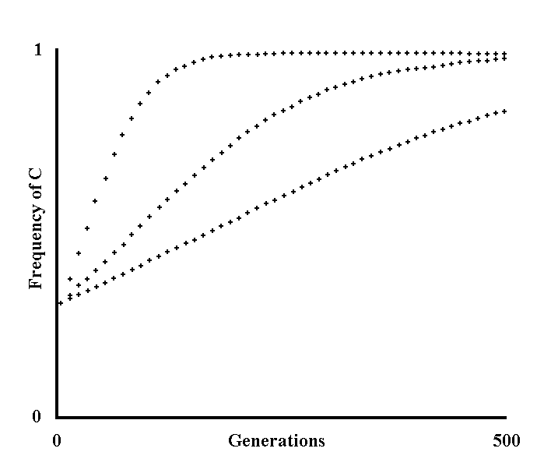
Fig. I 2-3 - Curves of frequency for a gene with advantage S, decay U and back-mutation V (Theoretical model).

The assumptions are the same as those of the preceding models, except that now the back-mutation of C’ in C with frequency V is also considered.
We have:

Cn+1 = Cn (1 + S) - Cn U + C’n V .
Cn (1 + S) - Cn U + C’n V + C’n + Cn U - C’n V

= Cn (1 + S - U) + (1 - Cn) V
Cn.(1 + S) + (1 - Cn)

= Cn (1 + S - U - V) + V (I-9)
1 + Cn S

Going from top to bottom, the assumed values for S, U and V are, respectively:

.03 , .0003 , .00003 ;
.01 , .0001 , .00001;
.005 , .00005 , .000005.

Moreover, C_{o} = .3 . The number of generations on the abscissas is 500, as in the preceding figures.
Note that assuming that both U and V = 0, we have the formulas of Fig. I 2-1, and assuming only that V = 0, we have the formulas of Fig. I 2-2.

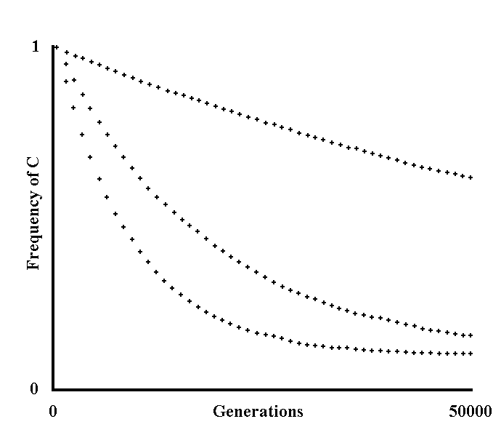
Fig. I 2-4 - Decay of a neutral gene (Theoretical model).

With the same conditions as in the preceding figures, it is now assumed that the advantage S of C over C’ is non-existent, that is that C is selectively neutral compared with C’. From the last formula of Fig. I 2-3, assuming that S = 0, we obtain:

C_{n+1} = C_{n} (1 + S – U - V) + V = C_{n} (1 - U - V) + V (I-10)
1 + C_{n} S

If we write:

Q = 1 – U - V, we have:

C_{n+1} = C_{n} Q + V (I-11)

If we wish to apply this simple formula over a period of thousands or more generations, the calculation becomes rather long, but with a mathematical procedure we can deduce that:

C_{n+2} = C_{n+1} Q + V = (C_{n} Q + V) Q + V

C_{n+3} = C_{n+2} Q + V = ((C_{n} Q + V) Q + V) Q + V

. . . . . . . . . . . . . . . . . . . . . . . . . . . . . . . . . . . . . . .

C_{n} = C_{o} Q^{n} V (1 + Q¹ + Q² .... + Q^{n}) (I-12)

and, by applying the formula of the geometrical series:

C_{n} = C_{o} Q + V 1 - Q^{n} (I-13)
1 - Q

This formula is not iterative, that is, it must be used only once and not n times to calculate the value of C at the nth generation. It means, therefore, that we can quickly calculate curves referring to a very large number of generations without lengthening the calculation times proportionately. In the figure, the number of generations on the abscissas is a good 50000 (1000 from one cross to the next). Going from top to bottom, the values of U and V for the various curves are:

.00001 and .000001.
.00005 and .000005;
.0001 and .00001;

C_{o} = 1 for all three curves.
Defining, then, the “equilibrium frequency” as that frequency with which the factors considered have equal value in their action, so that there is no further modification over subsequent generations, and observing, moreover, that Q < 1, and that, therefore, if n  , we also have Q^{n} 0, with n   we obtain C at equilibrium (C_{e}):

C_{e} = C_{o} 0 + V 1 - 0 = V = 1 = V (I-14)
1- Q 1 – 1 + U + V U+ V

This is a familiar formula in genetics and is independent from C_{o} (see Srb, 1965, p. 307).
As by definition in equilibrium conditions C_{n+1} = C_{n} = C_{e}, this formula is also obtained more simply from:

C_{n+1} = C_{n} (1 – U - V) + V

C_{e} = C_{e} (1 - U - V) + V

C_{e} (1 - 1 + U + V) = V

C_{e} = V (I-15)
U + V
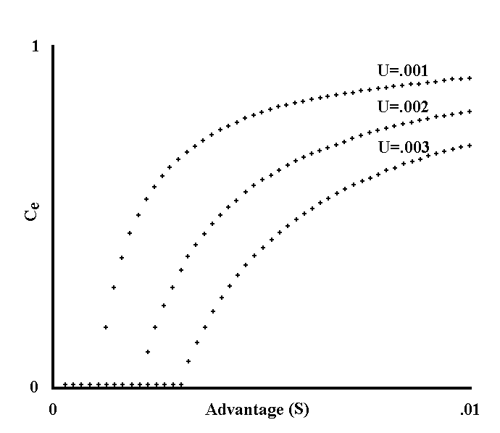
Fig. I 2-5 - Equilibrium frequencies of a gene with advantage S and decay U (Theoretical model).

For the definition of equilibrium frequency see Fig. I 2-4. Assuming the frequency of back-mutation of C’ in C equals zero, we have:

C_{n+1} = C_{n} (1 + S - U) (I-16)
1 + C_{n} S

As at equilibrium C_{n+1} = C_{n} = C_{e}, if we divide both members of this formula by C_{e} (an operation that is valid as long as C_{e}  0), we obtain:

1 = 1 + S – U
1 + C_{e} S

1 + C_{e} S = 1 + S - U

Ce = S – U = 1 – U (I-17)
S S

Using analogous procedures, it is possible to get C’_{e} = U/S, and so, again:

Ce + C’e = 1 - U + U = 1 (I-18)
S S

Note that if U > S, Ce must be assumed to equal zero and C’e = 1, being impossible frequencies lesser than 0 or greater than 1.
Mathematically, the correction is explained by the fact that dividing the members of an equality by zero is not permitted.
In the above figure, advantage S is shown on the abscissas (0 on the abscissa 0; .01 on the right side of the abscissas; the difference between one cross and the next is equal to .0002). C_{e} is on the ordinates. The curves, going from top to bottom, refer to the following values of U:

.001 ; .002 ; .003.

Note that if C is defined as the totality of the genes defining a character X, and U as the sum of mutation frequencies of the various genes defining X and, finally, S as the advantage deriving from having character X without any gene changes, the figure gives us an idea of the decay of a “complex” character. In particular, U will be high in proportion to the number of genes that define X, and if S is not high to the same extent, C_{e} will be low.

3) Extension of the formal definition of gene
In the ideal models illustrated thus far, the “gene” is defined as something that phenotypically shows itself in its entirety at each generation in all individuals in which it is present.
In an ideal model, this assumption is correct, but it should be noted that a gene thus defined has analogies in reality only with the genes of individuals of haploid species, which would render the validity of the model biased and doubtful.
On the other hand, I think that with opportune variations that do not invalidate its essence, the model can also be extended to the case of diploid organisms, thereby completely retaining its validity.
Firstly, I call to mind Hardy-Weinberg's law by which, with a simple probabilistic calculation, we can obtain the frequency of the three possible genotypes of two alleles, C and C':

for genotype CC = C²
for genotype CC’ = 2 C C’ = 2 C (1 - C)
for genotype C’C’ = C’² = (1 - C)²

Supposing too that if an allele in the heterozygote state shows an advantage, the other allele will also show the same advantage if in heterozygosis with the first, and that in both cases the heterozygote advantage must be divided by two, as each allele is present once. It must be noted, however, that this does not happen for an advantage that is consequent to the homozygote condition.
After this premise, using procedures analogous to those used up to this point for the calculations, let us consider three main cases:

A) The gene is recessive, that is, only in the homozygote state does it show advantage S’. We have:

C_{n+1} = C_{n} (1 + C_{n} S’ - U – V) + V (I-19)
1 + C_{n}² S’

B) The gene, if heterozygous, shows advantage S and, if homozygote, the advantage S’. The calculation is more elaborate and must be presented for clarity:

C_{n+1} = C_{n} + 2 C_{n} (1 - C_{n}) S + C_{n}² S’ - C_{n} U + C’_{n} V (I-20)
T

C’_{n+1} = C’_{n}+ 2 C_{n} (1 - C_{n}) S+ C_{n} U - C’_{n} V (I-21)
T

where:

T (sum of the two numerators) = C_{n} + 2 C_{n} (1 - C_{n}) S + C_{n}² S’ - C_{n} U + C’_{n} V + C’_{n} + 2 C_{n} (1 - C_{n}) S + C_{n} U - C’_{n} V (I-22)

By simplifying, we obtain:

C_{n+1} = C_{n} (1+ 2 S + C_{n} (S’- 2 S) - U - V) + V (I-23)
1 + 4 S C_{n} + C_{n}² (S’ – 4 S)

Note that in this formula, assuming S = 0, we obtain A).

C) The gene is dominant and shows an identical advantage S in the heterozygote and in the homozygote state. Assuming S’ = S in the formula B), we obtain:

C_{n+1} = C_{n} (1 + 2 S - C_{n} S - U - V) + V (I-24)
1 + 4 S C_{n} - 3 C_{n}² S

Other cases are conjecturable as well, but for brevity I will limit the subject to those mentioned above.
If it is assumed, as a simplifying condition, that V = 0, the equilibrium values of C and C’ are easily calculable with mathematical transformations analogous to those illustrated in Fig. I 2-5.
We obtain C_{e} = 0 or otherwise:

________
A’) Ce = 1 + 1 - 4 U/S’ (I-25)
2

_____________________
B’) C_{e} = S’ - 6 S +  (S’ – 2 S)² - 4 U (S’ - 4 S) (I-26)
2 S’ – 8 S
_________
C’) C_{e} = 5 - 1 + 12 U/S (I-27)
6

Note that, if in B’) we assume that S = 0 or S’ = S, the formula becomes A’) and C’), respectively.
Likewise, assuming that, in A), B) and C), U = 0 as a simplifying condition, and substituting S with -S and S’ with -S’ (so that the result is not banally the unit), we obtain C_{e} = 0 or C_{e} = 1 or otherwise:

____
A") Ce = V/[S] (I-28)

____________
B") C_{e} = - S - S² - V (S’ - 4 S) (I-29)
S’ – 4 S

_________
C") C_{e} = 1 + 1 - 3 V/[S] (I-30)
3

Note that, if in B") it is assumed that S = 0 or S’ = S, the formula changes to A") and C"), respectively.

* * *

If we observe the complications that diploid organisms entail, my choice of limiting the models to haploid organisms, omitting the possible but prolix extension to the most complex cases now expounded, would appear to be all the more appropriate, even though the latter are closer to reality. The meaning and the correctness of this choice will be discussed in Appendix 4.
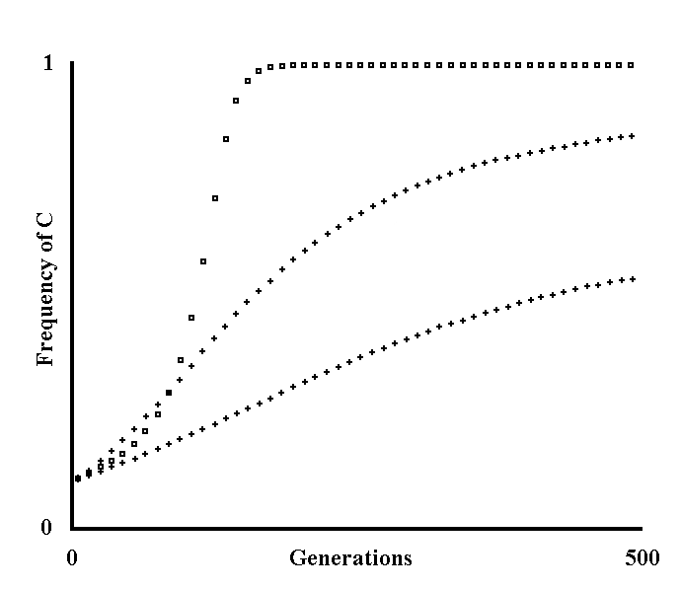
Fig. I 3-1 - Ideal models for the extension of the formal definition of gene.

For the formulas see the text. If the gene is recessive the frequency is expressed with a square, otherwise with a cross. The curves, going from top to bottom, illustrate the cases A, B and C described in the paragraph.
The assumed values are:

A) R = 1 ; S’ = .1 ;
B) R = 0 ; S’ = .01 ; S = .02 ;
C) R = 0 ; S' = .005; S = .005.

Moreover, for all curves:
C_{o} = .1 ; U = .0001 ; V = .000001 .

4) The postulate of the potentiality
If the conditions of the ecological niche of a species require the development of a character X, the selective pressures – by definition – drive the species in such a direction.
The "a priori" admission of the potentiality of character X development (postulate of the potentiality) is arbitrary. But to deny a priori such a potentiality is just as arbitrary. In many arguments that will be developed over the following pages the development potentiality of certain characters is implicitly admitted without its having been proven. The necessity of proving, from time to time, the development potentiality of a character X, would, in fact, be a critical or insurmountable obstacle to any argument. Obviously if, the development potentiality of a character X having been admitted, this potentiality is not-existent in the specific case, all the reasoning deriving from the aforesaid admission would be invalid. For this reason too, the definitive answer concerning the validity or invalidity of the arguments expounded is decided only by their confirmations in the biological reality. This is, moreover, clear because logic detached from reality can only prove itself. (On the other hand, however, the study of reality without the coordination of the logic is blind.)

Chapter II - Senescence

1) Definitions
- Senescence is a general title for the group of effects that, in various phyla, lead to a decreasing expectation of life with increasing age ... In a population not subject to senescence and exposed only to random overall mortality, the decline of numbers is logarithmic, and animals die, ex hypothesis, from causes that would have killed them at any age. In a population exposed only to death from reduced resistance, due to senescence, the curve approaches a rectangular form: after a certain age, animals die from causes that would not have killed them in youth. In one case the force of mortality is constant; in the second it rises steadily with age. Thus in rats the force of mortality rises after the ninth month of life in a geometrical progression ... Real survival graphs are commonly intermediate in form between the two ideal contours. - (Comfort, A., 1979, pp. 7 and 23)
In accordance with Comfort, but with a further specification (in italics), I say:
“Senescence” is a whole series of phenomena, with causes and mechanisms to be established, which manifests itself as a progressive increase in mortality rate as the age of the living being increases. The beginning of senescence is in that period of the life when, in natural conditions, the increase in the mortality rate exceeds an arbitrarily established threshold value.
In Fig. II 1-1, two diagrams are shown, the first, the one on the right, concerning the curve of numerical decline of a population that ages according to Comfort's definition, the other the typical curve of a population with constant resistance to “noxae”. On the curve of the right-hand side diagram, some symbols dividing the curve into periods have been added. With respect to the human species, I show two empirical diagrams in Fig. II 1-2, of which the first illustrates the variation of the mortality rate and the second the numerical decline of a population.
I will now express three further definitions which are indispensable for an understanding of the following paragraphs.
By “mean duration of the life" (ML) I am referring to the mean duration of life of the totality of the individuals of a species - or of a population - in their natural ecological niche.
On the other hand, by the term “longevity”, I am speaking about the mean duration of life in the natural ecological niche of those individuals of a species that are not dead in the first phases of life and have escaped pathological or accidental fatal events that are damaging at any age.
Finally, the expression “maximal longevity” means the greatest observable duration of life, even in an artificial ecological condition.

* * *

As regards Comfort's definition of senescence – which I fully share, albeit with a specification -, there are some points that need to be stressed.
1) The definition is not based on morphological or physiological criteria, but only on the observation of the life table in wild conditions of a population that is homogeneous by age. The increase of the mortality rate is tautologically due to a decline in the abilities of adaptation and resistance to selective pressures, but the substrate of this decline is not specified or arbitrarily postulated in the definition. It should be mentioned that such a substrate must not necessarily be some macroscopic alteration: in natural conditions even a very slight alteration of a function x could entail a significant reduction in survival abilities.
2) The aforesaid definition, which I will describe as “gerontological”, does not necessarily coincide with the one that a morphologist or a physiologist might give. The definition of this second type, which I will call “geriatric”, could be based on evident morphological or physiological parameters, such as, for example, teeth or coat wear, which manifest themselves frequently in animals which have grown old in captivity. A geriatric definition of this type is more restrictive than the gerontological one. More formally, the senescent individuals in geriatric terms, as now defined, are a subset of those individuals that are senescent in gerontological terms. To stress this concept, I will define as “hypersenescent” those among the senescent individuals (in gerontological terms) that show evident morphological and/or physiological alterations. Depending on the seriousness of the alterations, an easy prediction is that hypersenescent individuals are rarely - or even never - observable in natural conditions (see later).
3) The definition of the term senescence, and likewise those of ML and of longevity, must be used only to refer to populations in wild conditions, something that is not stressed by Comfort. If, as is plausible, the life table depends on the conditions according to which the population lives, which also means that the beginning of senility is influenced by the conditions of life, it is clear that, if there is no reference to a unique ecological niche, the gerontological definition of senescence becomes meaningless. It must be noted that, on the contrary, the geriatric definition in itself disregards any reference to an ecological niche.
I do not think that these specifications are idle semantic disquisitions. I want to show how Comfort himself (whose definition of senescence I have accepted), makes no distinction between a “gerontological” and a “geriatric” understanding of senescence.
- ... old age is undoubtedly a relatively rare or very rare termination to the life-cycle of vertebrates studied in the field - as it is for man in societies where medical and economic conditions are bad.
... in wild voles ... and in Peromyscus ... senescence is never observed, judging from the state of the teeth and bones of recent and fossil animals ... tooth wear is a reliable index of age in short-tailed shrews, those over 2 years being edentulous, but age limitation by this mechanical form of senescence is more potential than actual since few survive to exhibit it. - (Comfort, A., 1979, p. 140)
In my opinion, however, the correct conclusion is: individuals that are hypersenescent - and not those that are senescent in gerontological terms - are a rarity in the natural ecological niche.
Moreover: it should be considered a prejudice – which is absent in Comfort's definition - that senescence is identified with the alterations of individuals which have grown old in captivity, reaching ages that cannot be found in natural conditions.
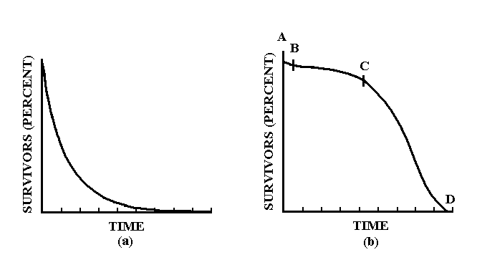
Fig. II 1-1 - Life table of a non-senescent population (a) and of a senescent population (b).

Source: Comfort, A., 1979, p. 22.
Some arbitrary symbols of delimitation have been added to the curve on the right. For this curve:
AB = first period of life with mortality higher than period BC both because the immature forms are more vulnerable to the dangers of the habitat, and because there is a loss of a certain number of genetically defective individuals;
BC = youth and adulthood with relatively constant mortality which depends on the environmental conditions;
CD = senility with a strong numerical decline in the surviving population.

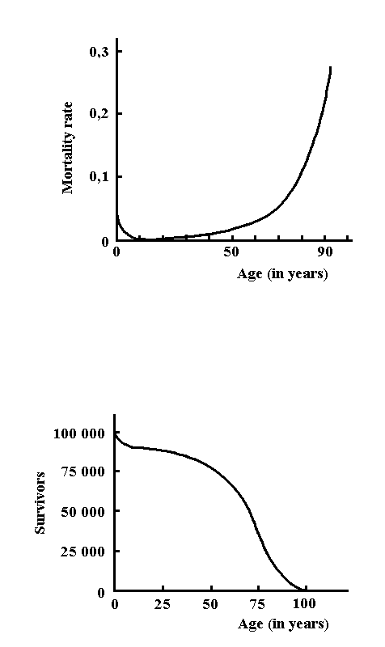
Fig. II 1-2 - Mortality and life table of a modern human population.

2) Evolutionary advantage of a lesser longevity.
From the given definitions, it can easily be deduced that greater or lesser longevity coincide with the onset of senility, the speed of which depends on the species. In this chapter, I put forward the question of why individuals age and therefore die a so-called “natural” death within a given time. Moreover, I wish to investigate the selective pressures that cause a greater or lesser longevity depending on the species.
It might seem strange to question the "why" of senescence for those who believe the progressive and fatal alteration of all vital functions to be obvious, but certainly this is an unscientific way of looking at it: discovering that something happens is not a rational reason for considering it justified. And it is also incorrect to argue that there is ongoing extensive research on those tissue and cell changes considered typical of senescence: in fact, as we must distinguish, this may explain from an evolutionary point of view how the organism ages and not why. In other words, here, I do not put forward the question of which chemical, hormonal, etc., mechanisms are implicated in the senile process, but the problem of their possible teleonomic meaning. Likewise, from an evolutionary point of view, the aforementioned research may lead to the discovery of the "how" but not of the "why" of the unbelievable variation in longevity among the innumerable species. Among living beings, there are, in fact, organisms that live for a few days (e.g.: rotifers) and others that even seem not to age at all (e.g.: Sequoiodendron). The answer to the "why" of senescence, and to greater or lesser longevity, is perhaps obtainable through reasoning in evolutionary terms. First, I want to demonstrate that, between two species with different longevity, other conditions being equal, the one with the lesser longevity is advantaged.

A premise.
Remembering that the term generation (G) in Chapter I (see Fig. I 2-1) has been defined as “the time needed for there to be N deaths within a population made up of a constant number N of individuals”, I wish to observe that, in a numerically constant population, ML and G coincide as values.
In fact, in a fictitious population, in which all individuals live for a period ML exactly, all N individuals born at any instant t die within, and not before nor after, the instant t + ML. Moreover, all individuals that replace the N original dead individuals, die after the instant t + ML. Therefore, as in the period t – t + ML a number N of individuals die, according to the given definition, we have:

G = (t + ML) - t = ML (II-1)

Moving on, then, to a real population in which the ML is a mean of unequal values, because the individuals that die before reaching an age equal to the ML are perfectly balanced, by definition, by those that die after passing the ML, by repeating, with the appropriate modifications the argument expressed above, we can reach the same conclusion of a quantitative identity between G and ML in a numerically constant population. Having said that, now let us consider two species, A and B, with longevity L_{a} and L_{b} , respectively, and with L_{a} < L_{b}.
For now, let us also assume arbitrarily that character longevity is free from mutations that alter it and from selective pressures within each of the two species.
It is hypothesized that, for mortality in the first phases of the life and as a result of pathological and accidental causes, the ML of each of the two species is lower and proportional to their respective longevities, so ML_{a} < ML_{b}. Let us also assume that both species are made up of a constant number of individuals and that, therefore, G_{a} = ML_{a} and G_{b} = ML_{b}.
Over a period of time T, we will have T / ML_{a} generations of A and T / ML_{b} generations of B. Furthermore, let us suppose that, in this period, there is a certain gradual modification of the ecological niche of the two species: selection obviously will favour the mutants that are better adapted to the new conditions of the ecological niche. But, while selection with regard to A will operate over a series of T / ML_{a} generations, for B it will be T / ML_{b} generations and, being by assumption T / ML_{a} > T / ML_{b}, A will be in an advantageous condition compared to B. In fact, evolution is describable as an endless diffusion within a species of mutations that somehow entail selective advantage. But it is known that a mutation, in order to reach a given frequency within a species, needs a certain number of generations, which are inversely proportional to the size of the selective advantage caused by the mutation. And, likewise, for a given selective advantage, the number of generations in the period of time considered is the critical factor in terms of the velocity with which the favourable genes are spread (see Fig. II 2-1).
As for A, over period T, there is a greater number of generations than for B, so character modification for A will be possible to a greater extent. Or, to say the same thing in another way, A will be able to acquire certain modifications of its own characters over a shorter time period than can B. This means that A will have better possibilities than B to adapt appropriately to the subsequent, new ecological niche, which is an advantage of A over B (see Fig. II 2-2).
In other words, the shorter the ML and, consequently, longevity, which concurs to affect the ML, the greater the possibility of rapid evolution, with selective advantage over species with a greater ML, or longevity.
As a specification of the argument expressed here, I would say that the spreading velocity of a gene within a species (see definition in the model of Fig. II 2-1), is proportional to the number of generations per unit of time (NG/T).
Moreover, defining the velocity of evolution as the velocity with which a species adapts itself to the conditions of the ecological niche, I maintain that it is also proportional to the spreading velocity of a gene, and therefore to the ratio NG/T as well.
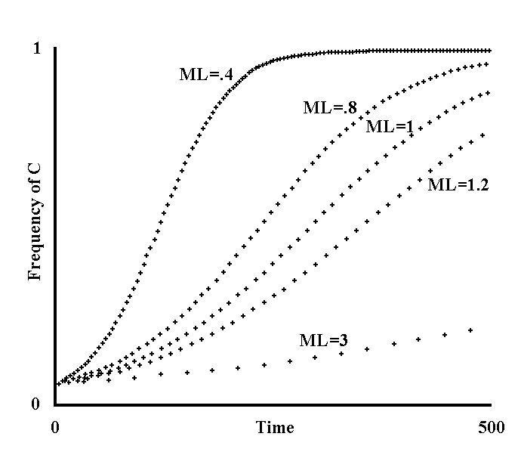
Fig. II 2-1 - Variation of the spreading velocity of a gene depending on ML variation (Theoretical model).

The expression “spreading velocity of a gene” means the inverse of the time necessary to pass from a frequency a to a frequency a’ of the gene C with advantage S. The values a, a’ and S are established arbitrarily, provided that a < a’ and S > 0. The formula used for the curves of the figure is the same as the iterative formula in Fig. I 2-1:

C_{n+1} = C_{n} (1 + S) (II-2)
1 + C_{n} S

The units of time are shown on the abscissas (10 u. from one cross to the next, with reference to the third curve, up to 500 u.). On the ordinates are the frequencies of C in 5 populations with different ML values. The populations are hypothesized as being numerically constant, so ML = 1 generation.
The values of C are illustrated with one cross every 10 generations. Going from top to bottom, the values of the MLs, in units of time, are:

ML₁ = .4 ; ML₂ = .8 ; ML₃ = 1 ; ML₄ = 1.2 ; ML₅ = 3.

Moreover, S = K = .01 and C_{o} = .05 for all curves.
For the third curve, ML and units of time coincide. Note that the curves are morphologically equal to those in Fig. I 2-1. If we bear in mind that, in this figure, ML = 1 unit of time for all five curves (as for the third curve of this figure), this was obtained by varying S to an appropriate extent. In fact, for Fig. I 2-1, going from top to bottom, S =:

K ; K ; K ; K ; K (II-3)
ML₁ ML₂ ML₃ ML₄ ML₅

Thus, the figure shows graphically that an increase in S or a proportional decrease in the ML, or vice versa, causes the same effects, as regards the spreading velocity of a gene.
It is possible to demonstrate mathematically that this statement is roughly true for small values of S. In this demonstration, it should be noted that:

C₁ = C_{o} (1 + S)
1 + C_{o} S

C_{o} (1 + S) (1 + S)
C₂ = C₁ (1 + S) = 1 + C_{o} S = C_{o} (1 + S)² ,
1 + C₁ S 1 + C_{o} (1 + S) S 1 + C_{o} S + C_{o} S (1 + S)
1 + C_{o} S

C₃ = C₂ (1 + S) = ... = C_{o} (1 + S)3 ,
1 + C₂ S 1 + C_{o} S + C_{o} S (1 + S) + C_{o} S (1 + S)²

. . . . . . . . . . . . . . . . . . . . . . . . . . . . . . . . . . . . . . . . . . . . .

C_{n} = C_{o} (1 +S)^{n} ,
1 + C_{o} S + C_{o} S (1 + S)¹ + C_{o} S (1 + S)² + ... + C_{o} S (1 + S)^{n-1}

= C_{o} (1 +S)^{n} (II-4)
1 + C_{o} S ((1 + S)⁰ + (1 + S)¹ + (1 + S)² + ... + (1 + S)^{n-1})

Using the formula of the geometric series, we obtain:

C_{n} = C_{o} (1 + S)^{n} = C_{o} (1 + S)^{n} (II-5)
1 - C_{o} S 1 – (1 + S)^{n} 1 - C_{o} (1 – (1 + S)^{n})
1 – (1 + S)

If n is an integer, then by using Newton's binomial formula and disregarding the terms having S with an exponent greater than 1, which is justifiable as S is assumed to be small, we obtain:

C_{n}  C_{o} (1 + n S) = C_{o} (1 + S n) (II-6)
1 - C_{o} (1 – 1 – n S) 1 - C_{o} S n

If we recall that the number of generations in a period T is inversely proportional to the ML:

n = T (II-7)
ML

By substitution, we obtain:

C_{T} = C_{o} (1+ S T / ML) (II-8)
1 + C_{o} S T / ML

that is:

C₁  C_{o} (1 + S / ML) (II-9)
1 + C_{o} S / ML

where the coefficient of C indicates the time and not the generation and this is proof of what I wanted to show for integer values of n. If we consider that the equality is rough, by interpolation it is possible to conclude that it is valid for fractional values of n too.
The exact non-iterative formula is, likewise:

C_{T} = C_{o} (1 + S)^{T/ML} (II-10)
1 - C_{o} (1 - (1 + S)^{T/ML}

that is:

C₁ = C_{o} (1 + S)^{1/ML} (II-11)
1 - C_{o} (1- (1 + S)^{1/ML})

For the subsequent models, I will favour, where necessary, the approximate formula because it is easily compatible with other iterative formulas.

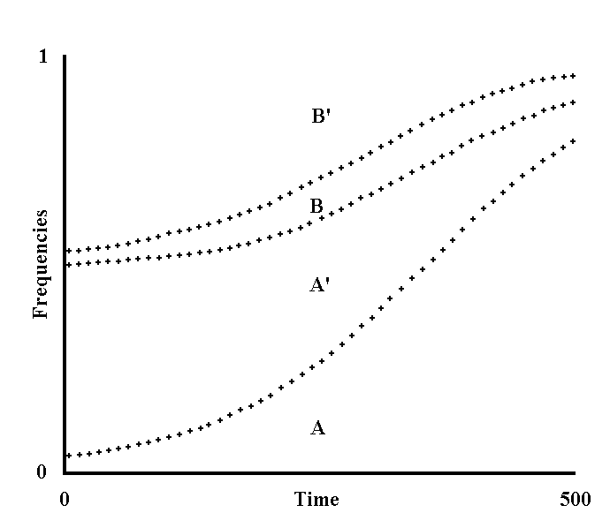
Fig. II 2-2 - Prevalence of a species over another on the basis of a different ML (Theoretical model).

Let us consider two species in competition, a and b. In species a, there are the alleles A and A’ with the advantage S_{a} of A over A’. For species b, analogous conditions are assumed, thus defined as B, B’ and S_{b}.
ML_{a} and ML_{b} indicate the ML of a and b, respectively.
In the previous model (Fig. II 2-1), it was shown that a decrease in S and a proportional increase in the ML, or vice versa, cause the same effects as regards the spreading velocity of a gene. Thus, assuming, for the sake of simplicity, that ML_{a} = 1 unit of time and multiplying S_{a} by 1/ML_{a} = 1 and S_{b} by 1/ML_{b}, it is possible to construct curves regarding the spreading velocity of a gene, as if ML_{a} and ML_{b} were identical and equal to the unit of time. Assuming that the species are isolated from each other, but with a constant overall number of individuals, we would have:

A_{n+1} = A_{n} (1 + S_{a}) ; A’_{n+1} = A’_{n}
D D

B_{n+1} = B_{n} (1 + S_{b} (1/ ML_{b})) B’_{n+1} = B’_{n} (II-12)
D D

where D indicates the sum of the numerators and maintains the sum of the frequencies constant:

A_{y} + A’_{y} + B_{y} + B’_{y} = 1 (II-13)

Now, if we consider that the two species are in competition with each other, and assume that, at each generation, advantage S_{i} is proportional to the fractions:

A_{n} = F_{a} for species a,
A_{n} + A’_{n}

B_{n} = F_{b} for species b, (II-14)
B_{n} + B’_{n}

These express the degree of spreading of a favourable gene within a species; from these conditions we obtain:

A_{n+1} (corrected) = A_{n+1} (1 + S_{i} F_{a})
D

A’_{n+1} (corrected) = A’_{n+1} (1 + S_{i} F_{a})
D

B_{n+1} (corrected) = B_{n+1} (1 + S_{i} F_{b})
D

B’_{n+1} (corrected) = B’_{n+1} (1 + S_{i} F_{b}) (II-15)
D

where D is, as usual, the sum of the numerators.
Assuming also that gene A changes into A’ with rate U_{a} and similarly defining U_{b}, we obtain, by using the same procedures for the isolated species:

A_{n+1} = A_{n} (1 + S_{a} - U_{a}) ; A’_{n+1} = A’_{n} + U_{a} A_{n}
D D

B_{n+1} = A_{n} (1+ (S_{b} - U_{b}) / ML_{b}) ; B’_{n+1} = B’_{n}+ U_{b} B_{n} / ML_{b} (II-16)
D D

and formulas identical to those above for the species in competition. Note that, if U_{a}, U_{b} = 0, this second group of formulas changes into the preceding one.
The curves were obtained using the second group of formulas. The time is on the abscissas (10 units from one cross to the next up to 500 units of time, equal to as many generations of a).
On the ordinates, going from bottom to top, are the frequencies:

A_{y} ; A_{y} + A’_{y} ; A_{y} + A’_{y} + B_{y}.

The assumed values are:

ML_{b} = 1.5 ; S_{a}, S_{b}, S₁ = .01 ; U_{a}, U_{b} = .0001; A_{o}, B_{o} = .03 ; A’_{o}, B’_{o} = .47.

Apart from the inequality of the ML, a and b start, therefore, with equal conditions. The curves show the prevalence of a over b as a consequence of the faster diffusion of the favourable gene within species a.

3) Evolutionary steadiness of character senescence
A character is defined as evolutionarily stable when it entails advantages greater than the possible disadvantages plus the load of disruptive mutations, so that the character is not lost.
In the reasoning of the previous paragraph, two species with different longevity were compared, with the assumption, however arbitrary, that the genes causing senescence are exempt from mutations, selective pressures and other factors that modify their frequencies within each species. The argument has shown that, between two species with different longevity, and other conditions being equal, the one with the lesser longevity is favoured; no indication has been given, however, about the steadiness of evolution within a species, of character senescence (or limited longevity, which is the same thing). I am now going to examine this fundamental question, thereby abolishing the assumption formulated in the reasoning above.
At first glance, it is difficult to justify the steadiness of the character senescence. In fact, the advantage of senescence would seem to apply over several generations and for the species in toto, although there are certainly a number of immediate advantages for the single organism, which is not - or is less - senescent, such as, for example: a greater ability to produce several offspring, a lesser incidence of the more vulnerable period of life, such as the period of growth, etc. (see Chapter II, par. 5 too). But it is implicit in the concept of selection that it cannot act on a future advantage or in defence of such a theoretical entity as a species.
It is necessary to prove that senescence brings about an immediate advantage at each generation for the genes causing it, and that the immediate advantages of the non - or less - senescent organism clash with such an immediate advantage. If this were not so, the genes causing the senescence would decay (see Fig. II 3-1).
I think that the answer should be looked for in the light of that which is the pivotal concept of modern sociobiology, namely the non-coincidence, in order to natural selection, of individual and genome of the same individual. I will start with the observation - inexplicable if this concept is not considered - that, in the animal world, there are behaviours defined as “unselfish”, which are harmful for the individual but advantageous for other genetically related individuals (Wilson, E. O., 1975, Chapter V). We have, for example, the social organization of certain mammals which sometimes engender disadvantages for the single individual, but which is useful for the survival of the herd. The stronger individuals in a troop of baboons are capable of stopping a fierce animal, even at the cost of their life, to keep the herd safe. In the herds of many species, the younger and more vulnerable individuals are at the centre, while the adult animals place themselves in more dangerous positions. Moreover, the adults of some bird species are able to distance themselves from the nest, pretending to be injured in order to attract the predator’s attention to themselves, thereby saving their young at the risk of their own life. But, the more sensational examples are offered by eusocial insects where sterile - but sometimes potentially fertile – individuals, devote their energies to caring for the offspring of few other individuals (queen bee, drones, etc.). Darwin, observing these phenomena, which are, seemingly, quite in contradiction with natural selection, already hypothesized the existence of supra-individual mechanisms of selection (Darwin, C., 1859). From the study of eusocial insects alone, a rigorous sociobiological explanation originated, in evolutionary terms, of the phenomenon of “unselfishness” as an alternative to the classic explanation of group selection.
If a character defined by the gene C is harmful for individual I, in which it is present, but entails an advantage for other related individuals having a fraction F of the genes identical to those of individual I and, therefore, a probability F of having C, the spreading of the gene C is subjected to two contrasting selective pressures. If the sum of the two pressures (inclusive fitness) is positive, gene C is favoured, although it entails a disadvantage for the specific individual in which it is present. Note that, according to this logic, gene and individuals are distinct entities in order to selective process and the individual is subordinate to the gene, so much so that Wilson even phrased the aphorism thus: “the organism is only the means by which DNA is able to make other DNA” (Wilson, E. O., 1975, p. 3).
For a more formal exposition, see the model of Fig. II 3-2.
Returning to the subject of senescence, it is now necessary to evaluate the inclusive fitness of a gene C that reduces longevity. If an individual I, when it dies prematurely as a consequence of the action of C, is substituted by genetically related individuals, the advantage of the faster spreading of any gene y must be calculated to the extent that the individual substituting I is related to it, namely to the extent that it has a mean portion F of identical genes (= kinship coefficient). As the genes y that are spreading in a species are many, the overall advantage of the faster spreading of the genes should not be negligible, even if F is small. The model of Fig. II 3-3 has been constructed on these concepts. This model shows how, with minor modifications of the model of the preceding figures, it is possible to achieve a simple demonstration of the evolutionary steadiness of character senescence.
Note that, if in the model, the fraction F is assumed to be equal to 0, the formula becomes identical to that of Fig. II 3-1.

* * *

Based on what we learn from population genetics and natural observation (Wilson, E. O., 1975), namely that:
1) the species is often divided into many small groups (demes);
2) the genetic flow among the various demes is not unlimited;
3) if the number of individuals of a deme is not great (<100-200), genetic drift is not a negligible phenomenon;
4) interdemic selection may have its importance in the evolution;
I have worked out an alternative model, which does not exclude the other, to maintain the steadiness of senescence character. The species is hypothesized to be divided into N demes, each made up of n individuals. C is, as usual, a gene that causes reduced longevity. The frequency of gene C in a deme, a frequency on which the ML of the individuals of the deme depends, varies from one deme to another because of the genetic drift. The demes have been hypothesized to be completely isolated from each other for a certain number of generations during which gene C frequency in each deme decreases moderately because of disadvantage S’ which is a result of the reduced longevity and also because the substitutions within each deme are hypothesized to be non-preferential for genetically related individuals (F = 0). At the same time, during the isolation period, frequency G of any favourable gene y increases to a differential extent for each deme because of the interdemic variation of C. In the period of isolation, let us assume that there is interdemic competition and selection (read: differential extinction) depending on the advantage deriving from the greater or lesser spreading of G. At the end of the isolation period, there is a phase in which all demes are merged and divided again immediately afterwards. The cycle then repeats itself once more.
This model too (Fig. II 3-4) shows that, with the appropriate values of the factors involved, the frequency of C increases.

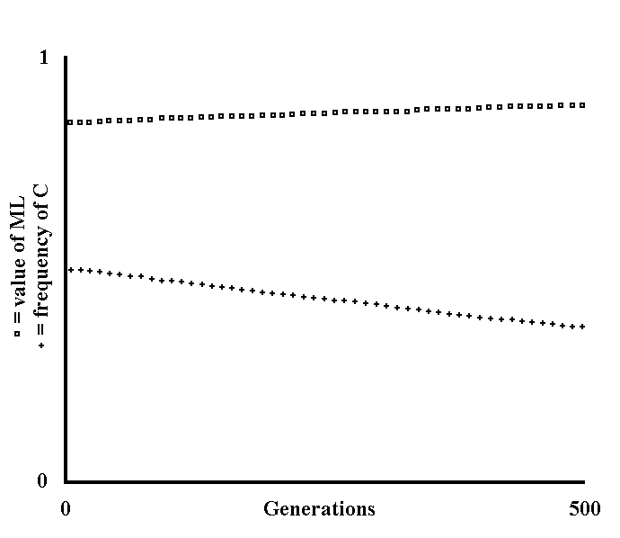
Fig. II 3-1 - Decay of the character senescence (Theoretical model).

C is a gene that brings about a more precocious senescence. The individuals with allele C’ have an ML equal to 1 unit of time and those with gene C have ML = V_{c} with V_{c}< 1. The reduced longevity results in disadvantage S’ (see Chapter II, par. 5). Likewise, reduced longevity brings the advantage of a faster spreading of the favourable genes within a species, as a consequence of the faster turnover of individuals (see Chapter II, par. 2). If this advantage is in favour of any individual of the species, both individuals with gene C and those with allele C’ are advantaged, so the advantage of C against C’ is non-existent.
With these assumptions and using the same procedures as in the preceding models and taking the ML of the whole population at the nth generation to be:

ML_{n} = C_{n} V_{c}+ C’_{n} 1 = C_{n} V_{c} + 1 - C_{n} = 1 - C_{n} (1 - V_{c}) (II-17)
1

we have:

C_{n +1} = C_{n} ( 1 - S’ / ML_{n}) (II-18)
1 - C_{n} S’ / ML_{n}

The assumed values are:

C_{o} = .5 ; S’ = .001 ; V_{c} = .7.

In the figure, the crosses indicate the frequency of C and the squares the value of the ML. The abscissas indicate the generations (values from 0 to 500). The ordinates express both the frequency of C (values from 0 to 1), and the value of the ML (values from 0 to 1 time unit). The figure shows the decrease in frequency of C and the consequent increase of the ML.

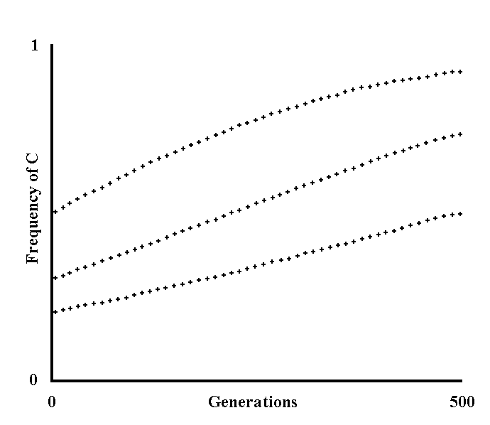
Fig. II 3-2 - Evolutionary steadiness of an “unselfish” character (Theoretical model).

C is a gene that brings disadvantage S’ for the individual I in which it is present.
Moreover, C brings advantage S for an individual I’ having the fraction F (= kinship coefficient) of genes in common with the individual I. Gene C, which has probability F of being present in the individual I’, shows, for each generation, an increase of frequency proportional to the product F S.
Therefore, we have:

C_{n+1} = C_{n} (1 + F S - S’) (II-19)
1 + C_{n} (F S - S’)

If the advantage S is expressed towards n individuals, and to a differential extent, the product F S must be substituted with the summation:
_{n}
 F_{x} S_{x}.
^{x=1}
If we also consider a rate U of mutation of C into the allele C’, which is assumed to be inactive, it is possible, in the end, to obtain:

_{n}
C_{n+1} = C_{n} (1 +  F_{x} S_{x} - S’ – U)
^{x=1} (II-20)
_{n}
1 + C_{n} ( F_{x} S_{x} - S’ – U)
^{x=1}

formula used for the curves of the diagram.
Going from top to bottom, the assumed values are:

C_{o} = .5 ; n = 1 ; S₁ = .03 ; F₁ = .5.
C_{o} = .3 ; n = 2 ; S₁ = .05 ; F₁ = .125 ; S₂ = .03 ; F₂ = .25.
C_{o} = .2 ; n = 3 ; S₁ = .04 ; F₁ = .25 ; S₂ = .01 ; F₂ = .125 ; S₃ = .003 ; F₃ = .5.

Moreover, for all curves: S’ = .01 , U = 0.
With the assumed values, the curves show an increase in frequency of gene C.

* * *

It should be noted that, for the sake of simplicity, an equal reproductive value for all individuals has been left out of this model (see definition in Wilson, E. O., 1975, p. 98) and all other conditions of asymmetry have been excluded. With appropriate modifications of the formulas, these factors can, however, be considered without modifying the general meaning.

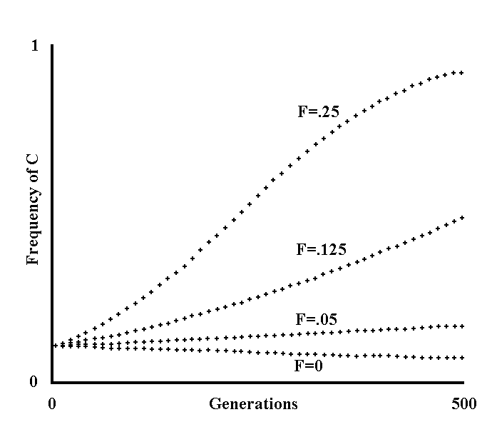
Fig. II 3-3 - Evolutionary steadiness of the character senescence (Theoretical model based on inclusive fitness).

C is a gene that brings about a more precocious senescence. The individuals with allele C’ are assumed to have an ML equal to 1 unit of time, and those with gene C an ML equal to V_{c} and lesser than 1.
Reduced longevity results in a disadvantage S’ (see Chapter II, par. 5).
It is also assumed that an individual I, when it dies, is substituted by another individual I’, which has, on average, a portion F of the genes identical to those possessed by I and has, therefore, a probability F of having C (preferential substitution).
For the remaining portion (1 - F) there is, between the genes of I and I’, the same likeness that there is between any two individuals of the species.
Within a species, gene y favoured by advantage S is spreading. Given that for the spreading velocity of a gene, a reduction of the ML is equivalent to a proportional increase of advantage S (see Fig. II 2-1), it is assumed, for the individuals with the lesser longevity, that:

S_{c} = S (II-21)
Vc

while for the individuals with normal longevity:

S_{C’} = S = S (II-22)
1

Moreover, all individuals are assumed to have a unique ML (= 1 unit of time).
The difference between the two advantages is:

S_{C} – S_{C’} = S - S = S (1/V_{C} - 1) (II-23)
V_{C}

This differential advantage is applied over that fraction F of genes that is identical in I and I’, so, if we also consider that (see Fig. II 3-1):

ML_{n} = C_{n} V_{c} + C’_{n} 1 = 1 - C_{n} (1 - V_{c}) (II-24)
1

we have:

C_{n+1} = C_{n} (1 + F S (1/V_{C} – 1) - S’/ML_{n}) (II-25)
1 + C_{n} (F S (1/V_{C}- 1) - S’/ML_{n})

The curves of the figure were obtained assuming the following values:

C_{o} = .1 ; S = .1 ; S’ = .001 ; V_{C} = .7 for all curves, F = .25 ; .125 ; .05 ; 0 for the various curves, going from top to bottom.
Note that it has been assumed that S >> S’ since S summarizes the advantage of the K genes y that are spreading within a species and so:

_{K}
S = Σ S_{x} (II-26)
^{x=1}

with K which is a not small number.
Note also: if we assume that F = 0 (non-preferential replacement), the formula changes into that of Fig. II 3-1 and the frequency of C decreases (see lower curve).

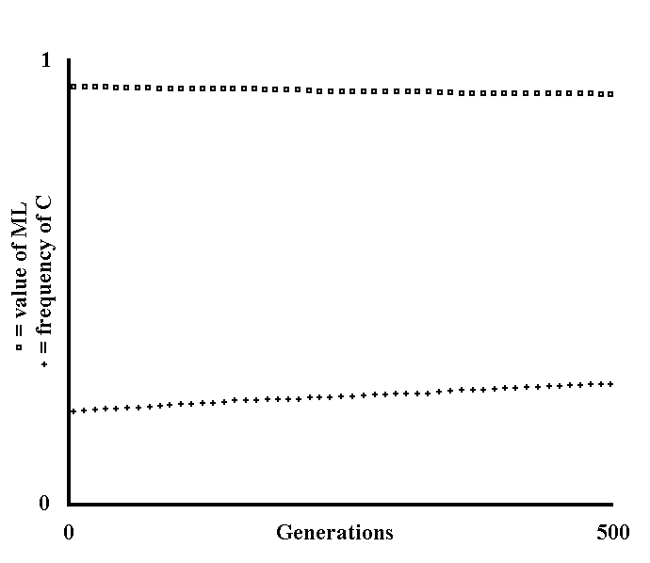
Fig. II 3-4 - Evolutionary steadiness of the character senescence (Theoretical model based on the division in demes).

Gene C, that gives rise to more precocious senescence, is present within the species. As for the preceding models, the ML of the individuals with gene C’ is equal to 1 unit of time, while for those with gene C, it is equal to V_{c} (< 1), and:

ML_{n} = 1 - C_{n} (1 - V_{C}) (II-27)

The species is divided into N demes, each made up of a number n of individuals. Because of the genetic drift, the frequency of C in each deme is variously different from the mean value of C for the whole species. Using mathematical method and a RANDOM function, the frequency of C in each deme is calculated at each “cycle” (see definition below). For further details on this point, see the source code of the program used (s. Appendix 4).
The demes are hypothesized to be completely isolated from each other genetically for a certain number (ST) of generations (ST generations = 1 cycle). In this period, the gene C undergoes a slight decrease in frequency for the disadvantage S’, deriving from a reduced longevity and because it is assumed that the replacement of predeceased individuals is not preferential (s. Fig. II 3-1 and Fig. II 3-3). The formula used is:

C_{n+1} = C_{n} (1 - S’/ML_{n}) (II-28)
1 - C_{n} S’/ML_{n}

In the same period, the gene G, favoured by the advantage S, is spreading within each deme with different velocities depending on the ML of the individuals of the deme. This is calculated using the formula:

G_{n+1} = G_{n} (1 + S/ML_{n}) (II-29)
1 + G_{n} S/ML_{n}

In the model, it is also assumed that there is interdemic competition (read: differential extinction) with advantage, depending on the greater or lesser spreading of G, proportional to:

D_{x,nf} = D_{x,n} G_{x,nf} (II-30)
n
Σ D_{k,n} G_{k,nf}
^{k=1}

where the terms D_{x,n} and D_{x,nf} indicate the fraction - with regard to the whole species - of individuals belonging to deme x at the beginning and the end, respectively, of the nth cycle and the term G_{x,nf} indicates the frequency of G in deme x at the end of the nth cycle.
From this, it is possible to calculate the mean frequency of C in the whole species at the end of each cycle, and at the beginning of the next cycle (C_{o}):

_{n}
C_{o} = Σ C_{k,nf} D_{k,nf} (II-31)
^{k=1}

where the term C_{k,nf} indicates the frequency of C in deme k at the end of the nth cycle.
After the isolation period, the demes are reunified, redistributing gene C within the species. Immediately afterwards, the species is again divided into numerically equal demes and the cycle resumes again.
Note that the frequency of G is assumed to be equal to a constant (G_{o} = .5) at the beginning of each cycle. In fact, as the spreading of G means the endless spreading within a species of all genes that entail an advantage, and G therefore represents the mean of a collection of constantly renewed genes, in spreading, it is preferable to assume G to be equal, at the beginning of each cycle, to a frequency halfway between that of the lowest spreading (= 0) and that of the greatest spreading (= 1). Moreover, because G is the average of the spreading of many genes, it must be assumed that S>>S’.
The figure was obtained assuming the following values:

N = 10 ; n = 10 ; ST = 10 ; V_{c} = .7 ; S’ = .0001 ; S = .1 ; C_{o} = .2.

In the figure, the crosses indicate the frequency of C and the squares the ML. With the assumed values, the figure shows an increase of the frequency of C within a species. The quite limited inclination of the spreading curve of C, gives the impression that interdemic selection is secondary for the steadiness of the character senescence, with regard to the mechanisms illustrated in the model of the previous figure.

4) Other selective pressures affecting longevity
The experimental verification or the confirmation in natural observations of that which is theoretically maintained in the preceding paragraphs, comes up against the significant problem that the phenomena discussed concern a period of many generations, and thus contrasts with the limited life duration of the Experimenter or of the Naturalist. An experimental confirmation could, perhaps, be obtained using the theoretical models described so far, as well as those that will follow. Moreover, useful data could be offered by accurate comparative observations on the longevity and velocity of evolution of species that are related and/or have a similar ecological niche, not forgetting to take into consideration the other selective pressures that contribute evolutionarily in affecting longevity.
It would, in fact, be simplistic to think that longevity is dependent only on the necessity of a greater or lesser velocity of evolution. It has to be observed that, other conditions being equal, the more long-lived species for a time likewise greater on the total of life duration are in the adult state. And the adult is usually less vulnerable to the dangers of the habitat then forms that are growing. A greater longevity has, therefore, this first advantage. This is, perhaps, particularly so in the case of trees. In fact, the development from seed to fully-grown tree, given the ruthless competition of the other plants, is a by no means short and highly problematic phase of the life cycle of trees. It is no surprise if examples of the greatest longevity are known among the trees. Sequoiodendron and Pinus aristata are species of which there are known to be millennia-old specimens which seem to not age at all. These are extreme cases and the evolutionary vulnerability caused by their non-ageing is, perhaps, indicated by the restricted nature of the zones in which they vegetate. Even among the trees, the species with limited longevity predominate.
A greater body mass should be, out of necessity, another factor influencing longevity: in such a case, the period of formation and growth of the individual will, evidently, tend to be longer and the longevity will have to increase proportionally, so that the percentage incidence of the vulnerable period of formation over the total duration of life decreases. It is probably for this reason that the whale’s longevity is not low (30-50 years according to Comfort, A., 1979, and 80 years as its greatest longevity, according to the data reported by Caleb, E. F., 1977).
The extent of learning abilities is probably another important factor: the greater the learning abilities, the greater longevity must be in order for an individual to learn and benefit from the advantage consequent to the learning. If one considers that man has high learning abilities, the fact that he has the greatest longevity among the mammals would seem to be justified.
The elephant, which combines a great body mass, albeit much lower than that of the whale, with a considerable learning ability, albeit much lower than that of man, also ranks among the longer-lived mammals (40 years as longevity and 70 years as its greatest longevity, according to the data reported by Caleb, E. F., 1977).
And yet, the fact that a species is more subject to r selection or, on the contrary, to K selection (see Wilson, E. O., 1975, Chapter 4) certainly influences, evolutionarily-speaking, the longevity, in the sense that the r-selection favours those populations that are less long-lived and the opposite happens with the K-selection. (However, the conditions in which there is r- or K-selection are perhaps describable as a subset of the conditions in which a greater or lesser velocity of evolution, respectively, is necessary).
Finally, periodical climatic variations are also decisive in terms of longevity, when the ecological niche of a species is strictly dependent on the afore-mentioned variations. For a great many insects and plants, the duration of the life-cycle is, in fact, strictly dependent on seasonal or annual variations.
It remains to be explained why many species that live in conditions of high mortality by causes damaging at any age, have a great or unlimited longevity.

5) The Methuselah effect
A name that smacks of legend might be of considerable help in remembering a particular phenomenon. The somewhat longer, more technical name, might read: “the evolutionary effect of longevity increase caused by mortality increase deriving from causes damaging at any age”. It is demonstrable, from a theoretical point of view, that mortality due to the afore-mentioned causes concurs in the determination of the longevity of a species.

* * *

A certain degree of variability of the ecological niche of a species requires an adequate velocity of evolution of the species. The velocity of evolution has been said to be inversely proportional to the ML of a species. I wish to stress that the ML is, in turn, dependent on:
1) how fast the senile age arrives;
2) the mortality rates by causes damaging at any age.
In other words, both 1) and 2) contribute to limiting the ML with the advantage discussed in the preceding paragraphs of a proportionally greater spreading velocity of the genes.
Now, let us consider a species where 2) is acquiring a greater importance in ML limitation: in such a case 1), namely senescence, should come later and later if ML is to remain constant. That is, the velocity of evolution is, to an ever greater extent, an effect of the increased mortality by causes damaging at any age rather than a consequence of a limited longevity. This would be an effective explanation of the rather high longevity that is observed for many small animals, which live in conditions of high environmental mortality. Many birds of small size in captivity survive for even 15-20 years, while in the original ecological niche, the ML is much lower because very few reach the age of “natural” death.
The study of a great number of amphibians, fishes, invertebrates, etc. give analogous data (Comfort, A., 1966a and 1979).
It seems almost excessive to stress that the Methuselah effect, if it really exists, will be observable only over a sufficient number of generations; it is by no means to be understood that a variation of the mortality by causes independent of senescence significantly modifies the longevity in the space of one or few generations.
For a better expression of the Methuselah effect, see figures II 5-1 and II 5-2.

* * *

In short, if the arguments so far expounded in this chapter are correct, longevity is increased by:
1) a greater stability of the ecological niche;
2) an increase in the incidence of the more vulnerable period of life, such as that of initial formation and of growth;
3) a greater body mass;
4) a greater learning ability;
5) a prevalence of “K-selection”;
6) an increase in mortality by causes damaging at any age;
and decreased by:
1) a lower stability of the ecological niche;
2) a decrease in the incidence of the more vulnerable period of life, such as that of initial formation and of growth;
3) a lower body mass;
4) a lesser learning ability;
5) a prevalence of “r-selection”;
6) a decrease in mortality by causes damaging at any age.

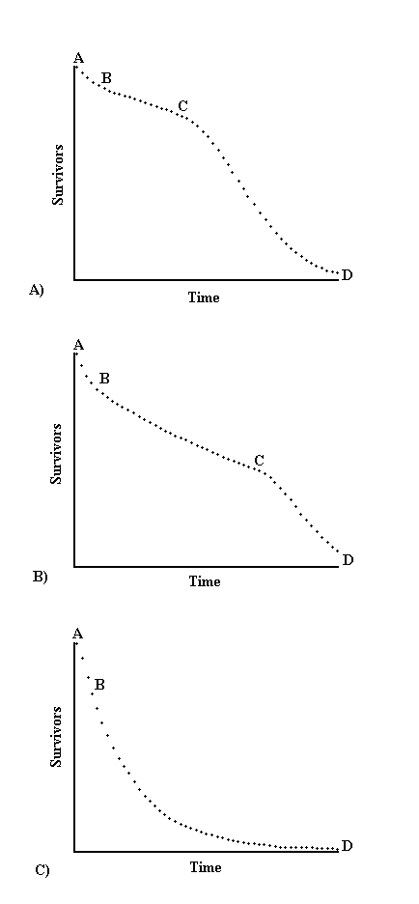
Fig. II 5-1 - Graphic illustration of the Methuselah effect.

A) Life table of an aging species. The time is on the abscissas and the percentage of the surviving individuals on the ordinates. There is an initial period AB with high mortality (see Fig. II 1-1), followed by a segment BC with almost constant mortality and which depends on the environmental conditions, and finally a segment CD with mortality that is high and increasing because of senescence. For the curve there is a calculable value z of ML species depending on the selective pressures discussed in the preceding paragraph.
B) In this second curve, other conditions being equal, there is an increase in the inclination of the segment BC, an expression of the mortality increase by causes that are damaging at any age. This would cause a decrease of z if not compensated by the displacement of point C toward the right.
C) Limit curve: a strong increase in the inclination of BC corresponds to a displacement to infinity of point C, meaning the species becomes of unlimited longevity. Such a displacement of C could also be caused by a sufficient increase in z, as a consequence of a decreased necessity for rapid evolution of the species.
The equation that defines the curves is:

Y_{t} = Y_{o} (1 - K)^{t} (II-32)

where: K = mortality rate; Y_{t} = surviving at time t.
In the first two curves K is different in the segments AB - BC - CD and, moreover, is decreasing in segment AB and increasing in segment CD.
In the third curve, K is greater in AB than in BD, and decreasing, but is constant in BD.
A program was used (see Appendix 4) to draw the curves, which are illustrative and not demonstrative. The values assumed are:

Curve A): B = 5; C = 20; K = .01; I1 = 1.1; 12= 1.1;
Curve B): B = 5; C = 35; K = .02; I1 = 1.1; 12 = 1.1;
Curve C): B = 5; C = 50; K = .1; I1 = .01; 12 = 0.

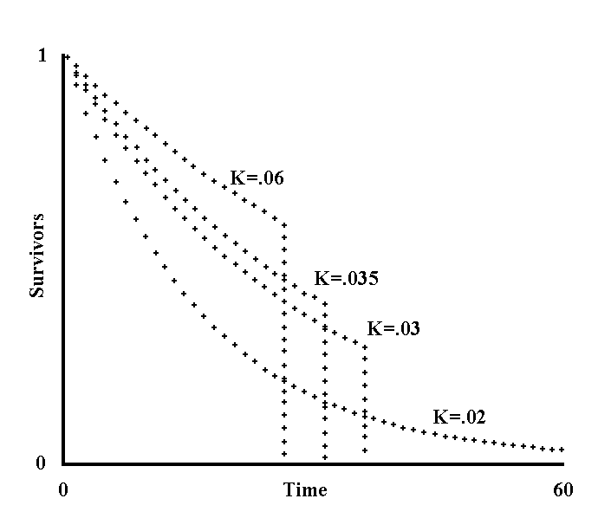
Fig. II 5-2 - Methuselah effect (Theoretical model).

In the model, the mortality rate (K) for each curve is constant from birth until an instant L, when all surviving individuals die at the same time. L is the ideal equivalent of longevity and the definition is such that will be easy to deal with mathematically. The curves are given by the formula:

Y_{t} = Y_{o} (1 - K)^{t} (II-33)

with: 0  t  L.
Y_{t} indicates the fraction of the survivors at time t. From instant L, each curve goes down, parallel to the ordinates, until it meets the abscissas. Let us calculate the ML:

ML = ₀^{L}∫Y_{o} (1 - K)^{t} dt = ₀^{L}∫(1 - K)^{t} dt
Y₀

= [(1 /Log_{e} (1 - K)) (1 - K)^{t} ]₀^{L} = (1 - K)^{L} – 1 (II-34)
Log_{e}(1-K)

Note that if L  , as K < 1, then it follows that (1 - K)^{L}  0 and we have the equation:

ML = - 1 (II-35)
Log_{e}(1 - K)

from which we have:

K₁ = 1 – e^{-1/VL} (II-36)

where K_{l} indicates the limit value of K beyond which the equation has no meaning.
If we want ML to remain constant, in spite of a variation in K, then L must also vary. So, if,

ML = (1 - K)^{L} - 1 = (1 - K’)^{L’} - 1 (II-37)
Log_{e}(1 - K) Log_{e}(1 - K’)

by solving with regard to L (or, is the same, with regard to L’), we obtain:

ML Log_{e}(1 - K) + 1 = (1 – K)^{L}

L = Log_{a}(ML Log_{e}(1 – K) + 1) (II-38)
Log_{a}(1 – K)

where a is any base.
This equation, to the extent that it is possible to verify, is, moreover, meaningless for values of K > K_{l}. The equations show that, when the condition of ML is constant, an increase in L corresponds to an increase in K. This is so until the value of K = K_{l}, at which point L reaches its maximal value (= ) and cannot increase further.
In the figure, four time–surviving individuals’ curves are shown. The value of the ML is equal to 20 units of time. Going from bottom to top, the assumed values for K are:

.06 ; .035 ; .03 ; .02.

K_{l} is obtained from the formula expounded above and is equal to: .0487705755.

6) Theories about the “how” of senescence
So far, I have investigated the “why” of senescence; that is, I have speculated on the possible teleonomic meaning that should be attributed to senescence phenomenon or to its appearance either sooner or later, depending on the species. In the light of what seems to be the conclusions of the arguments developed in the preceding paragraphs, and within the very general limits allowed by theoretical reasonings, I now wish to consider the theories about the "how" of senescence. Several theories (see Comfort, A., 1979 and Caleb, E. F., 1977 for a review) have been put forward to explain the slow decay of the aging organisms but disregard, in my opinion, the teleonomic question, often in a de facto manner, without any distinction between “how” and “why”. I do not intend, here, to do an exposition or a history of the theories put forward so far. Likewise, I have tried to focus attention on four different ways of explaining the senescence phenomenon, reworking and interpreting freely and without mentioning, therefore, the authors that first put each concept forward, and without distinguishing between what has been already expressed by others and what is, perhaps, expressed for the first time. After this premise, I will classify the theories about the "how" of senescence in this way:
a) Theories of senescence caused by wear;
b) Theory of senescence caused by insufficient selection;
c) Theory of hampered senescence;
d) Theory of programmed senescence.
I will dedicate this paragraph to a) and b), while c) and d) will be discussed in the next paragraph.

* * *

a) Theories of senescence caused by wear.
These theories are based on the concept of a “something” that continuously “wears out” the organs of the living being over time, progressively altering their functionality. This “something” was, at first, thought to be the simple use of the organs, but soon the untenability of this hypothesis was apparent. In fact, many organs, if not used become atrophied and, on the contrary, if used, strengthen and remain efficient for longer (e.g.: muscles). Many then tried to conceive of the "something" as being more closely related to time and independent of the use or non-use of the organs. There are, then, theories of aging caused by genetic alterations, mutations, chemical-physical alterations, stress, etc., in which the factors that cause the senescence are occasional mutations, stresses, duplication errors in division cells, progressive chemical alterations, etc. Even if the importance of one or more of these factors is a genuine factor in the genesis of the senescence, it should be noted that these theories do not put forward the question of the evolutionary usefulness or uselessness of the senescence, or of the precocity of the senescence. In the non-evolutionary terms in which they are worded, I reject them, deferring the evaluation of the importance of the empirical data, on which they are based, to the discussion about the theory of hampered senescence that, as we will see in the next paragraph, must be understood as a reformulation in evolutionary terms of the theories of senescence by wear.

* * *

b) Theory of senescence by insufficient selection.
This theory in itself is of little importance, but it is, perhaps, useful to express it because it allows us to make an important observation. I quote a passage that expounds it:
- Today biologists tend to regard aging not a phenomenon that has evolved according to a particular function, such as A. Weismann thought, but as a phenomenon due to the accumulation of processes that selective pressure has been unable to remove at old age, when the accidental causes have reduced the individual reproductive contribution; this way, as even in species not subject to senescence there are always more young than old individuals, a point is reached where homeostasis no longer meets a sufficient selective pressure to remain stable; on the contrary, it is possible a positive selection in favour, e.g., of a gene causing high fertility or great vigour in the first phases of the life, but disease or dysfunction in more advanced phases. - (Comfort, A., 1966b)
This theory can be criticized for various reasons:
1) It implies that a negligible percentage of the population reaches the senile age, meaning that life tables such as those allowing the definition of senescence formulated by Comfort (e.g.: see Fig. II 1-1, on the right) should not be observed. The theory in question is, perhaps, due to the observation that individuals which are clearly senescent in a geriatric sense - the same as those defined as “hypersenescent” in a gerontological sense - are rare in natural conditions. I have already stressed that such an interpretation is in intrinsic contrast with Comfort's definition: if rare individuals reach a certain age, it is probable that the increase in mortality, that is, senescence, began before, thereby implying that a considerable portion of the population has reached the senile age.
2) If we accept the existence of a gene that is favourable in young age and harmful later, it is also possible to hypothesize the existence of genes which are favourable at any age and which would be selectively advantaged over the former type of gene, in that percentage of the population reaching the age at which the former genes are harmful. Likewise, we hypothesize the existence of many harmful genes acting at various ages, with no period of life favoured or unfavoured, it is possible to prove (see Fig. II 6-2) that, in a population with non-ageing individuals, even a large number of such harmful genes would not cause a life table comparable to that of a population that ages.
3) Species with a high mortality by causes damaging at any age, as fewer individuals reach advanced ages, should have a more precocious senescence than those with low environmental mortality, which is exactly the opposite of that which is theoretically predicted by the “Methuselah effect". But:
- the greater part of small-sized Birds in the wild have constantly a high mortality, which is independent from the age: the probability of accidental death is so high to allow only to few individuals to age ... the potential life duration of the Birds is usually much greater than that of Mammals of analogous size, although the metabolism of Birds is higher and their growth period short ... Many small-sized Birds reach 15-20 years in captivity ... the slow growth of many Reptiles and Fish, not all of large size, suggests that some of these heterothermic animals age very slowly, so much that, for their mortality, diseases and accidental events have greater importance than age and decline of physical vigour in itself. Some experimental researches indicate that also in these species an aging process is noticeable. - (Comfort, A., 1966a)
I therefore consider the unreliability of this theory, according to which the senile process would be a consequence of the increasingly insufficient selective pressure caused by degenerative processes of unknown type as age advances and the number of surviving individuals decreases, to be obvious. In fact, this theory prompts us to ask the question whether, perhaps, the opposite is true, that is, that – speaking only in terms of the human species for now – the moderate incidence among senescent individuals - or rather “hypersenescent” individuals - of certain diseases caused by genetic defects is, perhaps, a consequence of the reduced selective pressure that they exert at such an age. Indeed, a disease that jeopardizes the survival of individuals that are already past their best in terms of reproductive potential and defence of their offspring, exerts a much lower selective pressure than those diseases that strike at younger ages (see Fig. II 6-1). This concept will also be discussed in Chapter III, par. 5 and in Chapter V, par. 3, 5 and 7.

* * *

Note that it would be wrong to maintain that the decline in reproductive function, as it does not allow the frequency reduction of harmful genes beyond a certain age, therefore causes an increase in mortality and, therefore, by definition, senescence. In such a case, in fact, the teleonomic question concerning senescence could be reformulated in terms of a teleonomic question about the decline in the reproductive function, all other concerns regarding greater or lesser longevity remaining unchanged.
Moreover, in Comfort's definition of senescence there is no hint at a decline in the reproductive function proportional to the increase of the mortality. It is necessary to avoid confusion between the reproductive decline in hypersenescent individuals, which is well demonstrable, and a possible reduction, which needs to be proved, in the reproductive abilities of individuals that are senescent in gerontological terms (see definition). On the other hand, the empirical confirmation of such a correlation having been accepted, it is more correct to consider the decline in reproductive abilities as a feature of senescence, rather than as an independent parameter.
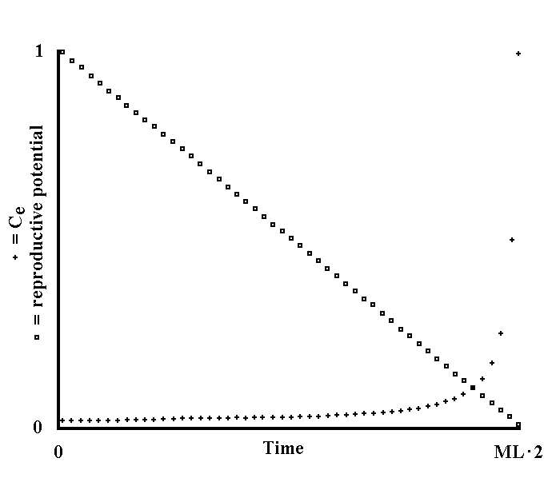
Fig. II 6-1 - Equilibrium frequencies of a gene that is harmful depending on the age of the individual when the gene expresses itself (Theoretical model).

C is a harmful gene with a C’ unique allele, which does not entail damage and which changes into C at the rate of V each generation. On the contrary, the mutation frequency of C into C’ is negligible.
C manifests its harmful action when the individual reaches age t. As the individual, which progresses in its vital cycle, expresses more and more of its reproductive potential and of its ability to defend its offspring, the damage S caused by C is in inverse relation to age t, in which the gene manifests its harmful action.
Therefore, we have:

S = S_{max} - f(t) (II-39)

where S_{max} is the damage caused by C if expressed from birth and f(t) is a function that must be empirically determined (but, in the present figure, it is defined arbitrarily for practical reasons).
By applying the procedures already used for other models, it is possible to obtain:

C_{n+1} = C_{n} (1 - S) + V C’_{n} = C_{n} (1 - S - V) + V (II-40)
1 - C_{n} S 1 - C_{n} S

At equilibrium, we have:

C_{e} = C_{e} (1 - S - V) + V (II-41)
1 - C_{e} S

Dividing by C_{e}, we obtain:

1 - C_{e} S = 1 - S - V + V/C_{e}

C_{e}² S - C_{e} (S + V) + V = 0
_____________
C_{e} = S + V ± √(S + V)² - 4 S V
2 S
______
= S + V ± √(S - V)² = S + V ± (S - V) (II-42)
2 S 2 S

Therefore, the two solutions are:

C_{e} = S + V + S - V = 2 S = 1
2 S 2 S

C_{e} = S + V – S + V = 2 V = V (II-43)
2 S 2 S S

The figure has been obtained by using the second solution, but assuming C_{e} = 1 when V/S > 1.
Function f(t) has been arbitrarily defined in this way:

f(t) = ML 2 – E (II-44)
ML 2

where ML is the mean duration of life and E indicates the age at which the gene manifests its harmful action. Thus, the formula of resolution becomes:

C_{e} = V (II-45)
S_{max} ML 2 - E
ML 2

In the figure, the equilibrium frequencies of C are shown, with crosses, on the ordinates. On the ordinates, the fractions of reproductive potential, not yet expressed are also illustrated, with squares. The abscissas indicate the ages (E) at which the gene expresses the damage and the age to which the fraction, not yet expressed, of reproductive potential is referred. The abscissas indicate values that go from 0 to ML 2.
The values assumed are:

S_{max} = .01 ; V = .0001.

The figure shows that, if C manifests itself when the greater part of reproductive potential is passed, the equilibrium frequency is high.

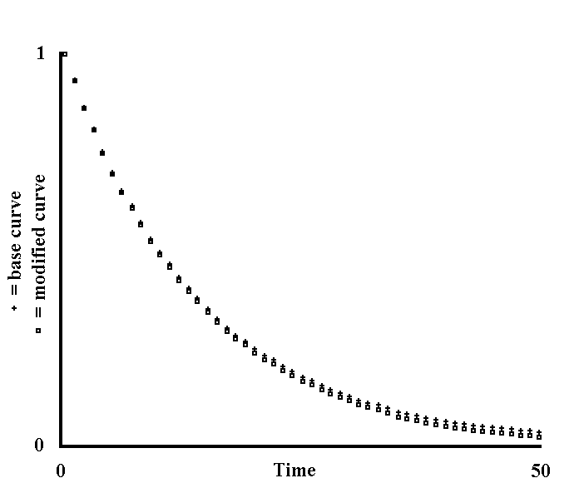
Fig. II 6-2 - Effects on a life table of a large number of genes that are harmful at various ages (Theoretical model).

There is a population made up of individuals with mortality K which is constant at any age of life and therefore not subject to senescence, according to Comfort's definition. Let us also assume that reproductive abilities do not decrease with age and, for simplicity, that the individuals are haploid. Now, I am going to consider the modifications of the life table caused by the action of numerous harmful genes that each manifest themselves exclusively at a certain age. One of these genes is C: it manifests itself at age t, causing damage S, and has no other manifestation. The only allele, C’, is inactive and changes into C with a rate of V at each generation, while C changes into C’ with negligible frequency.
Using F_{t} to refer to the fraction of the population surviving at time t, we have:

C_{n+1} = C_{n} (1 - S F_{t}) + V C’_{n} = C_{n} (1 - S F_{t} - V) + V (II-46)
1 - C_{n} S F_{t} 1 - C_{n} S F_{t}

At equilibrium, using the mathematical procedure of the preceding figure, we have:

C_{e} = V (II-47)
S Ft

Thus, a fraction equal to C_{e} of the individuals surviving at time t, will suffer damage S, meaning that:

F_{t} (corrected) = F_{t} - F_{t} - C_{e} S = F_{t} (1 - C_{e} S) (II-48)

Considering n genes with the same characteristics as C, it is necessary to multiply damage S by n, and so:

F_{t} (corrected) = F_{t} (1 - C_{e} S n) (II-49)

This correction having been made, the curve from time t+1 onwards must be properly accommodated by taking into account the individuals missing at time t.
Then, considering n genes with the same characteristics as C, but with action at time t+1, the same series of calculations must be carried out. Again, the same operations must be repeated for analogous genes which express themselves at times t +2, t +3, until the end of the life table.
In the figure, the base curve is expressed using crosses. With the procedure described above, and assuming t=0, a modified curve has been obtained, expressed using squares in the figure. The abscissas cover 50 units of time and each interval indicates 1 unit. The assumed values are:

K = .07 ; n = 100 ; S = .5 ; V = .00001.

For simplicity of calculation, constant values have been assumed for n, S and V.
The modified curve shows that a large number of harmful genes (50 · 100 = 5000) also moves down the base curve, but does not cause any modification indicating senescence according to Comfort's definition.

7) Theories of hindered senescence and of programmed senescence
The theory of hindered senescence, which must be considered as a reworking in evolutionary terms of the theories by wear, considers the living being as subjected to wear processes that it is useful to counter only in part, unless the advantage of a greater velocity of evolution is lost. According to the viewpoint of this theory, senescence is an unavoidable and universal process that the organism hinders with various and unknown mechanisms, and with varying intensity according to the species.
The theory of programmed senescence, on the other hand, considers the senile process as something which is predetermined, that is, a phenomenon that needs specific genes in order to exist. According to this theory, senescence instead of being hindered, is thought to be provoked. Indeed, if the common reasoning says that the decay of any living being or thing is natural, this theory, on the contrary, rejects the truth of such a concept. The living being is an entity that auto-renews itself and is not an inanimate object: the phenomenon, having a strangeness that needs an explanation, is the fact that such an entity ages, that is it ceases to renew itself, and not the contrary.
I think that there are weighty arguments in support of the theory of programmed senescence:
1) Hayflick's experiments (Hayflick, L., 1961, 1965, 1966), according to which cells (embryonic fibroblasts) of man and other species are able to divide themselves a limited number of times (50 for man), are perhaps more easily interpretable if senescence is considered a pre-arranged phenomenon and, among other things, dependent on precise genetically determined limits of cell duplication capacity. Hayflick's experiments become even more interesting if one remembers that the maximum number of cell divisions varies from species to species and has a certain correlation with the longevity of the species.
2) For species with high environmental mortality, it would, perhaps, be admissible to expect that, from a certain age, reached by a very limited number of individuals, natural selection is insufficient to favour those mutations that would hinder senescence. Thus, a non-excessive longevity for the aforesaid species should, perhaps, be expected, meaning that the “Methuselah effect” would have limited possibilities for performing its action if the theory of hindered senescence is true. This is in contrast with what we see from natural observation, as has already been stated in the previous paragraph.
3) Each species, in its embryonic and growth phases, develops in a very precise and constant manner and this certainly depends on genetic factors. Analogous precision and constancy is recognizable in senescence. This is by no means proof, but it would seem to provide evidence in favour of the hypothesis of genetic regulation of the "senescence" phenomenon.

8) Researcher and senescence
Ageing and death, in which it inevitably ends, are, perhaps, one of the aspects of reality that have influenced human thought and civilisation most.
- To a great extent human history and psychology must always have been determined and moulded by the awareness that the life-span of any individual is determinate, and that the expectation of life tends to decrease with increasing age. The Oriental could say “O King, live for ever!” in the knowledge that every personal tyranny has its term. - (Comfort, A., 1979)
The great importance of this subject urges us to evaluate that which has been written in the preceding paragraphs with the utmost attention.
There are two opposite ways of understanding the reality of the senile process.
The first is that senescence is something unavoidable due to the transitoriness of everything. As a tool or a car gradually wears out over time and is finally completely unusable, the living being, likewise, simply by living, in ways unknown, wears, ages and finally dies.
The second way of conceiving senescence, on the other hand, rejects the parallel between the unavoidability of an inanimate object wearing out and the senescence of a living being, as arbitrary and unproven. Senescence is, rather, thought of as something determined and caused by genes and has a usefulness, or teleonomic meaning, for the living being.
The conflict between these two different theses is evident and I think that the dilemma is not without possible consequences in the search for substances that hinder senescence. The Researcher, if the first hypothesis is true, is struggling against something inevitable, and his efforts are practically without hope. On the other hand, if the second thesis is true, the fight is against a very strange and little known “function”, but the difficulties - which are enormous – do not leave us without the hope that we will, some day, be able to master it. To trust the latter thesis is, perhaps, only a psychological, and contestable, advantage which, in itself, adds nothing to the possible results of the research into senescence and the means to dominate it. The great importance of the psychological attitude is, on the other hand, not to be undervalued in determining the outcome of an action. In fact, among other things, to conceive of ageing as a genetically determined process certainly overcomes a deep-rooted conception according to which:
- The ageing of the organism is a condition that is so well-known and innate to our way of considering reality and our personal destiny that it is, perhaps, difficult, at first, to put it forward as object of investigation, or even of experimentation. (Prodi, G., in Favilli, 1968)
Perhaps the Researcher who decides to break with tradition will be advantaged because, once free from certain prejudices, he will be more confident in possibilities of future success. But, I think that he will also certainly run into strong opposition, be it ethical, religious, or of another type, from those who are opposed to this new conception of senescence. It is, perhaps, useful at this point, to mention two statements made by a famous scientist, warning the Researcher who chooses such a path:
- Any confusion between ideas suggested by science and science itself is to be avoided.
- Modesty befits a scientist, but not the ideas that are inside of him and that he has a duty to defend (Monod, J., 1970).

9) Reformulation of the four observations
In the Chapter I, par. 2, I maintained that, for the persistence of a species, it is necessary, first of all, for all the individuals to be able to survive and propagate. In the light of that which has been brought to us by sociobiology and discussed in this paragraph, I will add that the individuals may also have characters that, although disadvantageous for themselves, are, on the contrary, advantageous to a greater extent for genetically close individuals. And likewise, as the object of the selection is more precisely the gene and not the individual, although the two entities often coincide as regards selection, it is necessary to reformulate the four observations thus:
1) Those genes with greater overall aptitude to persistence (inclusive fitness) have the greater probabilities of persistence.
2) A gene that, because of changes in the ecological niche, loses its overall aptitude to persistence, tends to a zero frequency.
3) The genome changes from generation to generation, according to probable and not to highly improbable modifications.
4) The frequency of each gene, and the genome in its totality, tends to be, in any evolutionary stage, the result of the actions of all selective pressures in the ecological niche.

INTERLUDE: Built-in obsolescence
Built-in obsolescence is that characteristic of an industrial product, specifically planned and pursued, for which the product deteriorates and becomes more and more difficult to repair after a definite time, although reliable and fully usable before that time.
Built-in obsolescence causes a waste of materials and a considerable economic overload for the consumer, but has at least three important advantages.
The first is to prevent the annual share of renewal of a product in a stable market from being minimal. For example, a nation in which there are 10 million motor-vehicles, with a mean duration of ten years, requires an annual production of 1 million of motor-vehicles for replacement. If the mean duration of a car increased to 20 years, annual production would fall to 0.5 million, with catastrophic consequences for profits and employment. The second advantage is the introduction of new technologies with a speed which is inversely proportional to the mean duration of the product. A product with unlimited duration would delay, or even render economically disadvantageous, the use of new and more effective technologies. The third advantage is that a productive system, organised for quick and continuous renewal, is easily adaptable to: a) unexpected market growth; b) the opening of new markets; c) conversion to the production of other items; d) transformation into a military industry, etc. On the other hand, the production of goods with very long duration, as there is a minimal annual production, is not very adaptable to the aforementioned events.
In this regard, I believe the following to be true:
Built-in obsolescence is a hidden pillar of the modern “consumer culture”. Neither manufacturers nor trade unions, nor politicians are interested in publicizing this pillar.
The consumer believes that it is not possible to make products with greater duration, or that the necessary modifications would render the product too expensive. These opinions are wrong and considerable efforts in the design of an industrial consumer product are, in fact, dedicated to making the product both precise and reliable up to a certain time, and then unreliable and increasingly expensive to repair thereafter.

* * *

Built-in obsolescence of an industrial product and the programmed senescence of a living being are two very different phenomena, yet the analogies are considerable and not superficial. With appropriate modifications of the terms, the main common aim is to allow the industrial product or the living being the greatest evolution, the greatest adaptability to new conditions, the greatest competitiveness in the struggle.
It is tragic to observe that man and his machines essentially share their ultimate fate.
It is ironic to consider that modern technology, even in this, has been preceded and exceeded by Mother Nature.
It is incredible that, in a civilisation in which built-in obsolescence is fundamental, it is not known that the living world obeys a parallel logic.

Chapter III — Parasitism

1) Limitation of the effectiveness of the defences of the parasited organism
“Parasites” are defined those living beings that use, for their persistence, the energy resources of other living beings, which we will call “parasited organisms". The parasited organism hinders the use by the parasite of its own energy resources through characters that will be defined “defences”. Parasite “means of attack” oppose the defences of parasited organism.
In the evolutionary process, parasited organism and parasite are forced, by contrasting selective pressures, to develop defences and means of attack, respectively. The parasited organism must preserve its own energy resources - which may coincide with its own soma in toto - and the parasite must exploit them for its persistence.
Now, let us assume, as a hypothesis, that the parasited organism can evolutionarily develop defences that are so effective as to stop the persistence of the parasite entirely. I maintain that such a possibility cannot occur and that the parasited organism is limited in the effectiveness of its defences against the parasite. This limitation (see model of Fig. III 1-1) derives from the fact that the usefulness of a defence depends on the reduction that it causes in the damage caused by the parasite. As the damage caused by the parasite decreases - precisely as a consequence of the existence of the defence - the advantage deriving from the defence decreases at the same time. The more the damage caused by the parasite decreases, the more the surplus of defence effectiveness becomes “superfluous” and - see the second consideration - the surplus disappears. I reiterate that this is deduced from the fact that the mutations which alter a character are more numerous than the few that improve it or nullify the alterations, thereby restoring character integrity. Thus, there is an evolutionary theoretical limit of the effectiveness of the defences of parasited organism, depending on the damage caused by the parasite and conceptually independent from the type of both defences and parasitism and it is, perhaps, admissible to maintain that:
the point of equilibrium for the effectiveness of the defences is where the selective pressure of the damage caused by the parasite - which favours the increase of the effectiveness of the related defences - and the frequency of the mutations that alter the genes determining the defences, have equal value (see again model of Fig. III 1-1).
I wish to stress two aspects of the problem:
1) The defences of the parasited organism are favoured by selection because they limit the damage caused by the parasitism and not the persistence of the parasite. Damage and persistence are certainly related, but nothing requires us to conceive them as always being proportional to each other.
2) The less a parasite damages the parasited organism, the less there is selective pressure in favour of more effective defences. The working out of this concept will lead to what I will say in par. 6 about the symbiotic parasite.

* * *

Note that the given definitions of parasite and parasited organism are such as to include the pairs predator-prey, herbivore-grass and analogues as well. The expounded reasoning therefore applies in these cases too, which are, however, outside the main thread of this work (see also Fig. III 1-2).

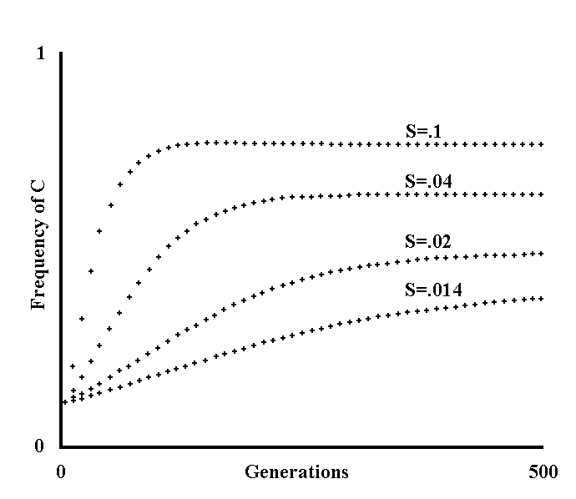
Fig. III 1-1 - Limitation of the effectiveness of the defences of the parasited organism (Theoretical model).

Let us consider a species A parasited by species B. In A, there is gene C that, against the only allele C’, shows the advantage S of contrasting to a large extent the damage caused by B. The extent of the damage caused by B and the extent of the persistence of B are also assumed to be entirely proportional to and inseparable from each other. The advantage of C over C’ depends, by definition, on the extent of the damage resulting from the parasitism of B. And yet, by definition, the extent of the damage is limited by the diffusion of C within species A, as this entails a decrease of the extent of the persistence of B. Therefore, S will vary from generation to generation, being proportional to the probability of parasited organism-parasite interaction at the nth generation (P_{n}), and will depend on the spreading of C, to an inversely proportional extent:

S_{n} = S_{max} P_{n} = S_{max} f(C_{n}) (III-1)

where f(...) indicates a function and S_{max} the damage that occurs when P = 1.
Writing S instead of S_{max}, we will say, therefore, that, by definition:

S_{n} = S f(C_{n}) (III-2)

C is also assumed to change into allele C’ with mutation rate U and that the inverse is assumed to happen with negligible frequency. Using the procedures and the formulas of the preceding models, we have:

C_{n+1} = C_{n} (1 + S f(C_{n}) - U) (III-3)
1 + C_{n} S f(C_{n})

At equilibrium, as C_{n+1} = C_{n} = C_{e}, dividing both members by C_{e} (an operation that is valid as long as C_{e}  0), we obtain:

1 = 1 + S f(C_{e}) – U (III-4)
1 + C_{e} S f(C_{e})

from which:

C_{e} = S f(C_{e}) – U = 1 - U (III-5)
S f(C_{e}) S f(C_{e})

Note that if U / (S f(C_{e})) > 1, as C_{e} >= 0, the contradiction is overcome assuming C_{e} = 0, which is admissible because, in the division by C_{e}, the case of C_{e} = 0 has been excluded. A comparison with the formula of Fig. I 2-5 is useful:

C_{e} = 1 – U (III-6)
S

As f(C_{e}) < 1, the value of C_{e} will be lower with the formula of this figure.
To draw this figure, it has been arbitrarily assumed that:

f(C_{y}) = 1 - C_{y} (III-7)

therefore, at equilibrium:

C_{e} = 1 - U ,
S (1 - C_{e})

S (1 - C_{e}) C_{e} = S (1 - C_{e}) - U

S C_{e}² – 2 S C_{e} + (S - U) = 0
______________
C_{e} = 2 S ± √4 S² - 4 S (S - U)
2 S
__________
= 1 - √S² - S (S - U)
S
___ ___
= 1 - √S U = 1 - √U/S (III-8)
S

One of the two solutions has been excluded because C <= 1. In the figure, the generations of A are on the abscissas (10 between one cross and the next). Going from top to bottom, the assumed values for S in the various curves are:

.1 ; .04 ; .02 ; .014.

Moreover, for all curves:

C_{o} = .1 ; U = .005.

The figure shows that C is limited in its spreading by the frequency of decay U and, moreover, by the progressive reduction in the damage caused by the parasite. If we suppose C to be a gene which defines a particular defence of A, it follows that A is limited in the overall effectiveness of its defences against B. It is opportune to observe that the advantage of C is dependent on the damage consequent to the persistence of the parasite and is not in direct relation with the persistence of the parasite. Persistence and damage consequent to the persistence are interdependent, but are not rigidly connected, as we have assumed for the sake of simplicity. If a parasite minimally damages the parasited organism, S will be minimal and C_{e} will be low.

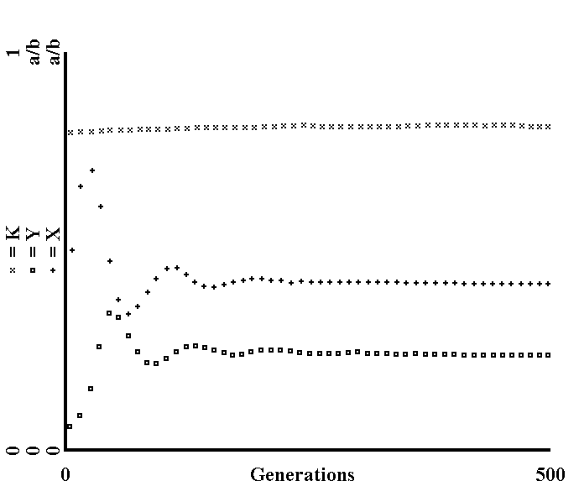
Fig. III 1-2 - Limitation of the effectiveness of the defences of the parasited organism: integration in Volterra's system of equations (Theoretical model).

Volterra's system of equations (1926; as reported by Maynard Smith,1975, p. 34), is as follows:

dX = a X - b X² - c X Y
dt

dY = - e Y + c’ X Y (III-9)
dt

X and Y express the density (= number of individuals in a given area) of a prey species and of its predator, respectively. The term - c X Y expresses the reduction in prey density caused by predation. The whole of the two terms a X - b X² indicates the increase in prey in the absence of predation up to a maximal density of equilibrium, defined as “carrying capacity” (and equal to a/b, as it is obtained using a simple calculation). The term + c’ X Y indicates the increase in the number of predators as a consequence of predation and the term -e Y the reduction in the number of predators in its absence.
Substituting the terms prey and predator for those of parasited organism and parasite used in this work, to mean the same thing but less likely to be misunderstood, and rewriting the equation system according to the method and the conventions followed thus far (see Appendix 4 for the differences and for a discussion on the subject), we have:

X_{n+1} = X_{n} (1 + a - b X_{n} - c Y_{n})

Y_{n+1} = Y_{n} (1 - E + c’ X_{n}) (III-10)

Let us now hypothesize that, within the parasited species, there is a gene K on which a greater defence against parasite attack depends, and that the parasite has no way of combating such an increase in effectiveness of the defences. It follows that c and c’ will be dependent on the spreading of K within the parasited species, to an inversely proportional extent. Therefore:

c = f(K) ; c’ = f’(K) (III-11)

With these hypotheses, we will also have the spreading of K favoured by an advantage S that is dependent on c - to a directly proportional extent - and that can have a maximal value (S_{max}) when c is maximal (c_{max}):

S = f"(c) (III-12)

Assuming also that K changes into K’, which is inactive, with a rate of U we will have:

K_{n+1} = K_{n} (1 + f"(c) - U) (III-13)
1 + K_{n} f"(c)

With the assumptions described thus far and also assuming for the sake of simplicity that parasited organism and parasite generations are of equal length, we obtain Fig. III 1-2.
The generations are on the abscissas (from 0 to 500). On the ordinates, the crosses express X (with values from 0 to a/b), the squares Y (with values from 0 to a/b too) and, finally, the x symbols express K (with values from 0 to 1). The assumed values are:

X_{o} = 10000 ; a = .1 ; b = .000005 ; c_{max} = .00002 ;
Y_{o} = 1000 ; and = .1 ; c’_{max} = .00002 ;
K_{o} = .8 ; S_{max} = .01 ; U = .001 .

The functions have been defined as follows:

c = c_{max} (1- K / 2)

c’ = c’_{max} (1 - K / 2)

S = S_{max} c (III-14)
c_{max}

Thus, the equations III-10 and III-13 become:

X_{n+1} = X_{n} (1 + a + b X_{n} - c_{max} (1 - K_{n} / 2) Y_{n})

Y_{n+1} = Y_{n} (1 – E + c’_{max} (1 - K_{n} / 2) X_{n})

K_{n+1} = K_{n} (1 + S_{max} c / c_{max} - U) (III-15)
1 + K_{n} S_{max} c / c_{max}

The diagram shows that K is limited in its spreading by the reduction of the damage due to parasitism.
As an additional note, it should be observed that, if we assume that K_{o} = 0, we obtain the equation system of Volterra.

2) Hypothesis of the greater evolutionary potential of the host
One could maintain that the optimal condition, both for the parasite and for the parasited organism, is that in which the parasite-parasited organism interaction at the same time entails the greatest persistence for the former and minimal damage for the latter. The fallaciousness of such a statement is in the reasoning in terms of advantage for the species – a theoretical entity - rather than for the individual, and in the assumption of an aim for selection that, to the contrary acts, by definition, only as a consequence of the immediate advantage existing at each generation. It is to be demonstrated in its entirety, therefore, whether it is true that selection can or must lead, albeit as effect of contingent advantages, to the “optimal” condition expressed above. I would like now to draw attention to a category of circumstances in which such a condition hardly seems to be achievable in the absence of a hypothesis which I consider to be plausible.

* * *

Our subject will be limited to the case in which there is a considerable difference between the parasited organism, which now will be called “host”, and the parasite, both as regards degree of organization and ML.
We will consider, then, only that case in which the host lives for a much longer time and, moreover, is larger and more structured compared to the parasite. From the assumed limitation it follows that:
the parasite has greater velocity of evolution compared to the host.
In fact, as expounded in the preceding chapter, a mutation will spread, assuming the same selective advantage, more rapidly within the parasite species than within the host species, as a consequence of the shorter ML of the parasite, and this entails a greater velocity of evolution.
Now, let us consider the case that, in the parasite species, a “more aggressive” mutant occurs, that is, an individual that propagates with greater success, but while causing more damage to the host. Such a mutant will be advantaged by the selection at the individual level and, likewise, in the host species a mutation that entails an increase in effectiveness of a defence to such an extent that most of the damage of such a parasite is neutralized, will spread with a lower velocity than the spreading velocity of parasite mutation.
Assuming the host species to be divided into many demes, a great reduction in or the extinction of the demes where the more aggressive mutant parasites have appeared - or have spread -, would succeed in stopping further diffusion of these mutants. Group selection, therefore, would be a curb on parasites that are too harmful for the host (see Fig. III 2-1), but this would require: a) that the host species be divided into demes with a high extinction rate of the same; b) that the passage of the parasite from one deme to another be of low frequency; c) that the host perpetually be in serious danger of extinction, caused by the more aggressive mutants. I now propose, as an alternative hypothesis, on the basis of the greater structuring of the host, that the host can develop defences in number greater than the number of parasite means of attack, and that such defences can, moreover, be of greater complexity (Hypothesis of the greater evolutionary potential of the host). It would follow that the host, although incapable of a defence so effective as to stop the parasite propagation entirely, as a consequence of what has been said concerning limitation of the effectiveness of the parasited organism defences, has, on the basis of the hypothesis expressed, the ability to develop a plurality of defensive mechanisms, so that, faced with a more aggressive mutant, the breaking down of a defence is compensated by the existence of the other defences. The plurality of the defences would not be “superfluous” given the endless appearance of more aggressive mutants, and this would balance the greater velocity of evolution of the parasite (see Fig. III 2-2).
On the basis of the hypothesis expressed, and if the arguments expounded are correct, an equilibrium is established between the parasite and the host. The host cannot prevail (Limitation of the effectiveness of the parasited organism defences), nor can the parasite prevail (Group selection and Hypothesis of the greater evolutionary potential of the host). The point of equilibrium is the same as that indicated in the previous paragraph with the implicit corrections that the damage caused by the more aggressive mutants is included in the damage caused by the parasite and that the defences of the host are subject to a greater load of mutations, being present in a greater number to combat the more aggressive mutants as well.
By way of definition, I will say that host and parasite are “better adapted” the closer they are to the conditions of equilibrium defined here.
Clearly, all that which has been said is not to be understood in static terms because host and parasite are dynamic entities and the point of equilibrium is a theoretical and ideal concept.

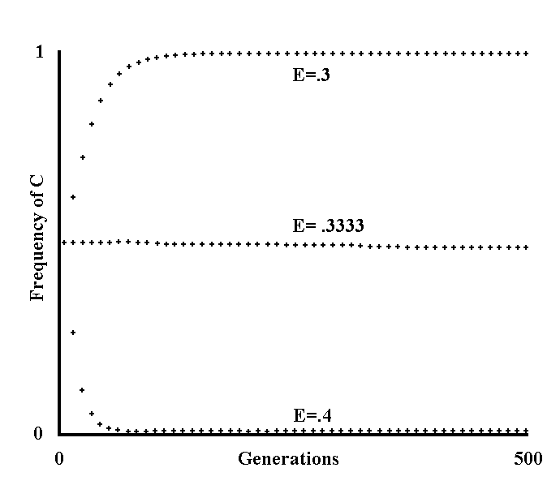
Fig. III 2-1 - Limitation of parasite aggressiveness determined by group selection (Theoretical model).

There is a host species h and a parasite species p.
Within the parasite species there is the gene C that, in comparison with the only allele C’, allows a more effective propagation of the parasite that brings about an advantage S. Let us assume that this more effective propagation damages the host species to such an extent that at, each parasite generation, there is an extinction - or, rather, a surplus of extinction - of a fraction E of the demes in which the host species is divided. Let us assume, as a further condition, that the extinction of a deme of h, causes the death of a proportional fraction of the species p. With the conditions expressed, we have:

C_{n+1} = C_{n} (1 + S) (1 - E) = C_{n} (1 + S) (1 - E) (III-16)
C_{n} (1 + S) (1 - E) + C’_{n} C_{n} (1 + S) (1 - E) + 1 - C_{n}

Finally, assuming that C changes into C’ with rate U at each generation and that the inverse happens with rate V, we obtain:

C_{n +1} = (C_{n} (1 + S - U) + C’_{n} V) (1 - E) ,
(C_{n} (1 + S - U) + C’_{n} V) (1 - E) + C’_{n} (1 - V) + C_{n} U

= (C_{n} (1 + S - U - V) + V) (1 - E) (III-17)
(C_{n} (1+ S – U - V) + V) (1 - E) + (1 - C_{n}) (1 -V) + C_{n} U

The figure was obtained using this last formula. The abscissas, as usual, cover 500 generations (of the parasite).
Going from top to bottom, the values of E are:

.3 ; .3333 ; .4.

The other parameters were assumed to be equal for all curves:

C_{o} = .5 ; S = .5 ; U = .0001 ; V = .00001.

The figure shows that only values of E that are almost equivalent to the advantage S, are able to stop the spreading of those mutants among the parasites that propagate with greater effectiveness, but which greatly damage the host. In the absence of an effective means of defence against these mutants, this would lead to a progressive extinction of both the host and the parasite. It is necessary to stress that the harmful mutant, clearly not knowing any prediction of the future or finalistic evaluation, is influenced in its spreading only by its contingent advantage.

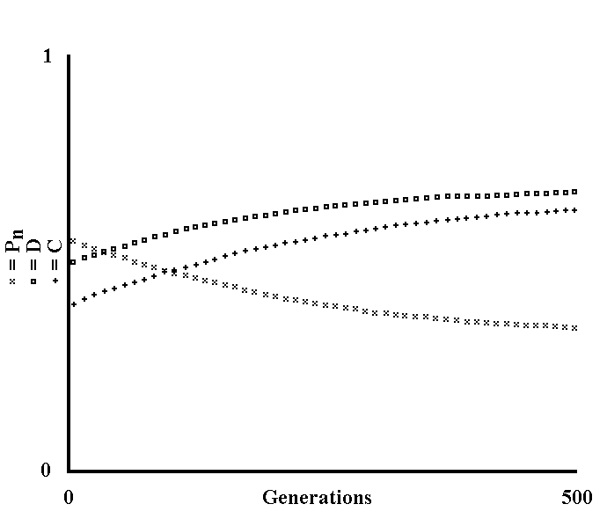
Fig. III 2-2 - Utility of several defences of the host against the parasite (Theoretical model).

C and D are two genes - widespread within a host species - which define two distinct defences against a certain parasite. The defences deriving from C and D entail an advantage equal to the product of the frequency with which the host is infected by a maximal value (S_{c} and S_{d}, respectively).
The frequency of infection at each generation (P_{n}) is dependent on the spreading of C and D within the host species, to an inversely proportional extent:

P_{n} = f(C_{n}, D_{n}) (III-18)

The individuals with the gene C also have the advantage S’_{c} of contrasting the mutants of the parasite that are more aggressive because they are resistant to the defence defined by the gene D. These particular mutants have a frequency M_{d}: as the parasite has a greater velocity of evolution compared to the host, it has not had the time necessary in evolutionary terms, for the spreading of a gene D_{bis}, which is able to combat the aforesaid mutants.
At the same time, an advantage S’_{d} is defined for gene D against the mutants which are resistant to C, with frequency M_{c}.
Let us assume that C and D change into the inactive alleles C’ and D’, respectively, with rates U_{c} and U_{d}.
With the assumptions formulated, we have:

C_{n+1} = C_{n} (1 + S_{c} P_{n} + S’_{c} M_{d} P_{n} - U_{c})
1 + C_{n} (S_{c} P_{n} + S’_{c} M_{d} P_{n})

D_{n+1} = D_{n} (1 + S_{d} P_{n} + S’_{d} M_{c} P_{n} - U_{d}) (III-19)
1 + D_{n} (S_{d} P_{n} + S’_{d} M_{c} P_{n})

The figure was obtained assuming the following values:

C_{o} = .4 ; S_{c} = .01 ; S’_{c} = .01 ; M_{c} = .001 ; U_{c} = .001 ;
D_{o} = .5 ; S_{d} = .01 ; S’_{d} = .01 ; M_{d} = .001 ; U_{d} = .001 ;

and defining the probability of infection thus:

P_{n} = 1 - C_{n}/2 - D_{n}/2 (III-20)

The model sets out to show, broadly speaking and not as a demonstration, that a whole series of greater defences of the host is evolutionarily “steadier” than a single defence, because each defence, in addition to being advantageous in itself, compensates for those cases in which the more aggressive mutants of the parasite overcome the other defences.
Moreover, the coexistence of more defences is admissible if the frequency of parasite infection, that is its propagation capabilities, are not excessively limited.
The model, in its great simplification, does not show how the plurality of host defences is obtained.
In the figure, the frequencies of C, D and P_{n} are symbolized with crosses, squares and x, respectively.

3) Ways in which the antibody defence acts
For practical reasons, I will limit the subject to the mammals. These animals, although they have the ability to produce an enormous number of types of antibodies against parasites, will, over a given time, only produce a number of antibodies that is limited and which depends on previous infections. This is in keeping with the necessity - due to antibody formation mechanisms - of having contact with the parasite before the synthesis of the relative antibodies, and with the need to economize its resources. On the other hand, one might question the usefulness - in a teleonomic sense - of using a preliminary identification and of saving resources as, because the defence is structured this way, the parasites often kill the host - if it is the first infection - or at least cause serious damages before the antibody defence has efficaciously swung into action. From this viewpoint, we can claim that, in terms of survival, it would be better for the non-existent host to produce, from birth, and therefore without previous contact, substances with activity similar to that of the antibodies that are specifically active against the more harmful micro-organisms. This would be disadvantageous in terms of saving resources, but would entail the greater advantage of minimizing the more destructive infections. Or we might also hypothesize - again with the reservation made about the postulate of potentiality (see Chapter I, par. 4) -, and considering the not insignificant amount of time in which, in certain first time infections the antibodies are synthesized in effective quantities, - greater velocity, which would combat the attack of the parasites more effectively. Such conditions would be advantageous for the host but, due to the argument expounded concerning the limitation of the effectiveness of the defences, for hosts thus structured, although it is conjecturable from a physiological point of view, it is, from an evolutionary point of view, impossible to break out. In fact, for the parasites to which the expressed hypotheses refer, propagation would be excessively hindered and their progressive extinction would gradually render the effectiveness surplus of the antibody defence superfluous, to the extent that it would be lost (see Fig. III 3-1). There would, therefore, be a return to a point of equilibrium when the host’s defences fail to achieve the maximal evolutionary potential of their effectiveness.
It should be noted that a second or further infection by a parasite may be combatted, with total effectiveness even, meaning that parasite reproduction is completely stopped, without this necessarily contradicting the argument concerning limitation of defence effectiveness, because the parasite has been allowed to propagate with the first infection to a sufficient extent.

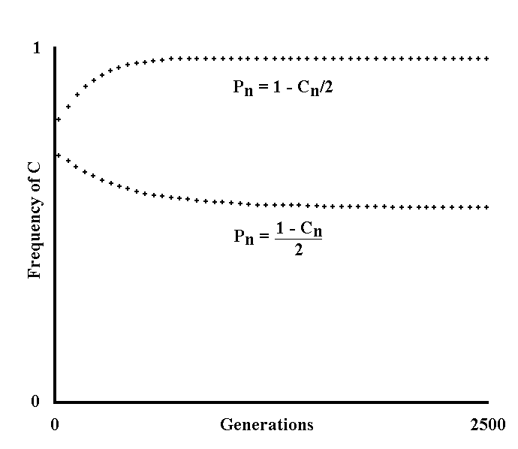
Fig. III 3-1 - Rapidity of coming into action of a defensive substance (Theoretical model).

There is a host species h and a parasite species p.
Within the host species, there is a gene C’ that determines the action of a defensive substance (antibody or interferon or other) at time t’ after the first contact with the parasite. The allele C causes the coming into action of the substance at time t < t’. This action of C reduces the propagation and the damage carried out by the parasite and this entails the advantage S. This advantage is achieved only when there is infection by the parasite and is, therefore, dependent on the probability of infection at each generation (P_{n}). In turn, P_{n} is dependent on the extent of parasite propagation and also, therefore, is in inverse relation to the frequency of C. Moreover, C is assumed to change into C’ with frequency U and the contrary is assumed to happen with negligible frequency. With the conditions expressed, we have:

C_{n+1} = C_{n} (1 + S P_{n} - U) (III-21)
1 + C_{n} S P_{n}

with:

P_{n} = f(C_{n}) (III-22)

The lower curve was obtained assuming:

S = .01 ; U = .001 ; P_{n} = (1 - C_{n}) / 2 ; C_{o}=.7 ;

and shows a strong limit of the rapidity with which the defensive substance goes into action, having assumed that parasite propagation is strongly influenced by the substance in question. The upper curve, in which the following values were assumed:

S = .01 ; U = .0001 ; P_{n} = 1 - C_{n} / 2 ; C_{o}=.8 ;

likewise shows that the limit is modest as a consequence of the assumption of a moderate antiparasitic activity of the substance. The equilibrium value of C in this second case, using the formula obtained in Fig. III 1-1, is:

C_{e} = 1 – U = 1 - .0001 .
S P_{n} .01 (1 - C_{e} / 2)

= 1 - .01 = 1 - .02 ,
(2 - C_{e}) / 2 2 - C_{e}

2 C_{e} - C_{e}² = 2 - C_{e} - .02

C_{e}² - 3 C_{e} + 1.98 = 0
________
C_{e} = 3 ± √9 - 4 1.98 = 3 ± 1.039 = .98 (III-23)
2 2

discarding the solution with a value greater than 1.
The solution for the first curve, calculated using the same method, is:

C_{e} = .5528.

The number of generations in the diagram is from 0 to 2500. The space between one cross and the next indicates 50 generations.

4) The interferon
The term 'interferon' indicates a class of substances studied in mammals that, in the light of research carried out so far, perform the following actions:
1) They combat the spread of viral infections;
2) Their production, stimulated by rickettsias, chlamydias, mycoplasmas, Gram- bacteria and, above all, viruses, protects the host from viral superinfections, non-specifically, for a certain period.
I now wish to examine what is stated in 2).
The organism has the ability of making substances that are able to inhibit broad-spectrum viral infections, but uses this power only for cases in which one of the stimuli hinted at is present. From a strictly physiological point of view - again with the reservations expressed regarding the postulate of potentiality - it is possible to hypothesize the existence of a species that uses such substances in advance, thereby benefitting from the significant advantage of parasitism damage limitation. But, from an evolutionary point of view, the argument is the same as that expounded on antibody defence: such a condition, which is physiologically conjecturable, means, in actual fact, a prevalence of the host over the viral parasite, which is impossible for the reasons given concerning the effectiveness limitation of the parasited organism defences. The concept stressed here is that the host does not use all its evolutionary potentialities, which are probably greater than those possible for an organism of simpler structure, such as the parasite. The host cannot have defences that are strong enough to eliminate its parasites forever, because the gradual weakening of the selective pressure caused by parasites would make this impossible (see Fig. III 3-1).

* * *

Note now that the substances of the interferon class, as well as acting, perhaps also combat another condition of disequilibrium, but in this case against the host.
Let us imagine a host species and two parasite species, A and B, which are sufficiently adapted against the host: that is, neither the infection of A, nor the infection of B cause excessive damage to the host. It is possible that the contemporaneous infection of A and B reaches a seriousness not possible for the separate infections. The interferon is, perhaps, the substance that avoids such a possibility in many cases. If the host is infected by A, B is excluded: this limits but does not jeopardize the propagation capabilities of B because this latter can propagate successfully when A is not present. Moreover, the host is preserved from the serious damage deriving the contemporaneous infection of A and B. In the specific case of the interferon, this group of substances would prevent, or at least would limit, the overlapping of viral infections with infections by other viruses and by rickettsias, chlamydias, mycoplasmas, Gram- bacteria, all of which are agents that are known, experimentally, to stimulate interferon production.
This is an example of how the host can raise more defences against infections, which may even be very structured and complex, as long as parasite propagation is not hampered beyond measure.

5) Possible errors of interpretation of the epidemiological data
By focusing on human pathology, as this is the best known, I want to investigate whether there is a “good adaptation” between man and his parasites, that is, in particular, whether human parasites are such as would provoke relatively minor damage in their parasitism. To this end, in the evaluation of the available data, one must be careful of possible false interpretations of the clinical and epidemiological data. In particular:
a) A parasite that causes a serious or deadly infection is noticed and studied more than a parasite that provokes slight or unapparent infections, infections that are, however, clearly more frequent.
b) A parasite can kill or cause serious impairments in a high percentage of the cases in which it provokes a clinically diagnosed disease, but it may be disregarded that the disease is clinically diagnosed in only a relatively small percentage of the infections. This would cause a false impression of great harmfulness of the parasite. I am reminded of the case of infective hepatitis which, in young subjects, is, for the most part a minor infection (lethality = .1 - .3%). In children, the ratio between anicteric and icteric cases can reach a ratio of 12 : 1. Many of the subjects infected by the hepatitis virus are not even diagnosed and only few of them end up in hospital (Jawetz, E., 1971).
To these two possible causes of error, which can easily be overcome, at least another three must be added that may escape our attention if we ignore the fact that the argument is evolutionary and not medical:
c) Many subjects with genetic defects may be more vulnerable than normal to the damage caused by the parasites. The extreme case could be that of the subjects with congenital hypogammaglobulinemia, which are mostly destined to be overcome by parasites. It is undoubtedly wrong to mention these cases as proof of great harmfulness - in the evolutionary sense - of the parasite, although the subject from a medical point of view is clearly entirely different. This cause of error should not be undervalued. If it is true that the defences against the parasites are very complex, it is presumable that the number of the genes that define them is proportionally high and, therefore, the total number of mutations altering these genes is likewise proportionally high. In short, it is perhaps admissible to suppose that, at each generation, a non-negligible percentage of individuals arises with genes defining the defective defences and that therefore are more vulnerable to the infections.
d) Many subjects are killed or seriously damaged by parasites in the senile age. A disease caused by a parasite and which kills an ageing subject carries out little selective pressure (see Fig II 6-1). From an evolutionary point of view, the parasite that kills “hypersenescent” individuals (see definition in the Chapter II) is rather even not harmful, as the aforesaid individuals are rare or non-existent in natural conditions.
e) As a consequence of the selective pressures in its ecological niche, each species tends to be adapted to it as best as possible. Each modification of the ecological niche is an unknown factor, that is, a potential alteration, because a species has no evolutionary experience thereof. This, as regards man, is of the greatest importance, given the enormous variations in his ecological niche caused by civilization, and it is certainly necessary to consider them in any assessment of relationships between man and his parasites. For example, a very important modification of the human ecological niche is the increase in population density and the birth of towns. That towns are centres of infections of epidemics is all too well-known, and this, in the past, has led to genuine carnage. Perhaps the virulence of the micro-organisms that are cause of diseases such as the plague, smallpox, cholera, typhus, etc., originates simply in the population coming together: the increased inter-human relations increase the possibilities of contagion enormously and, furthermore, the widespread availability of host individuals favours, in an initial phase of an epidemic at least, the more virulent strains among the parasites. With regard to this, I would make special mention of the fact that:
- Certain mouse pneumonia-causing viruses can be present as a latent infection in the lungs without manifest symptomatology. Intranasal inoculation in series of lung extracts ultimately leads to the development of the typical disease. Serial passages have selected a more virulent parasite, so this finally overcomes the efforts of the host to keep it under control, resulting in the onset of the disease. - (Gladstone, G. P., in Florey, L., 1970) [Translated from Italian]
In short, for many highly virulent micro-organisms it is perhaps right to maintain that man himself has unintentionally provoked their harmfulness.

* * *

Only after having considered the possible sources of the errors referred to, it will, perhaps, be possible to make an evaluation of the overall degree of adaptation of a host species to its specific parasites. Note that the majority of the possible errors mentioned tends to distort, upwards, the harmfulness - in evolutionary terms - of the parasites: by avoiding these errors, parasites will, perhaps, adapt very well.

6) From parasitism to symbiosis
I have said that the greater the damage caused by the parasite, the greater the effectiveness of the parasited organism defences tends to be, due to selection. I now want to consider the case of a parasite whose activity involves some advantage for the parasited organism, meaning that those individuals of the parasited species that oppose the parasite less, are disadvantaged to a lesser extent.
If, then, the advantage for the parasited organism entailed by the parasite in question will increases, the former will end up not combatting the latter (see Fig. III 6-1). Where the advantages equal or exceed the disadvantages that are consequent to the interaction between the two living beings, there is the limit of the transformation from parasite to symbiotic parasite.
As examples of symbiotic parasites of man, we could give intestinal bacteria, which are useful because they synthesize certain vitamins and stop other more virulent germs from taking root. We should remember that these same useful micro-organisms may become the cause of illness and even of death in certain cases, which should emphasize their fundamental parasitic nature.
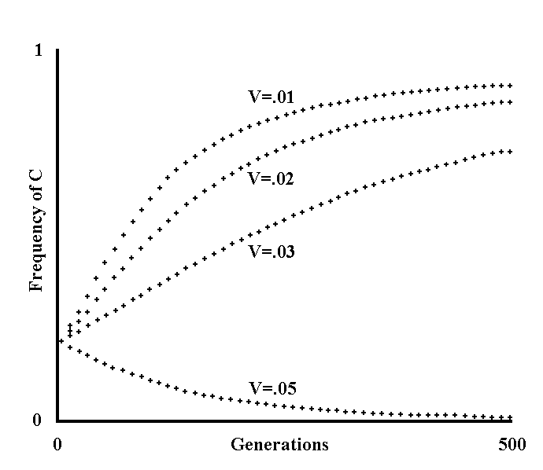
Fig. III 6-1 - Reduction of the defences of the parasited organism as a consequence of an advantage deriving from the parasitism (Theoretical model).

Let us assume the same conditions as in the model of Fig. III 1-1 with the addition that the parasitism of B causes the advantage V. This advantage depends on the probability of parasited organism-parasite interaction at the nth generation (P_{n}), which is, however, dependent on the spreading of C within the species A, to an inversely proportional extent. Therefore:

V_{n} = V_{max} P_{n} = V_{max} f(C_{n}) (III-24)

where V_{max} indicates the advantage occurring when P = 1.
If we write V instead of V_{max}, then, we have:

V_{n} = V f(C_{n}) (III-25)

With the conditions expressed, we obtain:

C_{n+1} = C_{n} (1 + S P_{n} - V P_{n} - U) = C_{n} (1+ f(C_{n}) (S - V) - U) (III-26)
1 + C_{n} (S P_{n} - V P_{n}) 1 + C_{n} f(C_{n}) (S - V)

and, at equilibrium:

C_{e} = 1 - U = 1 - U (III-27)
S P_{n} - V P_{n} f(C_{n}) (S - V)

Note that when the formula gives values of C_{e} lesser than 0 or greater than 1, which are, therefore, impossible, it is assumed that C_{e} = 0 because, as we have already seen in Fig. III 1-1, in one of the mathematical transformations both members are divided by C_{e}, while it is assumed that C_{e}  0.
Fig. III 6-1 was obtained assuming arbitrarily that:

f(C_{y}) = 1 - C_{y} (III-28)

For all curves:

S = .04 ; U = .0001 ; C_{o} = .2.

Going from top to bottom, the values of V are:

.01 ; .02 ; .03 ; .05.

In the lower curve V > S, so, if C_{e} > 1 according to the la formula, it is assumed that C_{e} = 0, i.e. the parasited organism does not put up defence.
Likewise, the other curves indicate that, as a result of an advantage deriving from the parasitism, there is a tighter limit for the effectiveness of the parasited organism defences.

Chapter IV — Antigenic polymorphism

1) Antigenic mimicry
A very important defence of the host is, in mammals, the ability to produce substances, antibodies, that can “cling” to the parasites with high selectivity, according to stereochemical structure, or antigenicity, thereby directing and facilitating the action of particular cells with phagocytic activity or neutralizing parasite infectivity itself. For obvious reasons the host, apart from in pathological cases, does not produce antibodies directed against substances belonging to its own body. The tendency of the parasite to take advantage of this, covering itself with substances similar to those of the host and thus enjoying the advantage of not being opposed by the antibody defence to an extent that is proportional to the degree of antigenic mimicry achieved, is, perhaps, predictable. In fact:
- Some bacteria show superficial antigenic structures very similar, or even identical to, antigens present in cells of multicellular organisms. It is possible that this antigenic likeness with the parasited organism contributes to bacterium pathogenicity because an animal organism does not produce antibodies against its own antigen substances. In other words, a bacterium can be more pathogenic for those animal species toward which it presents the greater portion of common antigens (in general polysaccharides). Antigenic mimicry is pretty common. The pyogenic streptococcus has a capsule composed of hyaluronic acid that is also a component of a connective fundamental substance; many Gram- bacteria have superficial polysaccharides that are antigenically similar to the antigens of the red cells. Antigenic mimicry may be useful in explaining the tropism of species in some cases: for example, Salmonella typhimurium has some antigens in common with the tissues of the mouse (for which it is very pathogenic), but has no antigen likeness with human tissues (and is not very or by no means pathogenic to humans). - (La Plaga, R., 1971)
Now consider that a great advantage of microbial parasites towards mammals is the greater velocity of evolution of the former as a consequence of their lesser ML (see the previous chapter). Thus, the parasite could imitate the antigenic formula of the host species much more rapidly than the host can change it by evolution. The parasite would thus tend not to be recognized as extraneous by the antibody defence, thereby prevailing evolutionarily over the host. All this leads us to hypothesize that there is some form of defence that protects the host from antigenic mimicry, unless we postulate either that the parasite cannot evolutionarily reach the same antigenicity of the host (which is contradicted by known cases of partial antigenic mimicry), or that the overall usefulness of antibody defence is of secondary importance.

2) Antigenic polymorphism
It is, perhaps, admissible to maintain that this defence is antigenic polymorphism among the individuals of the host species.
This expression means the mutability of the antigenic formula from individual to individual of the same host species. In other words, let us suppose that a host species has a certain number of antigen systems and that each individual of the species has only one of the antigens of each system. The term “system”, using the definition given by immunology, means the whole series of antigens defined by genes belonging to an allelic series, or to several allelic series with “loci genetici” linked tightly together.
For the first system there are the antigens: M, N, S;
For the second system there are the antigens: I, II, III;
For the third system there are the antigens: A, B;
For the fourth system there are the antigens: Z1, Z2, Z3;
An individual has one of the following antigenic formulas:
M, III, A, Z3, ... or
N, II, B, Z3, ... or
N, II, A, Z2, ... or
. . . . . . . . . . . . . . . . . . . .
No individual of the host species recognizes its own antigens as extraneous (= “self”), although it has the potential genetic ability to do so. The host, via some mechanism, learns to recognize its individual antigenic formula before preparing antibodies against extraneous antigens (= “not-self”). Afterwards, the host treats any other antigen with which it comes into contact for the first time as extraneous, even if it belongs to other individuals of its own species, and directs its own antibody defence against them. It is evident that the parasite, faced with such an antigenic polymorphism, has no fixed pattern for camouflaging itself antigenically and, to varying extents, depending on the degree of mimesis achieved, is subjected to the action of antibody defence. Although it has a greater velocity of evolution, the parasite cannot, therefore, sidestep antibody defence using antigenic mimicry.

* * *

About the establishment of antigenic polymorphism one might reason as follows. Let us consider a host species with an antigen A present in nearly all the individuals making up that species, while a very small fraction of them are mutants with the antigens A’, A", ... in the same site where A is present. Let us imagine that, among the many parasite individuals of the species in question, there is a mutant with antigen A. Note now that the parasite with this antigen is combatted by the antibody defences of the host species to an extent that is lesser than that of other parasites. This constitutes an advantage for the aforementioned parasite and, other factors being equal, facilitates prevalence over other parasites without antigen A. On the other hand, among the individuals of the host species, those few mutants with the antigens A’, A", ... are advantaged compared with the numerically prevalent ones having antigen A, because they are able to produce antibodies against antigen A of the parasite and, therefore, to combat it to a greater extent. In short, a large percentage increase of individuals with A’, A" should result, ... that is, we have the establishment of an antigenic polymorphism with regard to the aforementioned antigens, consequentially to the establishment of antigenic mimicry among the parasites.
At the same time, one might reason about other antigenic systems. For a more formal exposition, see the theoretical model illustrated in Figures IV 2-1, -2, -3, -4 and -5.

* * *

That which has been said and speculated upon concerning the antibodies may be repeated, with the appropriate modifications, about the organism’s ability to build antigen-selective cells with immunological activity (lymphocytes). Likewise, the subject thus far limited, for convenience of expression, to mammals only, can be extended to any species that is able to distinguish between the self and the non-self and, with regard to this, to have reactions of an immunological type.

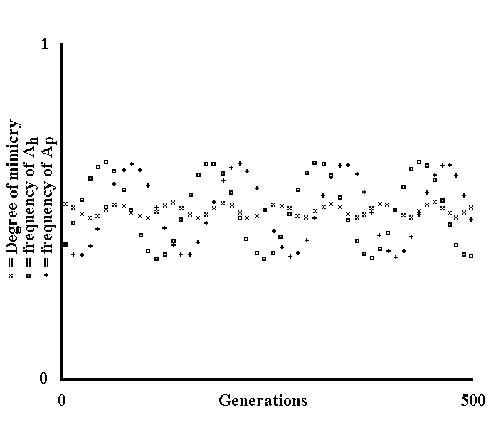
Fig. IV 2-1 - Mimicry of the parasite and polymorphism of the host (Theoretical model).

There is a host species h and a species p that is a parasite of h. The number of individuals of each of the two species does not vary from generation to generation. Within h, there are the characters - each defined by a single gene - A, B, C, Z, with a frequency at generation n that will be indicated A_{h,n}, B_{h,n}, C_{h,n}, ... Z_{h,n}. The presence of a character in a host excludes any other character. Analogously, among parasites there are - by hypothesis - mutually excluding characters, whose frequency at generation n are indicated A_{p,n}, B_{p,n}, C_{p,n}, ... Z_{p,n}. Let us assume that the infection of a host with character X_{h} by a parasite with character different from X_{p}, causes no advantage or disadvantage for either. Likewise, it is assumed that the infection of a host with character X_{h} by a parasite with character X_{p}, entails advantage +S_{p,x} for the parasite and disadvantage -S_{h,x} for the host. It should be noted that, with these assumptions, a correspondence between X_{h} and X_{p} has been established, without thereby implying an identity between X_{h} and X_{p}. Moreover, a character is not necessarily an antigen.
Let us also assume that a character causes an advantage, or a disadvantage, independently of the host-parasite relation, which is indicated S’_{h,x} for the host and S’_{p,x} for the parasite. Finally, it is assumed that a character X_{h} or X_{p} suffers a load of disruptive mutations at each generation, equal to U_{h,x} and U_{p,x}, respectively.
If the MLs of h and of p are equal, we have the formulas:

X_{h,n+1} = X_{h,n} (1 - X_{p,n} S_{h,x} + S’_{h,x} - U_{h,x})
_{Z}
 K_{h,n} (1 - K_{p,n} S_{h,k} + S’_{h,k} - U_{h,k})
^{K=A}

X_{p,n+1} = X_{p,n} (1 + X_{h,n} S_{p,x} + S’_{p,x} U_{p,x}) (IV-1)
_{Z}
 K_{p,n} (1 + K_{h,n} S_{p,k} + S’_{p,k} - U_{p,k})
^{K=A}

where the denominators, obtained by adding the numerators, have the function of maintaining the sum of X_{h} and of X_{p} (= 1) constant from generation to generation. On the other hand, if ML_{h} > ML_{p}, defining Q as the ratio ML_{h} / ML_{p}, for each single generation of h, it is necessary to repeat Q times the calculation indicated in the second formula - concerning the parasites - and it is also necessary to modify the first formula in the same way for the hosts:

_
X_{h,n+1} = X_{h,n} (1 - X_{p,n} S_{h,x} + S’_{h,x} - U_{h,x}) (IV-2)
_{Z} _
 K_{h,n} (1 - K_{p,n} S_{h,k} + S’_{h,k} - U_{h,k})
^{K=A}
_
where X_{pn} indicates the mean frequency of X_{p} in the nth generation of the host. The figure here as well as those in the next the paragraph were obtained using these formulas. The number of characters considered is 2. On the abscissas, each space signifies 10 generations of the parasite and 10/Q generations of the host. On the ordinates, the frequencies of the character A_{p} are indicated with crosses, the frequencies A_{h} with squares. The frequencies B_{p} and B_{h} are not indicated, but are immediately obtained remembering that:

B_{h,n} = 1 - A_{h,n} ; B_{p,n} = 1 - A_{p,n}. (IV-3)

In the figure, a coefficient is indicated with the symbol x, the arbitrary name of which is “degree of mimesis”, given by the formula:

_{Z}
G_{n} =  K_{h,n} K_{p,n} (IV-4)
^{K=A}

where G_{n} indicates the degree of mimesis at the nth generation. G is maximal (= 1) if there is total mimesis, and minimal (= 0) if the mimicry is non-existent.
The assumed values in this figure are:

A_{h,o}, A_{p,o} = .4 ; B_{h,o}, B_{p,o} = .6 ; Q = 1 ;
S_{h,a}, S_{p,a}, S_{h,b}, S_{p,b} = .1 ; S’_{h,a}, S’_{p,a}, S’_{h,b}, S’_{p,b} = 0 ;
U_{h,a}, U_{p,a}, U_{h,b}, U_{p,b} = 0.

The figure shows that the frequencies of the characters oscillate around values that will be defined as ‘equilibrium’. The parasite is able to camouflage itself only partially because of the polymorphism of the host.
As regards the cause of the oscillations and the meaning of ‘equilibrium’ frequency, it is necessary to reason in the following manner.
Let us assume that one of the two species, e. g.. the host, starts at time t with frequencies X_{h,t} at equilibrium (= advantage and disadvantage + decay that have equal value) on the basis of the frequencies X_{p,t} of the parasite. This is only the case if the frequencies X_{p,t} are likewise in equilibrium on the basis of the frequencies X_{h,t}. Thus, X_{p} will be modified up until they reach equilibrium frequencies at time t’ on the basis of the frequencies X_{h,t} of the host. But, at time t’ the frequencies X_{p} will be in equilibrium while the frequencies X_{h} will no longer be in equilibrium. Thus, the process, with roles exchanged each time, will be repeated an unlimited number of times. Only and exclusively if the frequencies X_{h} and X_{p} are contemporaneously in equilibrium, is there no subsequent change of the frequencies.
A corollary of that which has been said, is that the farther the initial frequencies are from the equilibrium frequencies, the wider the oscillations (see the next figure).
It is possible to come up with formulas that give the equilibrium frequencies. For the sake of brevity, I will omit demonstrations and formulas. I will give only an example for a system of two characters:

A_{h,e} = S_{p,b} + U_{p,a} - U_{p,b} (IV-5)
S_{p,a} + S_{p,b}

Where, for simplicity’s sake, it has been assumed that S’ = 0 for all characters.

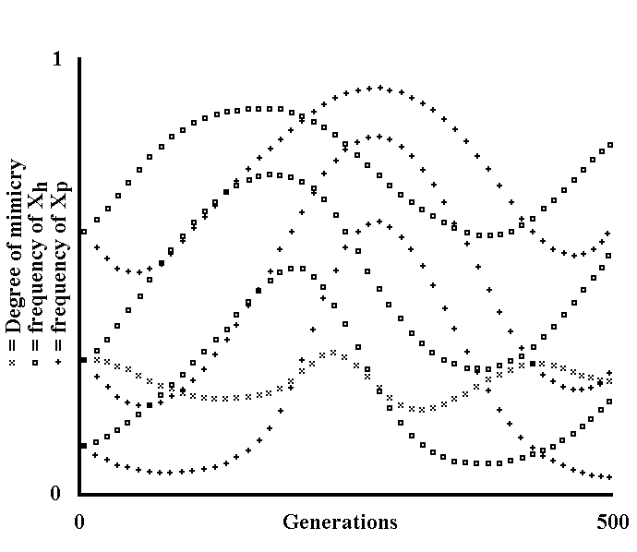
Fig. IV 2-2 - Mimicry of the parasite and polymorphism of the host (Theoretical model).

The conditions are as for the preceding figure. On the ordinates, going from bottom to top, the frequencies A_{p}, A_{p} + B_{p}, A_{p} + B_{p} + C_{p} are indicated with crosses, and the frequencies A_{h}, A_{h} + B_{h}, A_{h} + B_{h} + C_{h} with squares. The assumed values are:

A_{h,o}, A_{p,o} = .1 ; B_{h,o}, B_{p,o} = .2 ; C_{h,o}, C_{p,o} = .3 ;
D_{h,o}, D_{p,o} = .4 ; S_{h,x}, S_{p,x} = .1 ;
S’_{h,x}, S’_{p,x}, U_{h,x}, U_{p,x} = 0 ; Q = 2.

The figure, compared with the preceding figure, shows that the oscillations are wider, as predicted, and that the mean value of the degree of mimesis is lower (see next figure).

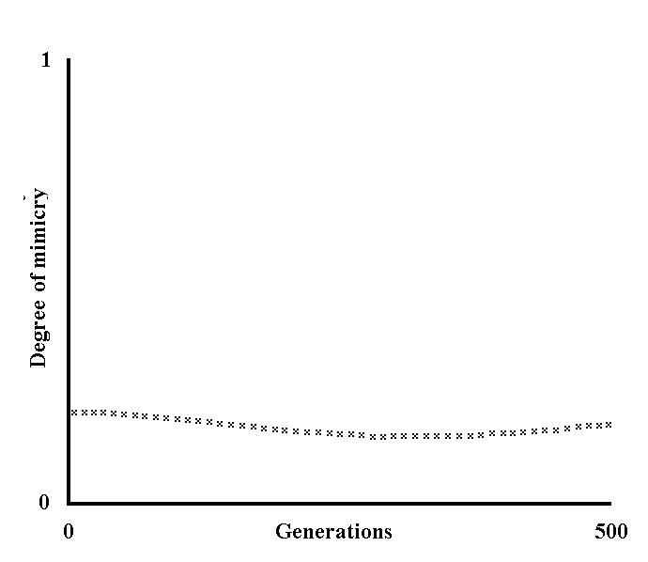
Fig. IV 2-3 - Dependence of the degree of mimesis on the number of characters (Theoretical model).

The conditions are as for the preceding figures but, as there are 6 characters, only the degree of mimesis (G) is illustrated, using the usual sign x, for the sake of simplicity. The assumed values are:

A_{h,o}, A_{p,o}, B_{h,o}, B_{p,o}, C_{h,o}, C_{p,o} = .1 ;
D_{h,o}, D_{p,o}, E_{h,o}, E_{p,o} = .2 ; F_{h,o}, F_{p,o} = .3 ;
S’_{h,x}, S’_{p,x}, U_{h,x}, U_{p,x} = 0 ; S_{h,x}, S_{p,x} = .03 ; Q = 1 :

The mean value of G seems lower than that of the preceding figures. This suggests that the value of the degree of mimesis is in inverse relation to the number of characters. This is rigorously true and demonstrable if the following simplifying conditions are assumed:

Q = 1 ; S’_{h,x}, S’_{p,x} = S’ ; U_{h,x}, U_{p,x} = U ; S_{hx}, S_{px} = S .

In fact, we have:

X_{h,n+1} = X_{h,n} (1 - S X_{p,n} + S’ - U)
_{Z}
 K_{h,n} (1 - S K_{p,n} + S’ - U)
^{K=A}

X_{p,n+1} = X_{p,n} (1 - S X_{h,n} + S’ - U) (IV-6)
_{Z}
 K_{p,n} (1 - S K_{h,n} + S’ - U)
^{K=A}

At equilibrium, as X_{h,n+1} = X_{h,n} = X_{h,e} and X_{p,n+1} = X_{p,n} = X_{p,e}, excluding that X_{h,e} = 0 and X_{p,e} = 0 and writing, for the sake of brevity X_{h,e} = X_{h} and X_{p,e} = X_{p}, division by X_{h} and X_{p} , respectively, gives:

Z Z Z Z
 K_{h} - S  K_{h} K_{p} + S’  K_{h} - U  K_{h} = 1 - S X_{p} + S’ - U
K=A K=A K=A K=A

Z Z Z Z
 K_{p} + S  K_{p} K_{h} + S’  K_{p} - U  K_{p} = 1+ S X_{h} + S’ – U (IV-7)
K=A K=A K=A K=A

Z Z
from which, as  K_{p} = 1 and  K_{p} = 1, we obtain:
K=A K=A

_{Z}
S  K_{h} K_{p} = S X_{p}
^{K=A}

_{Z}
S  K_{p} K_{h} = S X_{h} (IV-8)
^{K=A}

_{Z}
and as  K_{h} K_{p} = G by definition, we obtain:
^{K=A}
G = X_{p}

G = X_{h} (IV-9)

Finally, as no character is privileged, if n is the number of the characters, we have:

X_{p} = X_{h} = 1/n (IV-10)

and therefore:

G = 1/n (IV-11)

as supposed.

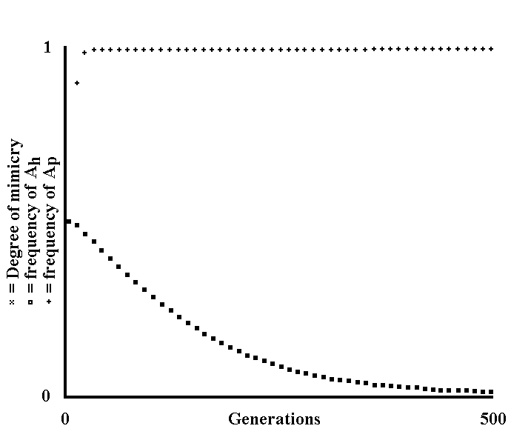
Fig. IV 2-4 - Absence of mimicry (Theoretical model).

In this figure, the following values have been assumed:

A_{h,o}, A_{p,o}, B_{h,o}, B_{p,o} = .5 ; S_{h,x}, S_{p,x} = .02 ;
U_{h,x}, U_{p,x} = 0 ; Q = 2 ;
S’_{h,a}, S’_{p,a}, S’_{h,b} = .0001 ; S’_{p,b} = -.2 ;

This means that the character B_{p} is strongly disadvantaged. Note that the x - indicating the degree of mimesis - and the empty squares - which indicate the frequency of A_{h} – are superimposed one over the other, thereby taking on the appearance of filled squares.
The final conditions clearly indicate an almost non-existent mimicry.

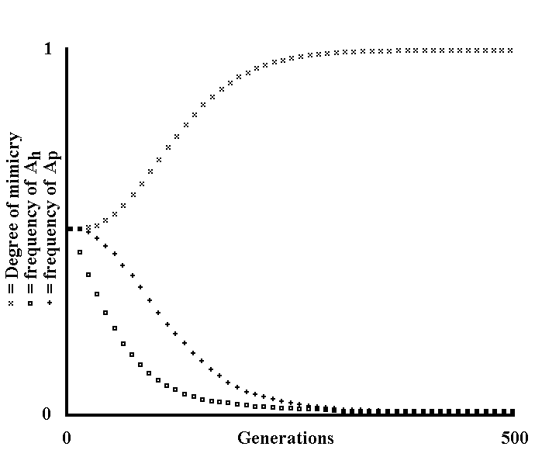
Fig. IV 2-5 - Absence of polymorphism (Theoretical model).

The assumed values are the same as those in the preceding figure, apart from:

S’_{h,a} = -.5 ; S’_{p,b} = .0001 ;

i.e. the character A_{h} is strongly disadvantaged.
The final conditions indicate an almost non-existent polymorphism and a practically total mimicry.
Note also that the inclination of the curves is lesser that that of the preceding figure because S’_{h,a} in the present figure is, as an absolute value, equal to a quarter of S’_{p,b} of the preceding figure.

3) Antigenic polymorphism in immunology
Now, it is useful to see briefly whether this hypothesis is really backed up by immunological experimental data.
It has long been known that red cells of the human blood have cell membranes that are by no means antigenically homogeneous for the whole species. In fact, we distinguish the system A-B-AB-O (which was the first to be discovered and is the most well-known), the systems Rh, MNSs, Kell, Lutheran, P, Levis, Duffy, Kidd, etc. Haemato-immunology gives us an incredibly complex framework: the existence of at least 15 blood groups genetically passed on independently of one another is known or suspected. Considering only the 9 blood systems first discovered (that is up to the secretory system excluded), a very high number of antigenic combinations is calculable. Other stereochemical structures with the same specificity of the various blood groups, or with analogous antigen variability, are known in many liquids of the organism too (ovarian cysts, saliva, etc.) and also on the membranes of many cell types, including leukocytes. The great differences in antigenic formula among the various individuals of the human species are well-known as being the main obstacle to transplants.
An individual receiving a transplant will, in fact, treat it as an extraneous body, unless it is compatible in terms of antigen combination, which is uncertain even among close relatives, leading progressively to its biological decay, or rejection.

* * *

It is not my intention to claim that antigenic mimicry is the cause - or, at least, the exclusive cause - of antigenic polymorphism, but simply to point out that the necessity of antigenic polymorphism among hosts is theoretically predictable in balancing the antigenic mimicry of parasites. The originality of the hypothesis expressed, as opposed to other hypotheses, lies in the fact that it attributes the causes of antigen variability to the advantage of the variability in itself as causal factor.
To what extent antigenic polymorphism derives from that which has been expounded and to what extent it derives from other factors, I am not at all able to establish in theoretical terms.

* * *

As regards the hypothesis maintained in this work, I refer the reader to Appendices 1, 2 and 3.

4) Parts of the organism subject to antigenic polymorphism
I wish to consider, from a theoretical point of view, which parts of the organism in an individual of the human species, and of mammals in general, must be antigenically variable if the hypothesis presented above is true. We should note that the antibodies - and the lymphocytes - are present in the:
1) plasma, 2) interstitial fluid, 3) cerebrospinal fluid, 4) liquids excreted by mucous membranes, etc., but do not penetrate the:
1) interior of the cells, 2) places where they are in contact with nervous cells, 3) inside of thyroid follicles, etc.
For all substances able to antigenic stimulus, that is, those above a certain molecular weight or which are part of more complex structures, such as cell membranes, and in contact with or contained in 1), 2), 3), 4), etc., and therefore in places where it is possible to stimulate antibody formation, it is necessary that they be recognized by the organism as their own and not extraneous. Therefore, in order to minimize the trick of antigenic mimicry by parasites, all, or nearly all, the aforesaid substances should have a certain antigen variability within the same species. On the other hand, the macromolecules or the aggregates of macromolecules contained in I), II), III), etc., or those molecules that are too small to be able to constitute an antigenic stimulus, could very well be antigenically uniform for the opposite reasons. Logically, certain substances, as soon as they emerge from their state of isolation, would be treated as extraneous by the organism, which would not recognize them as its own, something that actually happens in some autoimmune diseases.
In experimental confirmation of that which has been claimed, I would stress, among other things, that:
- Rabbits, if injected with extracts of homologous thyroid glands, form antibodies against the thyroid antigens, which can be proven using serologic techniques. At the same time, in many animals, a chronic thyroiditis breaks out when cerebral substance taken from an animal is mixed with adjuvant and injected in other members belonging to the same species; in many of these an encephalitis appears. - (Jawetz, E., 1971, p. 222)
This perhaps implies a certain antigen likeness among individuals of the same species in parts of the organism that are immunologically isolated.
- Lenticular proteins show significant immunological properties, but are characterized by specificity of organ and not of species, in the sense that an animal immunized with lenticular proteins, will react to any lenticular extract, without distinction regarding the species from which it has been extracted. - (Santoni, A., 1968, p. 79)
Here, we find antigen similarity even among different species. In short, I consider it appropriate to emphasize the fact that theories attempting to give an explanation for antigenic polymorphism, must also consider and justify the possible absence of such a polymorphism in certain parts of the organism.

5) Defence consequent to the differentiation of the host species
The theoretical model illustrated for antigenic polymorphism and mimicry is not connected to character type. This suggests the possibility that polymorphism and mimicry phenomena are not limited only to the antigenic structure. But the same theoretical model indicates a great obstacle to the manifestation of this possibility in the likely existence of advantages or disadvantages for a character, independent from the infection. Another and much greater difficulty, intrinsic to the theoretical model - but not expressed - is that a character can be determined from a single gene - see antigens - and it is then easy to admit the alternation postulated among the various characters. But, if the character is dependent on several genes, the alternation would not seem to be a realistic proposition, due to the hybrids for the characters being considered. Moreover, it would not seem plausible for the hybrid of two complex and distinct structures to have no disadvantage. All this leads us to think that non-immunological polymorphism and mimicry phenomena are very limited within the system host and related parasites. Likewise, this limit opens up a new horizon. Among various host - or parasite - species which are, by definition, genetically isolated from each other, the problem of the hybrids does not exist and the theoretical model, if we modify the terms of definition, regains, in my opinion, great value. In other words, I now maintain that the differentiation of the host species (= polymorphism) entails, for each of them, the advantage that only a small specifically adapted (= camouflaged) part of the total number of parasite species can infect it successfully. Here, I have not discussed the problem of the genesis of the species; rather I have emphasized an advantage in the relations with the parasites, consequent to the differentiation of the host species.

* * *

In verbal terms, the progressive differentiation of the host species forces the parasites to make a continuous choice:
A) either to differentiate themselves to an extent equal to that of the host species. In this case, parasite means of attack can become highly specific for the respective host and may reach a high level of adaptation in relations with the latter. But note that the extinction of a host species can easily entail the extinction of the parasites that are specific for said extinct host.
B) or to differentiate themselves to an extent lesser than that of the host species, that is become parasites of several species. Note that the greater the number of species of which a living being is a parasite, the more the means of attack of the parasite can be non-specific and often and the less efficacious it becomes. On the other hand, with such a higher level of effectiveness, each of the host species can defend itself without jeopardizing the parasite’s capabilities of persistence. It follows that the theoretical greatest effectiveness of the defences of the host is greater still (see argument on the limitation of the effectiveness of defences). On the other hand, the possibilities of parasite extinction are much smaller, because of the extinction of, or numerical decline in, one of the respective host species.
In any case, a parasite will be able to parasite effectively only a part of the host species, with a clear advantage for each of them.

* * *

From the theoretical model for polymorphism and mimicry, we have deduced that the final “degree of mimesis” is in inverse relation to the number of existing characters or forms. If it is assumed - as a plausible hypothesis - that the damage for the host is dependent, among other things, on the degree of parasite mimicry, it follows that a limitation of the damage for the host derives from the increase in the number of characters. Translating the aforesaid statement in terms of the number of host species and related parasites specifically adapted, I will say that:
if the habitat is resource-poor and, therefore, the advantage consequent to the limitation of parasitism damage is greater, a greater number of species, both host and parasite, may be predicted, save for limiting effects of other types.
In fact, this reduces the number of specific parasites for each host (or, in the terms of the theoretical model: the degree of mimesis).
As an empirical confirmation of this theoretical prediction, I offer the case of the tropical rainforest, an ecosystem that is very poor in energy resources, contrary to appearances, and is very rich in number of parasite and parasited species, with a very low ratio between the two biomasses valued at around .2T/900T per hectare. For the source of this information and for details about this ecosystem, refer to the bibliographical entry: Richards, P. W., 1973.

* * *

If a parasite adapted to a particular host species accidentally infects individuals of another species, two possibilities must be considered:
1) In the first, such infections are relatively frequent and, therefore, if the parasite is able to take root, the selective pressure due to the infection tends to favour the development of specific defences in the host.
2) In the second, the infections are very rare, so the casual host has no specific defences and the outcome of the infection is unpredictable. The infection will be ineffective - and this is perhaps the most common eventuality - the casual host being too different from the normal one. Or it may occur, on the other hand, that the infection turns out to be mortal: for example, the virus B parasite of monkeys and the rabies virus, adapted to the parasitism of bats, are fatal to humans in the rare cases in which they infect them. Or the infection may even, for unknown - but surely not adaptive -reasons, cause a result which is sometimes unnoticed and sometimes serious or deadly, as in the case of some encephalites caused by arboviruses.

Chapter V — Evolutionism and Pathology

1) Topic
On the basis of the empirical data, as a first attempt at description, it is possible to define the concept of disease as a state of deviation - in a pejorative sense - from the norm of one or more functions of a living organism. Clearly, the norm will be established in reference to the totality of the individuals of the population. With the opportune modifications and specifications - and discussions as regards the borderline with the "state of health", - this definition could be pacifically accepted by the clinician, the physiologist, the pathologist, etc.. In this chapter, I investigate a definition of the concept of disease that is not uncritically descriptive but that is, likewise, set within the phenomenon of evolution, which is also, it should be noted, firmly based on empirical data. I will, therefore, compare the definition expressed here, which I would say is peculiar to the non-evolutionary empiricist, with that which might be expressed by an empiricist who takes evolution into due account.

* * *

This work is based, among other things, on the concept - already stressed by others - that evolution is the most general theory of all biology: each biological phenomenon, which is not strictly contingent, is ultimately an aspect, an expression of the evolutionary process. With such an approach, the question arises of whether the pathology can be formulated in its outline in evolutionary terms. In other words, if the disease is an anomaly, an exception or rather a phenomenon that is an integral part of the evolutionary process. In this chapter, I look for possible answers to this question, maintaining among other things that:
a) From an evolutionary point of view, diseases are not something that breaks out of the mould but are, rather, a whole series of categories of phenomena which are evolutionarily “predictable” in their general essence. “To predict”, I stress once again, means to make certain deductions starting from the theory of evolution, with the suggestion, confirmation and confirmation in natural and experimental data: it is common practice, in scientific methodology, to obtain accepted interpretations and classifications of the actual phenomena deductively from a theory, looking then at empirical data for possible confirmation of the validity of the interpretations and classifications.
b) The evolutionary approach to the concept of disease is the most rational and general one possible. Any other more limited approach, even one which is more useful as regards a single pathological problem, simply because it is more limited and selectively oriented, should not be conceived in terms that run contrary to the theory of evolution. There must be no substantial contradiction, either basic or practical, between an evolutionary and non-evolutionary approach to the concept of disease, because both points of view are correct and the object of study is one. Contradictions may originate where one wishes to make illicit generalizations and interpretations from contingent empirical data or from reasoning in evolutionary terms.
c) To reason about pathological topics in evolutionary terms does not necessarily mean expressing things never spoken of before in the non-evolutionary approach, but largely to repeat things that have already been said, which are known and are empirically and inductively proven and accepted, with a view to unifying them.
d) The evolutionary approach to the concept of disease spontaneously raises suggestions and basic questions about the prevention and cure of the various categories of diseases.

2) The starting point
To formulate the immense complexity of the real world in terms which are necessarily simplified, inevitably entails a certain amount of loss and a flattening of the information that one wishes to get across, if we fail to consider that the simplicity and shortness of a word does not imply the simplicity of the concept expressed.
The term ‘species’ is a very good example of how an incredibly complex reality may be summarized in such a brutal manner that it may deceptively seem to be something much simpler than it really is. The subject requires us to consider the concept of species to an extent that is more detailed and complex, but certainly closer to reality.
I now wish to define better the concept of a hypothetical species A.
Let us imagine a whole series, unlimited numerically and temporally, of generations of mutually fertile individuals (read: I am not suggesting that this happens to an unlimited extent), which live in a whole series of ecological niches, varying (read: may not vary) from generation to generation, from individual to individual, from time to time; these ecological niches, of which the constitutive elements are both the modus vivendi of the individual and the physical environment in absolute in which they live, and the whole series of individuals of the species B, C, ..., Z, with which the species A is in relation (read: no limitation of relation types has been assumed). Let us consider each individual in terms of genome (read: it is not necessary for the definition to specify the physical substrate of genetic information) received by other individuals of the preceding generation and that can be handed down to other individuals of the next generation to an entirely or nearly accurate extent, a genome that, in the interaction with the n ecological niches that follow, one upon the other, for the individual x, expresses a certain phenotype (read: which therefore changes gradually over time) which is more or less suitable for survival in the various subsequent ecological niches.
This, or any similar formulation is certainly not practical to be repeated whenever the concept of species is used. However, this definition is indispensable for the following argument and is by non means negligible in its details and implications. From this formulation indeed, as spontaneous, natural and empirically confirmable facts, certain categories of events will arise, each with its own distinct definition, but which can be covered by a single, overall definition under the term “disease”.
Each of the paragraphs following immediately hereafter will discuss one of these categories of events.

3) Diseases deriving from alterations of the genotype
The transmission of the genetic information from the individuals, or from the individual, of the parental generation to the offspring is not accurate to a total extent. This has been proven experimentally and, moreover, the transmission inaccuracy - read: mutations, chromosome alterations, etc. - is the precondition for the evolutionary mechanism by natural selection, because on the basis of individual variety, by definition the fitter “mutants” prevail. On the other hand, as the genome of any living being is a highly ordered structure and as - see Appendix 5 - in an ordered system the entropy always tends to increase by the action of random forces, it follows from this that that the greater part of the “transmission inaccuracies”, that are not mute, will not improve but will alter in various ways the equilibrium of the system - read: living being – that depends on the genome.
A threshold having been arbitrarily set, I will define as sick, with the origin of the sickness in alterations of the genotype, any mutant of a species that is less fit than the norm - statistically and arbitrarily defined - to the persistence in the ecological niche to which a species is adapted.
It is important to emphasize that if many mutations are presumably harmful in any ecological niche, a part of the mutations are likewise disadvantageous only in connection with some, and not all, ecological niches and that the reference to an ecological niche, i.e. the ecological niche to which a species is adapted, is, therefore, indispensable, (or, as a questionable alternative, an arbitrary ecological niche, making the concept of disease deriving from alterations in the genotype even more arbitrary). Some considerations:
a) The factors - read: mutagenic agents in a broad sense - that increase the degree of inaccuracy in the transmission of the genetic information, likewise increase the incidence of diseases deriving from genotype alterations, provided that the arbitrary parameters of reference assumed are not changed.
b) If we take the expression “complexity of a function” to mean the extent of the genetic information that is necessary to define the function, and assume that, as proposed on an experimental basis, the mutation frequency of the various genes is roughly equal, it follows from this that, if we consider a particular function, the existence of diseases deriving from alterations of the genotype concerning the function is predictable, and the more complex the function, the greater the number of mutations altering it.
c) The frequency of an x alteration of the genotype is limited by the selective pressure deriving, to a proportional extent, from the degree of reduced fitness that the alteration entails. On the one hand, there will be deadly alterations or those that cause sterility, the frequency of which will only be that of the specific mutations that arise at each generation. On the other hand, it is necessary to consider those alterations that cause minimal damage and whose frequencies will, therefore, be greater than those of the frequencies of the specific mutations, as the subjects with such alterations are eliminated by the selective process over several generations (see Fig. V 3-1). It should now be noted that the more advanced the age - relative to the longevity of the species – in which an alteration causes damage, the lesser the selective pressure expressed against it. Thus, the frequency expected for this type of disease is not low (see Fig. II 6-1). Such diseases are defined as “senile diseases”, with the specification that this category of events must be kept well distinct from senescence. As examples of human senile diseases, I might mention: senile cataract and glaucoma, Parkinson's disease, atherosclerosis. An essential characteristic of senile diseases is that they may affect a large percentage, but never the totality of the ageing individuals of a species. (It should be noted that this it is not true for hypersenescent individuals because, as these are not found, or almost not found, in natural conditions, it follows by definition that there is no selection). Finally, note that, and this will be emphasized later, the concept of senile disease is not limited only to the category of diseases deriving from alterations of the genotype. See paragraph 7 for a further discussion of the concept.
d) The weakening of the selective mechanisms towards an x alteration of the genotype, for example, in man, as a consequence of the increasing effectiveness of medical therapy, causes an increase over generations in the frequency of alteration x. The topic will be discussed again in paragraph 10.

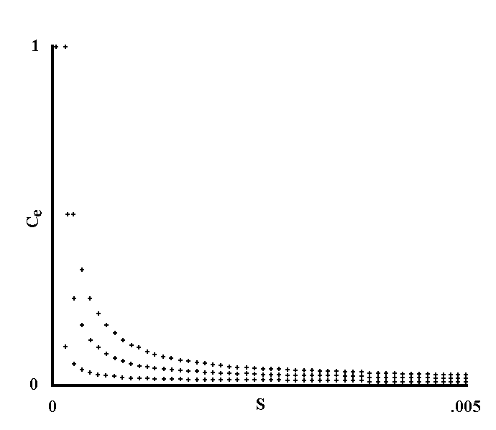
Fig. V 3-1 - Equilibrium frequencies of a gene with damage S, arising with frequency V (Theoretical model).

C and C’ are alleles. C causes the damage S, while C’ is inactive. C’ changes into C with frequency V at each generation and the contrary happens with negligible frequency.
With the assumptions formulated, we have:

C_{n +1} = C_{n} (1 - S) + C’_{n} V ,
C_{n} (1 - S) + C’_{n} V + C’_{n} - C’_{n} V

= C_{n} (1 - S - V) + V (V-1)
1 - C_{n} S

At equilibrium, as C_{n+1} = C_{n} = C_{e}, dividing by C_{e} and with the mathematical transformations already expressed for Fig. II 6-1, we obtain the two solutions:

C_{e} = 1 ; C_{e} = V (V-2)
S

The first solution is applied if V > S, because C_{e} <= 1.
The figure shows three curves with values of V, going from top to bottom respectively:

.0001 ; .00005 ; .00001.

The value of C_{e} is on the ordinates.
The damage S is expressed on the abscissas (0 on the abscissa 0; .005 on the extreme right of the abscissas; the difference for each interval is equal to .005/50 = .0001).

4) Diseases deriving from alterations of the ecological niche
As a consequence of the selective pressures, the totality of the individuals of a species is adapted, in so far as this has been possible, to the ecological niche - read: totality of ecological niches - according to which the species lives. It is clear that a further adaptation, when there is a change in the ecological niche, cannot happen immediately, as the effects of the selection manifest themselves over several generations. It is likewise obvious that a new ecological niche may be better, neutral or worse in reference to the aptitude of a species and towards the preceding ecological niche. However, considering that the totality of the individual-ecological niche relations is a highly ordered structure, reminding again of that which was expounded in Appendix 5, an easy prediction is that a random modification of the ecological niche, given that it reduces the order of the system, alters, for the most part, the equilibrium between species and ecological niche - read: adaptation -, i.e. it entails a lesser aptitude for persistence in the individuals of the species. Lesser fitness means, by definition, damage or the possibility of damage for the individuals of the species.
A threshold having been arbitrarily set, I will define as sick, with the origin of the sickness in alterations of the ecological niche, any individual with one or more functions altered as a consequence of a modification in the ecological niche.
It must be stressed that the individuals of a species are not identical to each other - for various reasons: a) due to the existence of mutants; b) because the selective pressures in the ecological niches according to which the species lives, are numerous and various; etc. - and that a modification in the ecological niche is, therefore, not necessarily an alteration for all individuals of the species. Note also that:
a) For the aforementioned definition, reference to the whole individual-ecological niche was necessary and the origin of the pathological event was attributed to the ecological niche.
b) An ideal ecological niche does not exist: I have spoken about modifications in the ecological niche towards a preceding ecological niche, for which a species is, in so far as this has been possible, adapted.
c) A minor modification in the ecological niche entails minor aptitude variations and not, therefore, the disease, since it falls below the threshold value arbitrarily chosen. On the other hand, the disease arises when the change is significant and occurs over one or few generations (see Fig. V 4-1).

* * *

The human species - see, for documentation, the large number of publications – provides significant examples of great modifications in the ecological niche that have led to, either by themselves or in concomitance with other factors, the outbreak of real epidemics. I could mention:
a) Smoking and lung cancer and chronic bronchitis;
b) The high calorie diet and atherosclerotic disease and diabetes mellitus type II;
c) Diets low in vegetable waste and constipation, haemorrhoids, rhagades, anal fistulas, diverticulosis of the colon and, possibly, cancer of the rectum;
d) The gathering of the population in large urban areas and the tremendous infectious epidemics of the pre-industrial era (and the less dramatic ones of modern times);
e) The stress of urban and “civilized” life and mental and psychosomatic diseases;
f) The intake of and contact with drugs, industrial chemical substances, etc. and related pathologies.
An observation. To cure the individual of the aforementioned diseases directly, means to treat the consequences and not the cause of the problem. The decision of accepting the alterations of the ecological niche - instead of correcting them - by curing only the individual, is a choice that is political and/or personal and/or dictated by necessity. The evolutionary point of view coincides with that which has become ever more predominant over the last few decades - on the basis of experimental, ecological, economic, etc. data - when stating that the core of the problem, on which it is necessary to focus our efforts, is the ecological niche (read: primary disease prevention).

* * *

There is an aspect that must be emphasized for which non-evolutionary and evolutionary points of view are substantially different.
For the non-evolutionary empiricist, a modification of the ecological niche must be subjected to judgment of observation in order to be considered harmful or insignificant. A prejudice concerning its harmfulness is dictated only by prudence or by preceding experiences. On the other hand, the evolutionary empiricist considers - on the basis of theoretical explanations - that a modification of the ecological niche is, more probably, an alteration, until evidence of the facts proves the contrary. This attitude is conservative, but I do not see any scientific reason why it should be rejected. Moreover, as regards certain types of modification of the ecological niche - see licence to use for new drugs -, the non-evolutionary empiricist is the first to maintain the correctness of this attitude.
I believe that, according to the theoretical reasons expressed, and with the support of painful past and present experiences, this attitude must rationally be extended to all types of ecological niche modification.

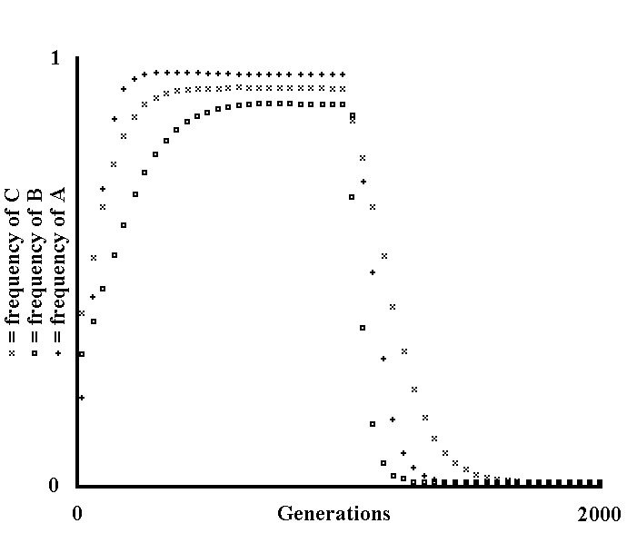
Fig. V 4-1 - Effects deriving from a sudden change in the ecological niche (Theoretical model).

Within a species, there are n genes - A, B, ..., Z – that manifest the advantages S_{a}, S_{b}, ..., S_{z} towards their respective unique alleles - A’, B’, ..., Z’.
Assuming that each of these genes changes into its allele with frequency U_{x} at each generation and disregarding, for the sake of simplicity, the back-mutation, the iterative formula that allows us to calculate the spreading of any of these genes, is that expressed in the model of Fig. I 2-2:

X_{n+1} = X_{n} (1 + S_{x} - U_{x}) (V-3)
1 + X_{n} S_{x}

Assuming that, at generation t, as a consequence of an abrupt change in the ecological niche, the values of the advantages change into S’_{a}, S’_{b}, ..., S’_{z}, respectively, the formula to be applied remains the same, but S_{x} is substituted with S’_{x}. The figure was obtained using the same conditions as above, with n = 3, and with the frequencies of A, B and C indicated using crosses, squares and x, respectively.
As usual, the frequencies are on the ordinates and the generations on the abscissas (but with values from 0 to 2000 and with each interval representing 40 generations).
The assumed values are:

A_{o} = .2 ; S_{a} = .03 ; S’_{a} = -.02 ; B_{o} = .3 ; S_{b} = .01 ;
S’_{b} = -.03 ; C_{o} = .4 ; S_{c} = .015 ; S’_{c} = -.01 ;
U_{a}, U_{b}, U_{c} = .001 ; t = 1000 .

The figure shows that, with the selective pressures suddenly varying, the species is suddenly in a non-equilibrium condition - at least for some genes - and for a certain number of generations, the frequencies of the genes involved vary considerably until a new equilibrium is reached.
If the genes that are optimal for the preceding ecological niche likewise cause, in the new ecological niche, alterations in the individual to an extent greater than an arbitrarily established threshold, then we have a state of disease deriving from alterations in the ecological niche as defined in the text.

5) Diseases deriving from the relations with other living beings
A living being may get the energy it needs for its own persistence either from the inanimate world or from the energy resources of other living beings. In the second case, this relation between living beings can cause damage for the organism from which energy resources are removed. Disregarding the cases in which said damage is inevitably and univocally the death of the parasited organism (predator-prey, herbivore-grass cases, etc.) and, moreover, limiting the subject to the organisms from which the energies are removed:
A threshold having been arbitrarily set, I will define as sick, with the origin of the sickness in relations with other living beings, any organism damaged by the taking away of its own energy resources on the part of other living beings.
In Chapter III, this situation was addressed in general terms. I think that one point must be emphasized, because it is essential for the argument. A parasite that is well adapted – and not, therefore, in the eventuality of sudden modifications in the ecological niche - damages the host as little as possible. I have suggested that this really happens to a minimal extent - in evolutionary terms - despite the fact that an initial superficial examination of many empirical data suggests the contrary. See Chapter III, par. 5, for the arguments expressed in support of this statement. Moreover, I remind the reader that the concept of senile disease that I will discuss again in par. 7, also concerns the category of events defined in this paragraph.

6) Diseases deriving from ‘excesses of the ecological niche’
The ecological niche of a species can also be constituted by events that are harmful for the individual, which:
a) are rare, that is to say, the selective pressure (which is proportional to the damage and to the frequency of the event) is not able to muster enough effective defences against such events, balancing the mutations that alter such defences. In other words, a defence against these events proves to be relatively superfluous and does not exist or is lost (see second observation, Chapter I, par. 2).
and/or:
b) are such as to demand defences that cannot be developed in a species because it is impossible (see postulate of the potentiality, Chapter I, par. 3), or because it contrasts with other more pressing evolutionary needs.
In the occurrence of any of these events - which will be defined “excesses of the ecological niche” - the individual involved will be damaged in various ways.
A threshold having been arbitrarily set, I will define as sick with origin of the sickness in “excesses of the ecological niche” any individual damaged by an event such as that defined above.

* * *

Some examples of “excess of the ecological niche” are: being struck by a lightning or swept away by an avalanche, an exceptional drought or famine, a fall from a considerable height of a non-flying individual of significant weight etc..
The origin of this category of events is in the ecological niche, albeit with different logic from that of the “diseases deriving from alterations of the ecological niche”. One observation needs to be made.
In an ecological niche which is notably different from that to which a species has adapted, and which is new, that is, the selective pressures have not had the possibility to have any effect, it is possible to classify an event as an “excess of the ecological niche” using criteria of analogy, given that it is impossible for the conditions described for defining the concept of excess to actually happen or be verified. For example, for man I will classify, as excesses of the ecological niche, a car accident, the amputation of a hand due to an accident at work, a sulphuric acid burn, a gunshot wound, etc.

* * *

The definition of this category of events, which is perhaps less interesting from an evolutionary point of view, is necessary to complete the picture of all those phenomena that I include under the single term "disease".

7) Disease and senescence
Senescence is not a disease.
The non-evolutionary empiricist may arrive at this conclusion after observing that it is a process which damages all individuals indiscriminately. The morphological and physiological analogies and identities between diseases and senile alterations become secondary compared to such a fundamental observation. (How could the non-evolutionary empiricist maintain that a process which damages all individuals is a disease if the disease is, likewise, defined as a deviation from the norm?).
On the contrary, the evolutionary empiricist may arrive at this conclusion after observing that senescence is a phenomenon that entails an evolutionary advantage - if what was said in Chapter II is true - and that therefore it is substantially different from the categories of events defined in the preceding paragraphs. The fact that senescence is a characteristic of all individuals of a species is, for the evolutionary empiricist, an outcome of the advantage entailed and not the fundamental criterion for judging it as a non-disease.

* * *

To maintain that senescence is not a disease does not automatically mean excluding or minimizing the importance that this phenomenon has in a discussion on diseases. First, there are the analogies of manifestation (and of the problems that derive from this from a medical point of view for the human species) between senescence and diseases. Furthermore, there is the phenomenon - already expounded in Chapter II, par. 6 (see in particular Fig. II 6-1) and stressed in par. 3 of this chapter - according to which the later in life a disease manifests itself in an individual, the less it causes selective pressure. These diseases, which have been defined as “senile diseases”, are an important subgroup in common between diseases with their origin in alterations of the genotype and diseases with their origin in relations with other living beings.
Now, I will give an explicit definition of senile disease:
It is a disease with its origin in alterations of the genotype or in relations with other living beings, which affects a part, even a great part, but never all of the senescent individuals of a species, and which is justified for its non-minimal frequency by the gradually decreasing selective pressure caused by an alteration, the later it manifests itself in the life of an individual.
Moreover, I should repeat that, as regards that subgroup of senescent individuals defined as “hypersenescent” , which show marked physiological and morphological alterations, it follows, given that such individuals are rarely or never observable in natural conditions (see Chapter II, par. 1), that:
a disease affecting only hypersenescent individuals does not exert, or hardly exerts, selective pressure and therefore may even concern the totality of hypersenescent individuals, and is sometimes indistinguishable from alterations of the senile process.

8) Diseases deriving from several causes. The epidemic
There is no theoretical explanation according to which we must exclude, in the genesis of the same pathological phenomenon, the coexistence of two or more of the events expressed in the preceding paragraphs. Likewise, the observation of human, and animal, pathology shows that the categories described must be considered as abstractions and idealizations of a reality where a combination of several factors is usual. I would mention, as an example of this statement, all the epidemics of plague or smallpox of past centuries. As an essential condition of any epidemic, there is a specific parasite involved. Among the factors that trigger the epidemic, there are the gathering of the population in urban centres, unresolved problems of removal and treatment of organic waste, etc., all of which are events that must be categorized as “great and fundamental modifications of the human ecological niche”. A complication of this is that there are individual differences, both genetic and those caused by senility and by senile diseases, in ability to endure infections. It must also be considered that the parasite, which is not a genetically static and unchanging entity, may tend to increase its aggressiveness in its serial passages from one host to another (see Gladstone, G. P., in Florey, 1970).

* * *

The concept of epidemic urges us to consider an aspect for which non-evolutionary and evolutionary points of view are different. If we define an epidemic as a pathological event, infective or otherwise, with a “high” incidence, for the non-evolutionary empiricist, the epidemic - without any other indications - differs from a disease with a “low” incidence only, and by definition, in its frequency. Observation must, then, define all other aspects.
Before observation, the evolutionary empiricist, can, perhaps, say only one thing in addition, but it is something with subtle implications:
If we define an epidemic as a pathological event with a high incidence and exclude senile diseases, epidemics are uncommon in an ecological niche to which the species has, as far as possible, adapted.
In fact, the harmful agents activate selective mechanisms that reduce the number of individuals damaged to a minimum. This minimum will be very small for the inanimate harmful agents, while for the parasites it must be less small, both in terms of number of individuals involved and in terms of threshold level, due to what was stated in Chapter III, par. 1 and 2. An epidemic could, likewise, happen only if the ecological niche changes suddenly (e.g., a new modus vivendi, a more virulent mutant parasite, etc.), or if the selection for a harmful gene is suppressed for many generations.
For the evolutionary empiricist, the phenomenon "epidemic" emerges as the marked breakdown of the equilibrium of the whole species-ecological niche: an event that is, therefore, distinguishable both qualitatively and quantitatively from the “non-epidemic”. This stimulates us - and I think that this stimulus should not be undervalued - to a greater understanding and more active intervention towards the epidemic event which is, for the human species, no longer a consequence only of random factors, but the result of well recognizable “behaviours” - in a broad sense - that can be modified, if there is a will.
For example, the current high incidence of many diseases in the human species (atherosclerosis, diabetes mellitus, constipation, mental diseases, sight defects, etc.) are, from an evolutionary point of view, an anomaly of colossal dimensions to be imputed, even before we know the particular causes of each disease, to humans and not to nature. I think that a great deal of empirical data confirms this statement.
In short, I think that evolutionism implies a more critical and dynamic view of epidemiology, with a focus on prevention.

9) Evolutionary definition of ‘disease’
For the non-evolutionary pathologist, disease is a deviation from the norm, where the norm is an entity statistically and arbitrarily defined on the basis of contingent experience. The non-evolutionary pathologist studies the causes of such deviations from the norm but - I would say - tends to conceive of such a norm as something static and unchanging and the causes of disease as something external that alters a “model”. The reality of evolution teaches that the “model” is not at all unchanging and that, furthermore, the term “normality” in any way it is - arbitrarily - defined, is meaningless except in reference to an ecological niche. From the evolutionary point of view, a model attacked and damaged by causes of disease does not exist: “causes” and “model” are integral parts of the evolutionary process. I think that it is not possible to conceive of an evolutionary process disregarding the facts of the:
a) transmission inaccuracy of the genetic information;
b) adaptation of the species to the ecological niche;
c) relations between living beings;
d) impossibility of adaptation to any event.

I suggest the following evolutionary definition of the concept of disease:
Using, as the norm, the ecological niche to which a species X is adapted, disease is a state of deviation from the norm, in a pejorative sense, of one or more functions of an individual belonging to the species X, which happens in conditions when the whole individual-ecological niche deviates from the ideal state of perfect adaptation.
Note that the substantial difference of such a definition against the non-evolutionary definition of disease is the reference to the ecological niche and, more precisely, to an ecological niche that may certainly be different from that contingent where the individual lives.
Moreover, even for the non-evolutionary empiricist, if a modification of the ecological niche causes alterations in a great part, or in all, individuals of a population, it is clear that we should more correctly refer to a different ecological niche in which the modification is not present, to define the “normality” and the deviation from the norm. The evolutionary definition gives a theoretical framework and a justification for this intuitive procedure.

10) Conclusions. Eugenics
The study of a species and of its pathology in a way which is detached from its ecological niche is wrong and misleading because the species depends on the characteristics of the ecological niche. This first point has already been stressed and here I only emphasize its importance. As a second point, I wish to stress the subject of “model” instability and the related subject of eugenics.
It is clear that the species is not something unchanging and that the events in which it is involved, given that they entail changes of the ecological niche, are, in themselves, sources of modifications of the selective pressures to which the species is subjected. On the other hand, the extent of these modifications, which might even be insignificant, should be weighed alongside the observation for each single event. Following this premise, we should ask to which degree, in which way and how fast the human species is modifying itself as an effect of the modifications of its own ecological niche. Without observation, is impossible to answer these questions. But there is an aspect which, on the basis of empirical data, I would like to stress.
It is common, among those who speak of eugenics, to refer to rare diseases and state that eugenic actions would have limited effectiveness and usefulness, maintaining, moreover, that, in any case, the eugenic problem will become significant only after several generations. This is, perhaps, a very wrong attitude. If it is true that the number of genes passed on is great, it must likewise be expected that the sum of all harmful mutations arising at each generation is relatively large - with no part of the genome spared - and that in, natural conditions, they are combatted by selection. The mortality curves for man in the pre-medical era (see Fig. V 10-1), show a marked fall (of the order of 35-40%) in the first period of life, which leads us to suspect the removal of a large number of individuals with some genetic defect at each generation. The mortality curves in industrialized countries show, on the other hand, that this fall is currently very much reduced (and this is one of the biggest achievements of modern medicine). A simple examination of the curves does not tell us the extent to which genetically defective individuals are preserved, nor the type of defects. However, I suggest that: a) the portion affected is not minimal; b) the majority of genetic defects is not classified in the light of current knowledge; c) no function is spared (considering, of course, that many mutations are deadly). This would imply that eugenics is not a problem of generations in the distant future and for rare and exceptional diseases, but rather a problem of generations in the near future, concerning the totality of the human “model”.

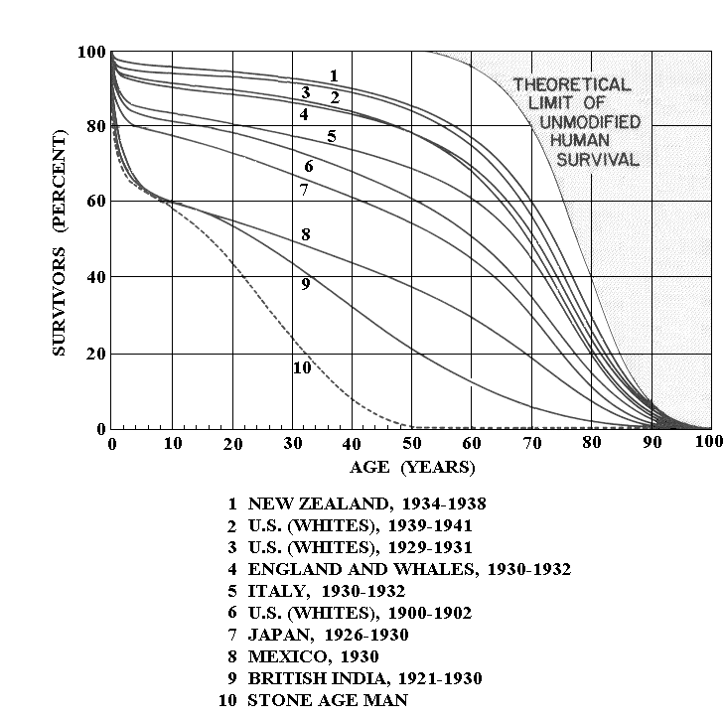
Fig. V 10-1 - Mortality of the first period of life in human species. Source: Comfort, A., 1979, p. 6.

The figure shows (curves 8 and 9) that about 37% of the population dies before age 6 in conditions that, perhaps, are closest to the original.
The tenth curve is hypothetical.

REFERENCES
1) Advisory committee to the surgeon general report: Smoking and health. U.S. Publ. Health Service, Publ. No. 1103 (1964).
2) Amos, B.D., Genetic and antigenetic aspects of human histocompatibility systems. Adv. Imm. 10, 251-297 (1969).
3) ANDERSON, D.O., FERRIS, B.G., Air pollution levels and chronic respiratory disease. Archs. Environ. Hlth, 10, 307-311 (1965).
4) ARBOR, A., Genetic selection in man. W.J. Schull (ed.), Mich. (1963).
5) BAUNGARTNER, D., Gerontologia, UTET (1971).
6) BJORKSTEIN, J., Crosslinkage and the aging process. In Theoretical aspects of aging, ed. Rockstein, M., pp. 43-59, New York: Academic Press (1974).
7) BODMER, W., CAVALLI-SFORZA, L.L., Genetics, evolution and man. San Francisco, W.H. Freeman and Company (1976).
8) BOURNE, G.H., Lipofuscin. Prog. Brain Res., 40, 187-201 (1973).
9) BROCKLEHURST, J.C., Textbook of geriatric medicine and gerontology. Livingstone (1978).
10) CALEB, E.F., HAYFLICK, L., Handbook of the biology of aging. Van Nostrand Reinhold Company (1977).
11) CLARKE, B., Le cause della diversità biologica. In Le Scienze (Dicembre 1975).
12) COMFORT, A., a) Longevità; b) Senescenza; in Encicl. Galileo, SADEA, Firenze (1966).
13) COMFORT, A., The biology of senescence. Livingstone (1979).
14) CURTIS, H.J., Genetic factors in aging. Adv. Genet. 16, 305-324 (1971).
15) DARWIN, C., On the origin of species by means of natural selection or the preservation of favoured races in the struggle for life (1859).
16) DAWKINS, R., The selfish gene. Oxford Univ. Press (1976).
17) DEMOPOULOS, H.B., The basis of free radical pathology. Fedn. Proc. Fedn. Am. Socs. Exp. Biol. 32, 1859-1861 (1973).
18) DOBZHANSKY, T., Genetics and the origin of species (1951).
19) DOBZHANSKY, T., Genetics of the evolution process. New York (1970).
20) EPSTEIN, F.H., Epidemiologic aspects of atherosclerosis. Atherosclerosis, 14, 1-11 (1971).
21) FAVILIA, Trattato di patologia generale. In part.: Cap. XXV di Prodi G., ed. Ambrosiana, Milano (1968).
22) FLOREY, L., Patologia generale. In part.: Cap. 27 di Gladstone, G.P., Piccin (1970).
23) GAUBATZ, J., PRASHAD, N., CUTLER, R.G., Ribosomal RNA gene dosage as a function of tissue and age for mouse and human. Biochim. Biophys. Acta, 418, 358-376 (1976).
24) GERSHON, D., GERSHON, H., An evaluation of the ‘error catastrophe’ theory of aging in the light of recent experimental results. Gerontology, 22, 212-219 (1976).
25) GOLDSTEIN, S., SROTLAND, D., CORDEIRO, R.A.J., Decreased proteolysis and increased amino acid efflux in aging human fibroblasts. Mech. Ageing Develop., 5, 221-233 (1976).
26) GOLDSTEIN, S., The biology of aging. New Engl. J. Med. 285, 1120-1129 (1971).
27) GUSSECK, D.J., Endocrine mechanisms and aging. Adv. Geront. Res., 4, 105-166 (1972).
28) HAIGH, J., MAYNARD SMITH, J., Can there be more predators than prey? In Theor. Popul. Biol., III, 290 (1972).
29) HAYFLICK, L., MOORHEAD, P.S., The serial cultivation of human diploid cell strains. Exp. Cell. Res., 25, 585-621 (1961).
30) HAYFLICK, L., Senescence and cultured cells in Perspectives in experimental gerontology: A festschrift for doctor F. Verzàr, Charles C. Thomas (1966).
31) HAYFLICK, L., The limited in vitro life-time of human diploid cell strains. Exp. Cell. Res., 37, 614-636 (1965).
32) HALDANE, J.B.S., The causes of evolution. Longmans, Green, London (1932). Ristampato da: Cornell University Press, Ithaca, N.Y. (1966).
33) HAMILTON, W.D., Altruism and related phenomena, mainly in social insects. Ann. Rev. Ecol. Syst., 3, 193-232 (1972).
34) HAMILTON, W.D., Selection of selfish and altruistic behavior in some extreme models. In Eisenberg, J.F., Dillon, W.S., Man and beast: comparative social behavior, pp. 57-91 (1971).
35) HAMILTON, W.D., Selfish and spiteful behaviour in an evolutionary model. Nature, London, 228 (5277): 1218-1220 (1970).
36) HAMILTON W.D., The genetical theory of social behaviour. J. Theor. Biol., 7 (I): 1-52 (1964).
37) HAMILTON, W.D., The moulding of senescence by natural selection. J. Theor. Biol., 12 (I): 12-45 (1966).
38) HARRIS, H., Enzyme polymorphism in man. Proc. Roy. Soc., B CLXIV, 298 (1966).
39) HART, R.W., SETLOW, R.B., Correlation between deoxyribonucleic acid excision repair and life-span in a number of mammalian species. Proc. Nat. Acad. Sci. USA 71, 2169-2171 (1974).
40) HORNE, M.T., Coevolution of Escherichia coli and bacteriophages in chemostat culture. Science, CLXVIII, 992 (1970).
41) JACOB, F., La logique du vivant, Parigi, (1970).
42) JAWETZ, E., MELNICK, J.L., ADELBERG, R.A., Microbiologia medica. Ed. Piccin (1971).
43) KANUNGO, M.S., Biochemistry of aging, London, Academic Press (1980).
44) LA PLAGA, R., Principi di microbiologia medica. Bologna (1971).
45) LEIGH, E., The ecological role of Volterra’s equations, in: Gerstenhaber M. (ed.), Some mathematical problems of biology, Providence (1968).
46) LERNER, J.M., Heredity, evolution and society, San Francisco (1968), ed. it.: EST (Mondadori, 1972).
47) LEWONTIN, R.C., Evolution and the theory of games. J. Theor. Biol., I, 382 (1961).
48) LEWONTIN, R.C., The genetic basis of evolutionary change. Columbia Univ. Press (1974).
49) MACARTHUR, R.H., Some generalized theorems of natural selection. Proceeding of the national academy of sciences, USA, 48 (II): 1893-1897 (1962).
50) MACARTHUR, R.H., WILSON, E.O., The theory of island biogeography. Princeton Univ. Press, Princeton, N.J. (1967).
51) MAYNARD SMITH, J., Group selection and kin selection. Nature, London, 201 (4924): 1145-1147 (1964).
52) MAYNARD SMITH, J., L’ecologia e i suoi modelli. EST (1975).
53) MAYNARD SMITH, J., PRICE, G.R., The logic of animal conflict. Nature, London, 246 (5427): 15-18 (1973).
54) MAYNARD SMITH, J., SLATKIN, M., The stability of predator-prey systems. In: Ecology, LIV, 384 (1973).
55) MAYR, E., L’evoluzione delle specie animali. Torino (1970).
56) MAY, R.M., Stability in model ecosystems. Proc. Ecol. Soc. Aust., VI, 18 (1971).
57) MAY, R.M., Stability in multispecies community models. Bull. Math. Biophys., XII, 59 (1971).
58) MEDAWAR, P.B., CIBA Found. Colloquia on ageing, Vol. I, ed. Churchill (1955).
59) MEDAWAR, P.B., The uniqueness of the individual. Methuen, London (1957).
60) MEDVEDEV, ZH. A., Repetition of molecular-genetic information as a possible factor in evolutionary changes of life-span. Exp. Geront. 7, 227-238 (1972).
61) MERTZ, D.B., Senescent decline in flour beetle strains selected for early adult fitness. Physiol. Zool. 48, 1-23 (1975).
62) MONOD, J., Il Caso e la Necessità, Mondadori, Milano (1970).
63) MOURANT, A.E., KOPEC, A.C., DOMANIEWSKA-SOBCZAK, K., Distribution of the human blood groups and other polymorphisms, Oxford (1976).
64) MURRAY, J.J., Genetic diversity and natural selection. Hafner Press (1972).
65) OMODEO, P., Storia naturale ed evoluzione. Ed. Le Scienze (1979).
66) PADOA, E., Evoluzione, in Encicl. Galileo, SADEA, Firenze (1966).
67) PIELOU, E.C., An introduction to mathematical ecology, New York (1969).
68) PIMENTEL, D., AL-HAFIDH, R., Ecological control of a parasite population by genetic evolution in a parasite-host system. Ann. Ent. Soc. Am., LVIII, I (1965).
69) Polymorphism and natural selection in blood groups. Proceedings of the conference on Genetic polymorphism and geographic variations in disease, New York (1961).
70) PRICE, J., Human polymorphism. J. Med. Genetics, IV, 44 (1967).
71) RACE, R.R., SANGER, R., Blood groups in man. Oxford, Blackwell (1975).
72) RALPH, A.R., BARRY, D.K., Markers of biological individuality. In Scientific American (June 1972).
73) RICHARDS, P.W., La foresta pluviale tropicale. In Le Scienze (Dicembre 1973).
74) RYAN, J.M., DUDA, G., CRISTOFALO, V.J., Error accumulation and aging in human diploid cells. J. Geront., 29, 616-621 (1974).
75) ROBERTSON, W.B., The geographic pathology of atherosclerosis. In Modern trends in pathology, 2, p. 176, ed. Crawford J., London, Butterworth (1967).
76) ROTHSTEIN, M., Aging and the alteration of enzymes: a review. Mech. of Ageing Develop., 4, 325-338 (1975).
77) SANTONI, A., Oculistica per medici e studenti (1968).
78) SHEPPARD, P.M., Natural selection and heredity. Hutchinson Univ. Press (1975).
79) SIMPSON, G.G., The major features of evolution (1953).
80) SRB, A.M., OWEN, R.D., EDGAR, R.S., Genetica generale. UTET (1965).
81) STREHLER, B.L., HIRSCH, G., GUSSECK, D., JOHNSON, R., BICK, M., Codon restriction theory of aging and development. J. Theor. Biol., 33, 429-474 (1971).
82) TREMONTI TERIGI, A., Longevità e vitalità. Ed. Patron (1967).
83) TRIVERS, R.L., Haplodiploidy and the evolution of the social insects. Science (1975).
84) TRIVERS, R.L., Parental investment and sexual selection. In Sexual selection and the descent of man, Campbell B. ed., 1871-1971, pp. 136-179 (1972).
85) TRIVERS, R.L., The evolution of reciprocal altruism. Quarterly review of biology, 46 (4): 35-57 (1971).
86) VOLTERRA, V., Variazione e fluttuazioni del numero di individui in specie animali conviventi, in Mem. Accad. Nazionale Lincei (ser. 6), II, 31 (1926).
87) WALFORD, R.L., Immunologic theory of aging: current status. Fedn. Proc. Fedn. Am. Socs. Exp. Biol., 33, 2020-2027 (1974).
88) WEST, K.M., KALB FLEISCH, J.M., Diabetes. 19, 656-663 (1970).
89) WILLIAMS, G.C., Pleiotropy, natural selection and the evolution of senescence. In Strehler, B.L. (ed.): The biology of aging, pp. 332-337, Washington, D.C., American Institute of Biological Sciences (1960).
90) WILLIAMSON, M.H., The analysis of biological populations, Londra (1972).
91) WILSON, D.L., The programmed theory of aging. In: Rockstein, M., Sussman, M.L. & Cheskj, J. (eds.), Theoretical aspects of aging, pp. 11-21, New York, Academic Press (1974).
92) WILSON, E.O., Group selection and its significance for ecology. Bioscience, 23 (II): 631-638 (1973).
93) WILSON, E.O., Introduzione alla biologia delle popolazioni. Ed. Piccin, Padova (1974).
94) WILSON, E.O., Sociobiology: the new synthesis. Harvard University Press (1975).
95) WILSON, E.O., The insect societies. Belknap Press of Harvard University Press, Cambridge (1971).
96) WRIGHT, S., Fisiologia applicata (1967).

Appendix 1) Markers of biological individuality

Excerpt from: Scientific American, June 1972 - Markers of biological individuality, Reisfeld, A. R. and Kahan, D. B., p. 36.
One puzzling observation is that cells from individuals never previously exposed to foreign markers in grafts, often act as if they had encountered the markers before. H. Scherwood Lawrence of the New York University School of Medicine has suggested that such individuals may have encountered the markers, or close copies of them, in molecules carried by bacteria or viruses. This idea is supported by the fact that grafts, like intracellular bacterial or viral parasites, are destroyed by a cellular immunological mechanism. It seems entirely possible that each person is characterized not only by his innate individuality markers but also by an entire menagerie of infectious agents to which he has been exposed and whose markers he carries around throughout his life. This, in turn, suggests that a person’s own markers may either help to protect him from certain disease processes, or increase his susceptibility to them. In other words, to attack a cell successfully, a bacterium or a virus might have to play a molecular game of wits with the immune potentials of the host that stand in its way. The hypothesis is supported by the observation that certain anti-HL-A antibodies that block leukocyte locus A marker sites, also interfere with the infectivity of viral agents, thus suggesting that the agent shares the determinants. There is evidence that various diseases are associated with leukocyte locus A factors, indicating that individuality markers are, indeed, related to the inception, development and pathogenic reaction to disease. On the other hand, the host’s life might be prolonged if he were fortunate enough to harbour a parasite that supplied markers he lacked. For example, it has been reported that leukaemia and Burkitt’s lymphoma have regressed after a patient had contracted measles.

Appendix 2) Excerpt from: Eredità Evoluzione Società

Excerpt from: Eredità Evoluzione Società - Lerner, J. M, EST (1972), p. 237.
A link has also been suggested between the geographical distribution of the genes AB0 and the previous epidemiological history of the various zones. Where the plague was once common, it seems that there is a relative deficiency of 0 individuals, while the zones known for former serious smallpox epidemics show a similar deficiency of group A people. According to a possible explanation, which is not accepted by all immunologists, in these cases the causative agents of the disease (bacterium Pasteurella pestis for the plague and virus Variola for the smallpox) have immunological properties similar to the antigens of the respective blood groups. The 0 individuals, which have the former disease, and the A individuals, which have the latter, are not able to recognize the infective agent as an extraneous antigen or to produce sufficient antibodies to contrast it. A study made in India has allowed us to confirm this explanation for one of the two diseases: the seriousness of smallpox was higher in patients carrying the allele for group A than in those without it.

Appendix 3) The causes of the biological variety

Abstract from: Le Scienze (December 1975, n. 88) - The causes of the biological variety of Bryan Clarke.
The paper is a review on the subject of genetic polymorphism within a species. After considering the evidence of a wide diffusion of the phenomenon in all species, the A. reminds that two explanations of the phenomenon as a whole are prevalent among the geneticists. The first, which is “neutralist”, and according to which the observed variability is explicable in terms of alleles that, at least in most cases, do not influence either survival or reproductive ability of the carrier individuals. This point of view is particularly well accepted by those geneticists with a “mathematical” approach, which would explain, in “non-selective” terms, the persistence of the variability. On the other hand, the second interpretation is the “selectionist” one, according to which the variability has broken out because natural selection has favoured it. According to this theory, polymorphic genes influence the survival and reproductive ability of the carrier individuals and various and discordant selective pressures actively maintain the genetic variability. Therefore, the A. reminds us of various examples that support the "evolutionary" theory experimentally, maintaining among other things:
- Individuals of Group 0 are, it seems, more prone than others to contracting the A₂ type of influenza, the so-called Asian flu. The histocompatibility antigens are associated with different predispositions to other diseases, including rubella, multiple sclerosis, and allergic disorders such as bronchial asthma. - [Translated from Italian]
Finally, the A. ends by saying:
- The arguments in support of the classic neutralist interpretation of variability are, today, very weak. It has been proven that the greater part of the natural population of plants or animals is genetically heterogeneous. Moreover, many facts indicate that the difference of forms exists because natural selection favours it, as the variants, in themselves, influence the survival and the reproductive ability of the carrier individuals. - [Translated from Italian]

Appendix 4) Method used for the mathematical models

A) As regards the concept of “model”.
I quote a passage of J. Maynard Smith (1975), with a single caveat that the term “ecology”, and its derivatives, should be considered to be replaced with the more general term “biology” and its derivatives:
- ... any researcher who does his job directly on nature, is familiar with the complexity of the phenomena that he studies and his worry that an understanding of the phenomena in their entirety may escape him, if he disregards a particular detail, would seem to be justified. In the examination, then, of a mathematical model, he really finds that many aspects, of which he appreciates the importance, are excluded. In the classical equations of Volterra concerning the predator-prey system, for example, neither the age structure of predator and prey populations, nor their distribution in space, nor the possible hiding places for the prey are considered. At this point, the ecologist who studies the ecosystems in situ will ask himself how a mathematical model like that can help him in understanding the real situation.
The question deserves more than a superficial answer. To that end, I would begin by saying something about the function of mathematical theory in a completely different branch of science. My first degree was in engineering, not in biology, and for six years after graduation I worked on a study of aeronautical projects. To design an airplane is not as difficult as having to deal with an ecosystem, but is still somewhat complicated. It is not enough to take into account the law of aerodynamics, it is necessary to think about the economics of air transport, the distribution of the airfields, the technological level of construction materials, the psychology of pilots and passengers, and many other things. Still, an essential part of the training of an aeronautical engineer takes place within the framework of classical mechanics and has to do with non-existent objects, such as completely frictionless joints or perfectly elastic spheres. Even more surprising is the fact that most of the calculations made in the real project of an airplane are based on clearly false assumptions, such as, for example, air incompressibility. What an engineer must learn to do is combine the results of sufficiently abstract mathematical calculations with a certain amount of practical good sense; I believe that ecologists must learn to do the same.
Logically, just because mathematical models are useful in engineering, it does not follow that they are useful for ecology too. It is up to those of us who work with ecomathematics, to prove that our models are really useful for something. What the analogy with an engineer's work demonstrates, on the other hand, is that to be useful, a mathematical model must not include all the major aspects of the real situation. But I would go further and say that a mathematical model that includes too many details would, in the end, prove to be useless because it would be impossible to understand or analyze it. It is necessary, however, to proceed as the experimental researchers do: to start with a very simple model and, thereafter, insert one factor of complexity at a time; in that way it will be possible to get an idea of what particular effects on the behaviour of the system are caused by particular factors of complexity. - [Translated from Italian]

Only through verification by means of natural observation and experimentation it is possible to judge whether a model is too simplistic and misleading, or, conversely, well-pruned of everything not necessary to achieve what one is attempting to achieve.
An example of macroscopic simplification adopted in the models of this present work is the one highlighted and supported in Chapter I, par. 3. This and other simplifications have been weighed up in the spirit of that which is expounded in the Maynard Smith excerpt above, and not in the sense of a search for artificial and unreal models.

B) Mathematical approach.
Let us consider an equation showing the constant increase in a population:

dN = N_{t} r (A-1)
dt

where N_{t} indicates the number of individuals at time t and r the increase coefficient.
The solution of this differential equation is:

N_{t} = N_{o} e^{t r} (A-2)

Remembering the definition of “generation” given in Fig. I 2-1 and assuming that 1 generation = 1 unit of time, we may express the equation of population increase as follows:

N_{t+1} = N_{t} (1 + r) (A-3)

The solution of this iterative (or recursive) equation is:

N_{t} = N_{o} (1 + r)^{t} (A-4)

The second equation differs from the first because the growth coefficient is applied once at each generation while, in the first, it is applied for each infinitesimal fraction of time event on the growth portion. We have:

N_{o} (1 + r)^{t} < N_{o} e^{t r} (A-5)

but the inequality is smaller when the growth coefficient r is lesser. Reasoning and natural observation indicate that the differential equation describes the population increase with greater accuracy, while the iterative equation is only an approximation by defect, but with little error if the time considered and the increase coefficient are both limited.
With that in mind, let us now consider a gene that has an advantage S. In Fig. I 2-1, disregarding the denominator, I have defined the advantage S through the following equation:

C_{n+1} = C_{n} (1 + S) (Iterative definition) (A-6)

If we wish to use differential equations, S could be defined as follows:

dC = C_{t} S (Differential definition) (A-7)
dt

In the comparison of these two different possible definitions, it should, first of all, be noted that both are arbitrary simplifications. That is, the problem is, therefore, not to establish which of the two definitions is the true one, but rather to investigate which is a) accurately descriptive; b) easy to treat mathematically; c) readily expandable to consider other factors such as U, V, etc.: d) useful for highlighting the phenomena being studied; etc.
The differential equations are those usually used in biology: once resolved, they have the advantage that it is possible to draw a curve extended for an unlimited time with a limited number of calculations equal to the number of points that one wishes to express. The disadvantage is that differential equations, especially if there are denominators and systems of equations, may have difficult or impossible solutions.
The iterative equations, on the other hand, must be used as many times as the number of generations to which the calculation is extended and this entails a considerable increase in the number of necessary calculations. The first advantage is that the iterative equations do not need to be solved to be applied, and this spares us the difficulty of hunting for solutions, which is, however, indispensable for differential equations. The disadvantage deriving from the repetitiveness of calculations becomes secondary through the use of a computer, which is inevitable and highly facilitative.
A further positive element was decisive in choosing to use the iterative definitions in this work. A pivotal concept of the work is that the spreading velocity of a gene within a species is inversely proportional to the ML (see Fig. II 2-1). This concept, by using iterative equations, proves to be immediate, without the help of any artifice. On the other hand, if we wish to use differential equations, we would have to use certain artifices, which in turn, would have to be justified by using iterative equations!
As a last note, the possible objection that the iterative equations give quantitatively lower results than analogous differential equations, would seem to be unimportant because the difference is only quantitative and, at the moment of the empirical verification, opportune modifications of the value of S (or of U or of V or of another parameter) would eliminate the quantitative difference.

C) Hardware and software
The computer used is an APPLE II Europlus with its monitor and 5-inch DISK II DRIVER. The printer is an EPSON MX-80 F/T with hardware modification to print graphs. The programs are in APPLESOFT BASIC. The DISK DRIVER program is DOS 3.3. For software information, see APPLE COMPUTER Inc. handbooks.
The programs used (see source codes in paragraph D) have a “COMMON PART” (from row 1200 on) and a variable part for each figure (from row 1 to row 1190). Each program is named in the same way as the figure to which it relates.
For some figures that use a program in common with other figures, appropriate indications have been expressed.

D) Source code of the programs that have been used

] LOAD COMMON PART
] LIST
1200 GET Q$ : PRINT : IF Q$ < > "1" THEN 1000
1210 CALL 27648 : CALL 28115 : GOTO 1000
1200 HGR : POKE –16302,0 : HCOLOR = 3 : HPLOT 0,1 TO 0,191 TO 279,191 : HPLOT 1,1 TO 1,190 TO 279,190 : RETURN
1500 N = 1
1510 Y = 188.5 - YN * 186 : X = XN * W + 3.5 : DRAW N AT X, Y : RETURN
1580 B$ = "CURVES" : C$ = "THE CURVE "
1590 GOSUB 1600 : GOSUB 1650 : GOSUB 1680 : GOSUB 1900 : GOTO 1300
1600 SCALE = 1 : ROT= 0 : IF PEEK (27646) = 10 AND PEEK(27647) = 10 THEN 1630
1610 PRINT CHR$(4)"BLOADPROMX-82" : POKE 968,2 : POKE 969,1 : POKE 27646,10 : POKE 27647,10
1620 FOR K = 27621 TO 27645 : READ D : POKE K,D : NEXT : POKE 232,229 : POKE 233,107
1630 TEXT : HOME : GOSUB 10 : PRINT : PRINT "TO PRINT THE IMAGE AT THE END PRESS 1." : PRINT : PRINT : RETURN
1650 INPUT "MAXIMUM NUMBER OF GENERATIONS?";X9 : W = 275 / X9
1660 INPUT "STEP OF GENERATIONS?";ST : RETURN
1680 PRINT :PRINT "HOW MANY ";B$; : INPUT C9 : RETURN
1900 PRINT : PRINT "C FOLLOWED BY A VALUE X SETS X FOR ALL ELEMENTS."
1905 FOR K = 0 TO K2 : PRINT : FOR C = 1 TO C9 : PRINT "VALUE OF ";A$(K);" FOR ";C$;C : INPUT Q$ : C(K,C) = VAL(Q$)
1910 IF LEFT$(Q$,1) = "C" THEN FOR C = 1 TO C9 : C(K,C) = VAL(MID$(Q$,2))
1920 NEXT C, K : RETURN
2000 DATA 3,0,8,0,13,0,19,0,244,45,23,6,0,56,54,45,36,7,0,28,22,13,4,96,0

] LOAD FIG. I 2 – 1
] LIST 1, 1190
1 K2 = 3: DIM C(K2,20), A$(K2) : A$(0) = "C(0)" : A$(1) = "S" : A$(2) = "U" : A$(3) = "V"
9 GOTO 1000
10 PRINT "SPREADING WITHIN A SPECIES OF A GENE" : PRINT "WITH ADVANTAGE S, DECAY U AND BACK-MUTATION V." : RETURN
1000 GOSUB 1580
1100 FOR C = 1 TO C9 : YN = C(0,C) : S = C(1,C) : U = C(2,C) : V = C(3,C) : Q = 1 + S – U - V
1120 FOR XN = 0 TO X9 STEP ST : GOSUB 1500
1130 FOR K = 1 TO ST : YN = (YN * Q + V) / (1 + YN * S) : NEXT
1140 NEXT XN, C

] LOAD FIG. I 2 – 2
] LIST
5 HOME
10 PRINT "CURVES OF FREQUENCY FOR A GENE WITH ADVANTAGE S AND DECAY U."
20 PRINT : PRINT "PLEASE, USE FIG. 1 2 - 1"

] LOAD FIG. I 2 –3
] LIST
2 HOME
10 PRINT "CURVES OF FREQUENCY FOR A GENE WITH ADVANTAGE S, DECAY U AND BACK-MUTATION V."
20 PRINT : PRINT "PLEASE, USE FIG. I 2 - 1"

] LOAD FIG. I 2 – 4
] LIST 1, 1190
1 K2 = 2: DIM C(K2,20), A$(K2) : A$(0) = "C(0)" : A$(1) = "U" : A$(2) = "V"
5 GOTO 1000
10 PRINT "DECAY OF A NEUTRAL GENE." : RETURN
1000 GOSUB 1580
1100 FOR C = 1 TO C9 : Y0 = C(0,C) : U = C(1,C) : V = C(2,C) : A = 1 - U – V
1120 FOR XN = 0 TO X9 STEP ST
1130 YN = Y0 * A^XN + V * (1 – A^XN) / (1 - A) : GOSUB 1500
1170 NEXT XN, C

] LOAD FIG. I 2 – 5
] LIST 1, 1190
1 K2 = 0: DIM C(K2,20), A$(K2) : A$(0) = "U" : B$ = "CURVES" : C$ = "THE CURVE "
5 GOTO 1000
10 PRINT "EQUILIBRIUM FREQUENCIES OF A GENE WITH ADVANTAGE S AND DECAY U." : RETURN
1000 GOSUB 1600 : INPUT "S MAX?";X9
1010 W = 275 / X9 : ST = X9 / 50
1050 GOSUB 1680 : GOSUB 1900
1100 GOSUB 1300 : FOR C = 1 TO C9 : U = C(0,C)
1120 FOR XN = ST TO X9 STEP ST
1130 YN = (XN - U) / XN : IF YN < 0 THEN YN = 0
1170 GOSUB 1500 : NEXT XN, C

] LOAD FIG. I 3 – 1
] LIST 1, 1190
1 K2 = 5: DIM C(K2,20), A$(K2) : A$(0) = "C(0)" : A$(1) = "S" : A$(2) = "U" : A$(3) = "V"
2 A$(4) = "REC. (S/N = 1/0)" : A$(5) = "S’"
5 GOTO 1000
10 PRINT "IDEAL MODELS FOR THE EXTENSION OF THE FORMAL DEFINITION OF GENE." : RETURN
1000 GOSUB 1580
1100 FOR C = 1 TO C9 : YN = C(0,C) : S = C(1,C) : U = C(2,C) : V = C(3,C)
1105 R = C(4,C) : S1 = C(5,C)
1120 FOR XN = 0 TO X9 STEP ST : N = R + 1 : GOSUB 1510
1130 FOR K = 1 TO ST : IF R = 1 THEN YN = (YN * (1 + YN * S1 - U - V) + V) / (1 + YN^2 * S1) : GOTO 1145
1140 YN = (YN * (1 + 2 * S + YN * (S1 – 2 * S) - U – V) + V) / (1 + 4 * S * YN + YN^2 * (S1 - 4 * S))
1145 NEXT K : NEXT XN, C

] LOAD FIG. II 2 – 1
] LIST 1, 1190
1 K2 = 2: DIM C(K2,20), A$(K2) : A$(0) = "C(0)" : A$(1) = "S" : A$(2) = "ML" : B$ = "CURVES" : C$ = "THE CURVE "
5 GOTO 1000
10 PRINT "VARIATION OF THE SPREADING VELOCITY OF A GENE DEPENDING ON ML VARIATION." : RETURN
1000 GOSUB 1600 : INPUT "MAXIMUM NUMBER OF TIME UNITS?";X9 : W = 275 / X9 : INPUT "STEP?";ST : GOSUB 1680
1010 GOSUB 1900 : X8 = C(0,1) : FOR C = 1 TO C9 : IF C(0,C) < X8 THEN X8 = C(0,C)
1020 NEXT
1100 GOSUB 1300: FOR C = 1 TO C9 : YN = C(0,C) : SS = C(1,C) : S = C(2,C)
1120 FOR XN = 0 TO X9 / X8 STEP ST
1121 IF XN * S > X9 THEN 1170
1125 XN = XN * S : GOSUB 1500 : XN = XN / S : FOR K = 1 TO ST : YN = YN * (1 + SS) / (1 + YN * SS) : NEXT K, XN
1170 NEXT C

] LOAD FIG. II 2 – 2
] LIST 1, 1190
5 GOTO 1000
10 PRINT "PREVALENCE OF A SPECIES OVER ANOTHER": PRINT "ON THE BASIS OF A DIFFERENT ML." : RETURN
1000 GOSUB 1600 : GOSUB 1650
1020 PRINT : INPUT "MLB?";VB : BV = 1 / VB
1030 INPUT "A, A’, B, B’?";A3, A4, B3, B4 : IF A3 + A4 + B3 + B4 < > 1 THEN 1030
1035 INPUT "S(I)?";SI
1040 INPUT "S(A), S(B)?";SA, SB
1050 INPUT "U(A), U(B)?";UA, UB
1100 GOSUB 1300 : FOR XN = 0 TO X9 STEP ST
1112 YN = A3: GOSUB 1500: YN = A3 + A4: GOSUB 1500 : YN = A3 + A4 + B3 : GOSUB 1500
1116 FOR K = 1 TO ST
1118 D = 1 + A3 * SA + B3 * SB * BV
1120 A5 = A3 * (1 + SA - UA) / D : A6 = (A4 + A3 * UA) / D
1124 B5 = B3 * (1 + SB * BV - UB * BV) / D : B6 = (B4 + B3 * UB * BV) / D
1128 R3 = 1 + (A5 / (A5 + A6)) * SI
1130 R4 = 1 + (B5 / (B5 + B6)) * SI
1132 A5 = A5 * R3 : A6 = A6 * R3
1134 B5 = B5 * R4 : B6 = B6 * R4
1136 D = A5 + A6 + B5 + B6
1138 A3 = A5 / D : A4 = A6 / D : B3 = B5 / D : B4 = B6 / D : NEXT
1170 NEXT XN

] LOAD FIG. II 3 – 1
] LIST 1, 1190
1 K2 = 4 : DIM C(K2,20), A$(K2) : A$(0) = "C(0)" : A$(1) = "S’" : A$(2) = "VC" : A$(3) = "S" : A$(4) = "F"
5 GOTO 1000
10 PRINT "DECAY OF THE CHARACTER SENESCENCE.": PRINT
12 PRINT "EVOLUTIONARY STEADINESS OF THE CHARACTER SENESCENCE": PRINT "(THEORETICAL MODEL BASED ON INCLUSIVE FITNESS)" : RETURN
1000 GOSUB 1580
1100 FOR C = 1 TO C9 : YN = C(0,C) : S1 = C(1,C) : VC = C(2,C) : S = C(3,C) : F = C (4,C)
1120 FOR XN = 0 TO X9 STEP ST : GOSUB 1500 : IF F + S = 0 THEN Y3 = YN : YN = 1 - YN * (1 - VC) : N = 2 : GOSUB 1510 : YN = Y3
1125 FOR K = 1 TO ST : ML = 1 - YN * (1 - VC) : WW = (F * S * (1 / VC - 1) - S1 / ML)
1130 YN = YN * (1 + WW) / (1 + YN * WW) : NEXT
1170 NEXT XN, C

] LOAD FIG. II 3 – 2
] LIST 1, 1190
1 K2 = 3 : DIM C(K2,20), A$(K2) : A$(0) = "C(0)": A$(1) = "S’" : A$(2) = "U" : A$(3) = "N" : B$ = "CURVES" : C$ = "THE CURVE "
5 DIM N(2,20) : GOTO 1000
10 PRINT "EVOLUTIONARY STEADINESS OF AN 'UNSELFISH' CHARACTER." : RETURN
1000 GOSUB 1600 : GOSUB 1650 : GOSUB 1680 : GOSUB 1900
1010 FOR C = 1 TO C9 : N = C(3,C) : IF N > 20 THEN N = 20
1015 PRINT : PRINT : PRINT "VALUES OF S(I) AND F(I) FOR THE CURVE ";C: PRINT
1020 FOR K = 1 TO N : PRINT : PRINT "VALUE OF S(";K;")"; : INPUT N(0,K)
1030 PRINT "VALUE OF F(";K;")";: INPUT N(1,K) : NEXT K
1040 N(2,C) = 0 : FOR K = 1 TO N : N(2,C) = N(2,C) + N(0,K) * N(1,K) : NEXT K,
C
1100 GOSUB 1300 : FOR C = 1 TO C9 : YN = C(0,C) : S1 = C(1,C) : S = N(2,C) : U = C(2,C) : WW = S – S1 - U
1120 FOR XN = 0 TO X9 STEP ST : GOSUB 1500
1130 FOR K = 1 TO ST : YN = YN * (1 + WW) / (1 + YN * WW): NEXT
1170 NEXT XN, C

] LOAD FIG. II 3 – 3
] LIST
5 HOME
10 PRINT "EVOLUTIONARY STEADINESS OF THE CHARACTER SENESCENCE”: PRINT “(THEORETICAL MODEL BASED ON THE INCLUSIVE FITNESS)"
20 PRINT : PRINT "PLEASE, USE FIG. II 3 - 1"

] LOAD FIG. II 3 - 4
] LIST 1, 1190
1 B$ = "GROUPS" : GOSUB 1600 : GOTO 1005
10 PRINT "EVOLUTIONARY STEADINESS OF THE CHARACTER SENESCENCE”: PRINT “(THEORETICAL MODEL BASED ON THE DIVISION IN DEMES)" : RETURN
1000 RUN
1005 GOSUB 1650 : GOSUB 1680 : DIM G(C9), C(C9), D(C9)
1010 INPUT "HOW MANY ELEMENTS FOR EACH GROUP?";NE
1020 INPUT "DISADVANTAGE OF C OVER C’?";SC
1030 INPUT "ADVANTAGE OF G OVER G’?";SG
1045 INPUT "ML FOR THE INDIVIDUALS WITH THE GENE C?";VC
1050 INPUT "C(0)?";C(0)
1060 G(0) = .5
1100 GOSUB 1300 : FOR XN = 0 TO X9 STEP ST : YN = C(0) : GOSUB 1500
1102 Y3 = YN : YN = 1 - YN * (1 - VC) : N = 2 : GOSUB 1510 : YN = Y3
1105 FOR K = 1 TO C9 : T = 0 : FOR L = 1 TO NE : IF RND(1) < C(0) THEN T = T + 1
1110 NEXT L : C(K) = T / NE : NEXT K
1111 T = 0 : FOR K = 1 TO C9 : T = T + C(K) : NEXT
1112 T = C(0) * C9 / T : FOR K = 1 TO C9 : C(K) = C(K) * T : NEXT
1115 FOR K = 1 TO C9 : G(K) = G(0) : NEXT
1120 FOR K = 1 TO C9 : ML = 1 - C(K) * (1 - VC) : S2 = SG / ML : S3 = - SC / ML
1125 FOR L = 1 TO ST : G(K) = G(K) * (1 + S2) / (1 + G(K) * S2)
1130 C(K) = C(K) * (1 + S3) / (1 + C(K) * S3) : NEXT L, K
1135 D = 0 : FOR K = 1 TO C9 : D = D + G(K) : NEXT
1136 FOR K = 1 TO C9 : D(K) = G(K) / D : NEXT
1140 T = 0 : FOR K = 1 TO C9 : T = T + C(K) * D(K) : NEXT
1145 C(0) = T : NEXT XN

] LOAD FIG. II 5 – 1
] LIST 1, 1190
5 GOTO 1000
10 PRINT "GRAPHIC ILLUSTRATION OF THE METHUSELAH EFFECT." : RETURN
1000 GOSUB 1600 : PRINT "DURATION OF THE LIFE = 50 U. OF T." : X9 = 50 : W = 275 / X9
1050 PRINT "STEP = 1" : PRINT : ST = 1
1055 YN = 1
1060 INPUT "B, C?";G1, G2
1070 INPUT "MORTALITY’?";K1
1080 INPUT "COEFFICIENTS I1 AND I2?”;I1, I2
1100 GOSUB 1300
1120 FOR XN = 0 TO X9 STEP ST : GOSUB 1500
1122 FOR Q = 1 TO ST
1124 T = XN + Q : IF T < G1 THEN K = K1 * (1 + (G1 - T) / 2)^I1 : GOTO 1130
1126 IF T > G2 THEN K = K1 * (1 + (T - G2) / 2)^I2 : GOTO 1130
1128 K = K1
1130 YN = YN * (1 - K) : NEXT
1170 NEXT XN

] LOAD FIG. II 5 – 2
] LIST 1, 1190
1 K2 = 0 : DIM C(1,20), A$(K2) : A$(0) = "K" : B$ = "CURVES"
5 GOTO 1000
10 PRINT "METHUSELAH EFFECT." : RETURN
1000 GOSUB 1600 : GOSUB 1680
1010 INPUT "ML?";ML : X9 = ML * 3 : ST = X9 / 50
1020 W = 275 / X9 : KL = 1 - 1 / (2.71828182845^(1/ML))
1025 PRINT : PRINT "KL = ";KL : PRINT
1030 GOSUB 1905 : FOR C = 1 TO C9 : IF C(0,C) > = KL THEN C(1,C) = 1E37 : GOTO
1045
1040 C(1,C) = LOG(ML * LOG(1 - C(0,C)) + 1) / LOG(1 - C(0,C))
1045 NEXT
1100 GOSUB 1300 : FOR C = 1 TO C9 : K = C(0,C) : L = C(1,C)
1110 FOR XN = 0 TO X9 STEP ST
1130 YN = (1 - K)^XN : IF XN < L THEN GOSUB 1500 : NEXT XN : GOTO 1150
1140 FOR YN = YN TO 0 STEP - 6 / 187 : GOSUB 1500 : NEXT
1150 NEXT C

] LOAD FIG. II 6 – 1
] LIST 1, 1190
1 K2 = 1 : DIM C(K2,20), A$(K2)
5 GOTO 1000
10 PRINT "EQUILIBRIUM FREQUENCIES OF A GENE" : PRINT "THAT IS HARMFUL DEPENDING ON THE AGE OF THE INDIVIDUAL"
12 PRINT "WHEN THE GENE EXPRESSES ITSELF." : RETURN
1000 GOSUB 1600
1002 X9 = 50 : W = 275 / X9 : ST = 1
1004 PRINT : PRINT "E(MAN) = AGE OF DAMAGE MANIFESTATION"
1005 PRINT "S = S(MAX) * F(E(MAN))"
1010 PRINT "F(E(MAN)) = (ML*2 - E(MAN)) / ML*2"
1020 PRINT : INPUT "S(MAX)?";S
1025 INPUT "V?";V
1100 GOSUB 1300
1110 FOR XN = 0 TO X9 STEP ST : PP = (X9 - XN) / X9 : IF PP < 0 THEN PP = 0
1120 YN = PP : N = 2 : GOSUB 1510
1125 S1 = S * PP : IF S1 = 0 THEN YN = 1 : GOTO 1170
1130 YN = V / S1 : IF YN > 1 THEN YN = 1
1170 GOSUB 1500 : NEXT XN

] LOAD FIG. II 6 – 2
] LIST 1, 1190
1 X9 = 50 : DIM L(X9) : GOTO 1000
10 PRINT "EFFECTS ON A LIFE TABLE OF A LARGE NUMBER OF GENES THAT ARE" : PRINT "HARMFUL AT VARIOUS AGES." : RETURN
1000 GOSUB 1600 : PRINT "LIFE DURATION = 50 U. OF TIME" : W = 275 / X9
1010 PRINT "STEP = 1" : PRINT : ST = 1
1020 PRINT "AFTER THE OUTPUT OF THE BASE CURVE"
1025 PRINT "WAIT FOR THE OUTPUT OF THE MODIFIED CURVE." : PRINT
1055 YN = 1
1070 INPUT "MORTALITY’?";K
1075 INPUT "N. OF HARMFUL GENES AT EACH AGE T?";NM
1080 INPUT "DISADVANTAGE AND V FOR EACH GENE?";S, V
1100 GOSUB 1300 : YN = 1
1120 FOR XN = 0 TO X9 STEP ST : L(XN) = YN : GOSUB 1500 : YN = YN * (1 - K): NEXT
1130 FOR XN = 0 TO X9 : S1 = S * L(XN) : IF S1 = 0 THEN DE = 0 : GOTO 1150
1135 DE = V * NM / S1 : IF DE > 1 THEN DE = 1
1140 L(XN) = L(XN) * (1 - DE * S) : IF XN = X9 THEN 1150
1145 FOR XB = XN + 1 TO X9 : L(XB) = L(XB - 1) * (1 - K) : NEXT XB
1150 NEXT XN
1160 N = 2 : FOR XN = 0 TO X9 : YN = L(XN): GOSUB 1510 : NEXT XN

] LOAD FIG. III 1 – 1
] LIST 1, 1190
1 K2 = 3 : DIM C(K2,20), A$(K2) : A$(0) = "C(0)" : A$(1) = "S" : A$(2) = "U" : A$(3) = "V"
5 GOTO 1000
10 PRINT "LIMITATION OF THE EFFECTIVENESS OF THE DEFENCES OF THE PARASITED ORGANISM." : PRINT
12 PRINT "REDUCTION OF THE DEFENCES OF PARASITED ORGANISM" : PRINT "AS A CONSEQUENCE OF AN ADVANTAGE DERIVING FROM PARASITISM." : RETURN
1000 GOSUB 1580
1100 FOR C = 1 TO C9 : YN = C(0,C) : S = C(1,C) : U = C(2,C) : V = C(3,C)
1120 FOR XN = 0 TO X9 STEP ST : GOSUB 1500
1130 FOR K = 1 TO ST : YN = YN * (1 + S * (1 - YN) - V * (1 - YN) - U) / (1 +
YN * S * (1 - YN) - YN * V * (1 - YN)) : NEXT
1170 NEXT XN, C

] LOAD FIG. III 1 – 2
] LIST 1, 1190
1 DEF FN A(Z) = CX * (1 - KK / 2)
2 DEF FN B(Z) = CY * (1 - KK / 2)
3 DEF FN C(Z) = FN B(Z) / CY
5 GOTO 1000
10 PRINT "LIMITATION OF THE EFFECTIVENESS OF THE DEFENCES OF THE PARASITED ORGANISM:” : PRINT "INTEGRATION IN VOLTERRA'S SYSTEM OF EQUATIONS." : RETURN
20 IF YN > 1 THEN YN = 1
21 IF YN < 0 THEN YN = 0
22 RETURN
1000 GOSUB 1600 : PRINT : GOSUB 1650 : PRINT
1010 INPUT "X(0), A, B, C MAX?";XX, AX, BX, CX : IF AX = 0 OR BX = 0 THEN A =
XX * 2 : GOTO 1020
1015 A = AX / BX
1020 INPUT "Y(0), E, C’ MAX?";YY, EY, CY
1030 INPUT "K(0), S MAX, U?";KK, SK, UK
1100 GOSUB 1300 : FOR XN = 1 TO X9 STEP ST
1110 YN = XX / A : GOSUB 20 : GOSUB 1500 : YN = YY / A : GOSUB 20 : N = 2 : GOSUB 1510 : YN = KK : N = 3 : GOSUB 1510
1120 FOR K = 1 TO ST
1130 XX = XX * (1 + AX - BX * XX - FN A(Z) * YY)
1140 YY = YY * (1 - EY + FN B(Z) * XX)
1150 WK = SK * FN C(Z) : KK = KK * (1 + WK - UK) / (1 + KK * WK)
1170 NEXT K, XN

] LOAD FIG. III 2 – 1
] LIST 1, 1190
1 K2 = 4: DIM C(K2,20), A$(K,2) : A$(0) = "C(0)" : A$(1) = "S" : A$(2) = "U" : A$(3) = "V" : A$(4) = "E"
5 GOTO 1000
10 PRINT "LIMITATION OF PARASITE AGGRESSIVENESS DETERMINED BY GROUP SELECTION." : RETURN
1000 GOSUB 1580
1100 FOR C = 1 TO C9 : YN = C(0,C) : S = C(1,C) : U = C(2,C) : V = C(3,C) : and = C(4,C)
1110 Q = 1 + S - U – V : Q2 = 1 – and : Q3 = 1 - V
1120 FOR XN = 0 TO X9 STEP ST : GOSUB 1500
1130 FOR K = 1 TO ST : WW = (YN * Q + V) * Q2
1140 YN = WW / (WW + (1 - YN) * Q3 + YN * U) : NEXT
1170 NEXT XN, C

] LOAD FIG. III 2 – 2
] LIST 1, 1190
1 DEF FN A(Z) = 1 - CN /2 - DN / 2
5 GOTO 1000
10 PRINT "UTILITY OF SEVERAL DEFENCES OF THE HOST AGAINST THE PARASITE." : RETURN
1000 GOSUB 1600 : PRINT : GOSUB 1650
1010 PRINT : INPUT "C(0), D(0)?";CN, DN
1015 INPUT "S(C), S(D)?";SC, SD
1020 INPUT "S’(C), S’(D)?";TC, TD
1025 INPUT "M(C), M(D)?";MC, MD
1030 INPUT "U(C), U(D)?";UC, UD
1100 GOSUB 1300 : PN = FN A(Z)
1120 FOR XN = 0 TO X9 STEP ST
1125 YN = CN : GOSUB 1500 : YN = DN : N = 2 : GOSUB 1510 : YN = PN : N = 3: GOSUB 1510
1130 FOR K = 1 TO ST : PN = FN A(Z)
1140 WC = PN * (SC + TC * MD)
1145 CN = CN * (1 + WC - UC) / (1 + CN * WC)
1150 WD = PN * (SD + TD * MC)
1155 DN = DN * (1 + WD - UD) / (1 + DN * WD)
1170 NEXT K, XN

] LOAD FIG. III 3 – 1
] LIST 1, 1190
1 DEF FN X(Z) = (1 - CX) / 2
2 DEF FN Y(Z) = 1 - CY / 2
5 GOTO 1000
10 PRINT "RAPIDITY OF COMING INTO ACTION OF A DEFENSIVE SUBSTANCE." : RETURN
1000 GOSUB 1600 : PRINT : GOSUB 1650
1005 PRINT : INPUT "CX(0), CY(0)?";CX, CY
1010 INPUT "SX, SY?";SX, SY
1015 INPUT "UX, UY?";UX, UY
1025 GOSUB 1300 : FOR XN = 0 TO X9 STEP ST
1030 YN = CX : GOSUB 1500 : YN = CY : GOSUB 1500
1035 FOR K = 1 TO ST : PX = FN X(Z) : PY = FN Y(Z)
1040 CX = CX * (1 + SX * PX - UX) / (1 + CX * SX * PX)
1045 CY = CY * (1 + SY * PY - UY) / (1 + CY * SY * PY)
1050 NEXT K, XN

] LOAD FIG. III 6 – 1
] LIST
5 HOME
10 PRINT "REDUCTION OF THE DEFENCES OF THE PARASITED ORGANISM": PRINT "AS A CONSEQUENCE OF AN ADVANTAGE DERIVING FROM THE PARASITISM."
12 PRINT : PRINT "PLEASE, USE FIG. III 1 - 1"

] LOAD FIG. IV 2 – 1
] LIST 1, 1190
1 DIM A$(4), P(4,8), H(4,8) : A$(1) = "STARTING" : A$(2) = "OF S FOR" : A$(3) = "OF S FOR" : A$(4) = "OF U FOR"
5 GOTO 1000
10 PRINT "MIMESIS" : PRINT
12 PRINT "MIMICRY OF THE PARASITE AND POLYMORPHISM OF THE HOST." : PRINT
14 PRINT "DEPENDENCE OF THE DEGREE OF MIMESIS ON THE NUMBER OF CHARACTERS." : PRINT
16 PRINT "ABSENCE OF MIMICRY." : PRINT
18 PRINT "ABSENCE OF POLYMORPHISM." : RETURN
1000 GOSUB 1600 : GOSUB 1650 : PRINT : INPUT "ML(H)/ML(P)?";Q
1015 INPUT "NUMBER OF CHARACTERS?";C9 : IF C9 > 8 THEN 1015
1020 PRINT : PRINT "C FOLLOWED BY A VALUE X, SETS X FOR ALL CHARACTERS."
1025 PRINT : FOR K = 1 TO 4 : PRINT : PRINT "VALUES ";A$(K);" HOST AND PARASITE"
1030 FOR C = 1 TO C9 : PRINT "CHARACTER N.";C; : INPUT G$ : H(K,C) = VAL(G$) : IF LEFT$(G$,1) = "C" THEN 1035
1032 INPUT G$ : P(K,C) = VAL(G$) : IF LEFT$(G$,1) < > "C" THEN NEXT C, K : GOTO 1040
1035 XX = VAL(MID$(G$,2)) : FOR C = 1 TO C9 : H(K,C) = XX : P(K,C) = XX : NEXT C, K
1040 C4 = 0 : D = 0 : and = 0
1045 FOR C = 1 TO C9 : D = D + P(1,C) : and = and + H(1,C) : H(0,C) = 0 : H(3,C) = H(3,C) — H(4,C) : P(3,C) = P(3,C) - P(4,C) : NEXT
1050 IF D > 1.001 OR D < .999 OR and > 1.001 OR and < .999 THEN PRINT : PRINT "ERROR!" : PRINT : GOTO 1020
1060 PRINT : PRINT "MUST ONLY THE DEGREE OF MIMESIS BE REPRESENTED (Y/N)"; : INPUT G$: RA = 0 : IF G$ = "Y" THEN RA = 1
1100 GOSUB 1300 : FOR XN = 0 TO X9 : IF XN / ST < > INT(XN / ST) THEN 1125
1102 IF RA = 1 THEN 1115
1105 YN = 0: FOR C = 1 TO C9 — 1 : YN = YN + P(1,C) : GOSUB 1500 : NEXT
1110 YN = 0: FOR C = 1 TO C9 – 1 : YN = YN + H(1,C) : N = 2 : GOSUB 1510 : NEXT
1115 YN = 0: FOR C = 1 TO C9 : YN = YN + P(1,C) * H(1,C) : NEXT : N = 3 : GOSUB 1510
1125 C4 = C4 + 1
1130 D = 0: FOR C = 1 TO C9 : P(0,C) = P(1,C) * (1 + H(1,C) * P(2,C) + P(3,C)) : D = D + P(0,C): NEXT
1140 FOR C = 1 TO C9 : P(1,C) = P(0,C) / D : NEXT
1145 FOR C = 1 TO C9 : H(0,C) = H(0,C) + P(1,C) : NEXT : IF C4 < Q THEN 1170
1150 C4 = 0 : D = 0 : FOR C = 1 TO C9 : H(0,C) = H(1,C) * (1 — H(0,C) * H(2,C) / Q + H(3,C)) : D = D + H(0,C) : NEXT
1160 FOR C = 1 TO C9 : H(1,C) = H(0,C) / D : H(0,C) = 0 : NEXT
1170 NEXT XN

] LOAD FIG. IV 2 — 2
] LIST
5 HOME
10 PRINT "MIMICRY OF THE PARASITE AND POLYMORPHISM OF THE HOST."
15 PRINT : PRINT "PLEASE, USE FIG. IV 2 — 1"

] LOAD FIG. IV 2 - 3
] LIST
5 HOME
10 PRINT "DEPENDENCE OF THE DEGREE OF MIMESIS ON THE NUMBER OF CHARACTERS."
15 PRINT : PRINT "PLEASE, USE FIG. IV 2 - 1"

] LOAD FIG. IV 2 – 4
] LIST
5 HOME
10 PRINT "ABSENCE OF MIMICRY."
15 PRINT : PRINT "PLEASE, USE FIG. IV 2 - 1"

] LOAD FIG. IV 2 – 5
] LIST
5 HOME
10 PRINT "ABSENCE OF POLYMORPHISM."
15 PRINT : PRINT "PLEASE, USE FIG. IV 2 - 1"

]LOAD FIG. V 3 – 1
]LIST 1, 1190
1 K2 = 0: DIM C(K2,20), A$(K2) : A$(0) = "V" : B$ = "CURVES" : C$ = "THE CURVE "
5 GOTO 1000
10 PRINT "EQUILIBRIUM FREQUENCIES OF A GENE WITH DAMAGE S, ARISING WITH FREQUENCY V." : RETURN
1000 GOSUB 1600
1010 GOSUB 1680 : PRINT : INPUT "SMAX?";X9 : ST = X9 / 50 : W = 275 / X9
1020 GOSUB 1900
1100 GOSUB 1300 : FOR C = 1 TO C9 : V = C(0,C)
1120 FOR XN = 0 TO X9 STEP ST : S = XN
1130 IF S = 0 THEN YN = 1 : GOTO 1150
1140 YN = V / S : IF YN > 1 THEN YN = 1
1150 GOSUB 1500
1170 NEXT XN, C

] LOAD FIG. V 4 – 1
] LIST 1, 1190
1 K2 = 3 : DIM C(K2,20), A$(K2) : A$(0) = "Y(0)" : A$(1) = "S(X)" : A$(2) = "S’(X)" : A$(3) = "U(X)" : B$ = "GENES" : C$ = "THE GENE "
5 GOTO 1000
10 PRINT "EFFECTS DERIVING FROM A SUDDEN CHANGE IN THE ECOLOGICAL NICHE." : RETURN
1000 GOSUB 1600 : GOSUB 1650 : GOSUB 1680 : GOSUB 1900
1010 PRINT : INPUT "GENERATION T?";T
1100 GOSUB 1300 : FOR C = 1 TO C9 : YN = C(0,C) : S = C(1,C) : S2 = C(2,C) : U = C(3,C)
1120 FOR XN = 0 TO X9 STEP ST : IF C9 > 3 THEN GOSUB 1500 : GOTO 1125
1122 N = C : GOSUB 1510
1125 IF XN >= T THEN S = S2
1130 FOR K = 1 TO ST : YN = YN * (1 + S – U) / (1 + YN * S) : NEXT K
1170 NEXT XN, C

Appendix 5) The natural trend toward disorder increase

Let us assume a whole series of K elements that can be arranged in a reciprocal relation, forming a structure in N ways, or combinations. Note that I have not defined the type of either the elements, the reciprocal relation or of the structure.
Now, we define as “non-ordered” any combination that is chosen independently of the fact of whether or not it obeys a generation algorithm. By definition, in randomly choosing one of the N combinations, the probability of choosing a combination is 1, i.e. the total of the probabilities of all combinations.
Likewise, let us define as “ordered” any combination that obeys an algorithm X of generation. In randomly choosing a combination, the probability P_{x} of choosing a combination that obeys altogether, or in very large part, the algorithm X, is, by definition, < 1. Moreover, if N is very great and X is an algorithm with many specifications, it follows that P_{x} << 1. Now, if a combination A that obeys X is modified by a random variation, the smaller the probability that the new combination A’ obeys the algorithm X to the same extent or even more, the more limited is the number of combinations that obeys the algorithm X with regard to the total N of combinations (= P_{x}/1).
Now, let us evaluate, as an example, the real case of the linear sequence of K amino acids of an enzyme. The number of possible combinations, considering 20 types of amino acids, is equal to 20^{K}, a very large figure, even for the not so high values of K. The generation algorithm in this case requires, among other things, that the amino acid sequence allows an enzymatic function z to perform efficiently. Plainly, among 20^{K} combinations, only a small part will have the ability to perform the function z. Therefore, if a combination that is able to perform z - and that, according to the definition above is “ordered” -, is changed by a random modification - as it is the effect of a mutation of the DNA by which the sequence is defined -, the most probable outcome is that the modification will alter, or at least not improve the ability to perform, function z.
As can be seen, the trend toward a greater “disorder” is not the effect of the action of an external disruptive force, but the mere manifestation of a principle that is proven by dint of its being a tautological expression:
The events that have greater probabilities of happening are those that happen with greater probabilities.
This principle is at the root of the 2nd Principle of Thermodynamics, in which it is expressed as the trend toward an ever-increasing entropy. Another way of expressing this, and one closer to the aims of this work, is as follows:
Ordered structures are improbable compared with disordered ones. Random modifications of an ordered structure reduce the degree of order.

[Back cover of 1983 edition]
Every character of a living being has its function: the teeth are there to chew, the lungs to breathe, the eyes to see, etc. But what is the function of aging, if there even is one?
If it is true that the living being is modelled by natural selection, what are the evolutionary needs that bring about limited longevity or variable longevity according to the species? Why does a mouse live less than two years, a tortoise many tens of years and Pinus Aristata not seem to age at all? Are these differences casual or is evolution somehow at the origin of it all, as A. Weismann hypothesized back in the last century?
The book broaches this and other questions with a rigorous evolutionary approach, using mathematical models in its arguments and a computer for the graphic expression and confirmation of the models.
The results are beyond all expectations: it is possible to provide an explanation for the “why” of senescence in evolutionary terms. The reader is challenged to confute it!
(In the appendix is the source, in BASIC, of the programs used in the work.)

