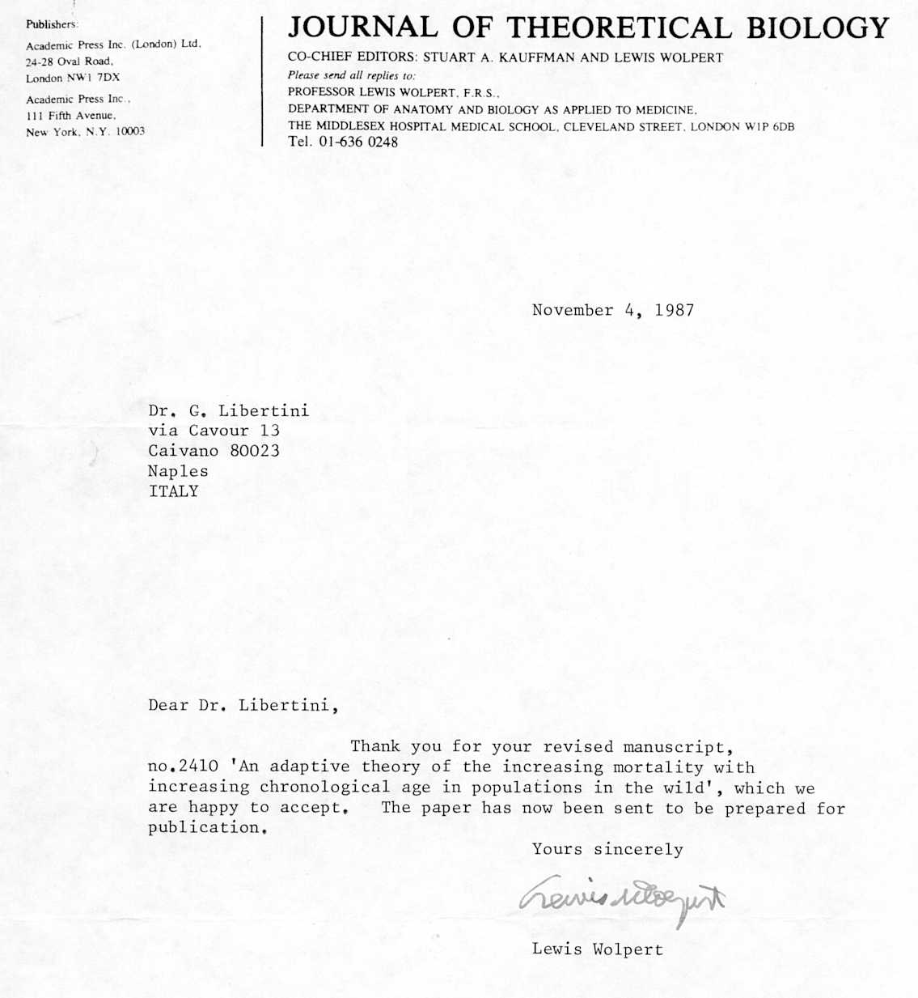

J. theor. Biol. (1988) 132, 145-162

An Adaptive Theory of the Increasing Mortality with
Increasing Chronological Age in Populations in the Wild

GIACINTO LIBERTINI
Via Cavour 13, Caivano 80023, Naples, Italy
(Received 13 December 1985, and in revised form 19 October 1987)

An "increasing mortality with increasing chronological age in populations in the wild" (IMICAW) is a phenomenon shown by many species, and the greater or smaller (or non-existent) IMICAW has an adaptive value, since it reduces the "mean duration of life" (ML). As Leopold (1961) pointed out, a smaller ML brings about a greater spreading velocity, within the species, of any advantageous mutation. However, this is an argument of group selection and is, therefore, inadequate to demonstrate that within a species a C gene causing IMICAW is stable compared with a C' allele not having this effect. The problem may be solved if we consider the inclusive fitness of C with the hypothesis that the dead individuals are replaced by kin individuals. In such a case, even with low values of the coefficient of relationship (Hamilton, 1971) of the substituting individuals, C tends to be stable and favoured by the selective mechanism as compared with C'. When the preferential replacement by kin individuals does not happen and/or when the turnover of generations is swift enough, C is not favoured and hence IMICAW loses its hypothesized adaptive value. In such cases, survival curves must be of type II or III of Pianka's classification (1970). It is discussed if IMICAW might be a consequence of the action of many harmful genes that express themselves tardily in the course of life.

1. Definitions

For the sake of simplicity, in all the following definitions and arguments, we will omit the early stages of life (development and growth of the individual) which for various reasons usually have a high mortality, not necessarily correlated with the adult mortality.
We define "IMICAW" as the phenomenon of an "increasing mortality with increasing chronological age in populations in the wild". IMICAW is a real phenomenon (see, e.g., survival curve of natural populations reported by Beverton & Holt, 1959; Laws, 1966, 1968; Laws & Parker, 1968; Deevey, 1947; Spinage, 1970, 1972).
The increment of mortality of an IMICAW population is approximately described by the Gompertz-Makeham equation (see Comfort, 1979):

λ_{t} = λ_{o} ⋅ e^{αt} + B (1)

where λ_{t} = mortality at time t; λ_{o} = hypothetical mortality at time 0; α = slope constant; B = non-age-specific mortality. The term λ_{o} ⋅ e^{αt} is the age-specific mortality (for the sake of brevity we will write "A").

145

0022-5193/88/100145 + 18 $03.00/0 © 1988 Academic Press Ud
146 G. LIBERTINI

When the derivative of the mortality exceeds an arbitrary threshold value "λ*", we define the time at which this occurs to be "t*". The time, after the early stages of life and before t*, when the mortality is at its lowest value, λ_{min}, is defined as "t _{λmin}" (for the sake of brevity we will write "τ"). Fig. 1 illustrates these definitions.

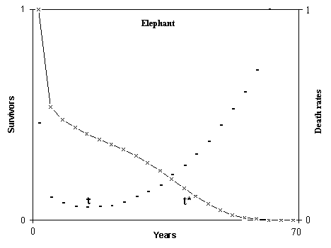
Fig. 1. Definitions of τ and t*.

If a gene causes a shift to left of the survival curve (and of t*), we say that it causes a "premature" IMICAW. Those species that do not show the phenomenon IMICAW (see, e.g., Beverton & Holt, 1959; Deevey, 1947; Bourlière, 1959; Comfort, 1979) are defined as "non-IMICAW".
The term "ML" denotes the "mean duration of life - from the birth to the death - in the wild" of the whole body of individuals of a population. By definition, a non-IMICAW species has the ML in function only of B while an IMICAW species has the ML in function both of A and of B. We may consider a non-IMICAW species as an IMICAW species with t* = ∞. The ML of a non-IMICAW species (t* = ∞) is not necessarily greater than the ML of an IMICAW species (t* << ∞). For example, the ML of the Robin, a non-IMICAW species, has been found to be 1.01 years (Deevey, 1947), while the ML of the Impala, an IMICAW species, is 5.8 years (Spinage, 1972).
However, in two IMICAW species of equal mortality due to the term B, that species with greater t* has a greater ML.
If a non-IMICAW species in captivity, i.e. with conditions of mortality lower than that in the wild, shows an increasing mortality with increasing chronological age (obviously starting from ages never or very rarely observable in nature), we define such a hypothetical phenomenon as "IMICAC". By definition, IMICAC is unobservable in the wild and since natural selection, by definition, acts only in the wild, IMICAC is not subjected to selective pressures and cannot have an adaptive

ADAPTIVE THEORY OF INCREASING MORTALITY 147

value. Likewise, if an IMICAW species in conditions of mortality lower than in the wild shows a shift to the right of the survival curve ("IMICAW-shift"), neither the shift nor possible "morphologic or physiologic alterations found in individuals survived in ages never or very rarely observable in the wild" ("related phenomena"), might have an adaptive value.

2. Topic

In this paper we hypothesize a teleonomic meaning - or finality in deterministic sense, or adaptive value - of the phenomenon IMICAW and of its greater or smaller precociousness.
The consistency of the arguments has been tested with the formulation of theoretical models and their subsequent analysis. For the sake of simplicity, organisms are considered as haploid, asexual and having discrete generations. The arguments may be formulated for diploid and recombinant organisms also with unduly useless complications. The condition of discrete generations is a mathematical simplification. In defence of the scientific correctness of this method, we mention Bell (1982, Section 2.1).
The following arguments are divided into three parts:
a) First, it is affirmed that, other things being equal, between two species with different t*, that with the smaller t* is selectively advantaged.
b) The second part shows under which conditions a gene that causes a more precocious IMICAW is stable within the species compared with a neutral allele.
c) The third part maintains that a species with a high value of B should be non-IMICAW (survival curve of type II and III; Pianka, 1970), and it is verified if the prevision is confirmed by data from natural observation.
Finally, it is discussed if genes that express themselves tardily might cause IMICAW or IMICAC.

3. Comparison between Two Species with Different t*

Evolution is described as a continuous spreading within the species of alleles that somehow present a selective advantage. If, all other things being equal, considering two species with different t*, that species with the smaller t* will have a greater spreading velocity of the favourable alleles, we assert that such a species has an "advantage".
In order that an allele may pass from a frequency f to a frequency f' (with f < f'), a certain number of generations is necessary. But since the number of generations in a period is inversely proportional to the ML, and as the ML is in function (in various proportions) of both A (namely of t*) and B, it is easily deduced that (B being equal for both species) the species with smaller t*, having a quicker turnover of generations, takes advantage of a faster diffusion of favourable alleles compared with that species having a greater t*.
Figure 2 illustrates the variation of the spreading velocity within a species, with a constant number of individuals, of a gene C with advantage S according to the
148 G. LIBERTINI

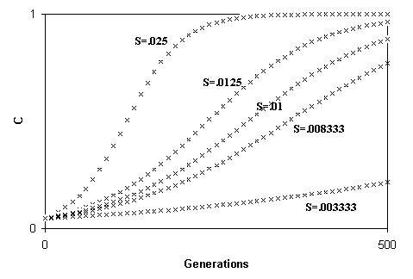

Fig. 2. Spreading of a gene (C) according to the variation of S (while ML = k).

variation of the value of S and in comparison with a neutral allele C'. The formula used is:

C_{n+1} = C_{n} ⋅ (1 + S) = C_{n} ⋅ (1 + S) (2)
C_{n} ⋅ (1 + S) + C' _{n} 1 + C_{n} ⋅ S

(C_{n} indicates the frequency of C at the nth generation; the denominator has the function of keeping constant the sum of the frequencies: C_{n} + C'_{n} = 1).
Going from top to bottom, the values of S (arbitrarily chosen) are: S₁ = .025; S₂ = .0125; S₃ = .01; S₄ = .008333; and S₅ = .003333. Moreover: C_{o} = .05.
In Fig. 3, the formula used is the same (2), but the abscissas indicate time and not the generations. The advantage S has a constant value, arbitrarily chosen (K = .01) for all the five curves, while ML has the following different values: ML₁ = .4; ML₂ = .8; ML₃ = 1; ML₄ = 1.2; ML₅ = 3.
The curves are morphologically equal to those in Fig. 2. If we notice that the values of S in Fig. 2 are given by:

S₁ = K / ML₁; S₂ = K / ML₂; S₃ = K / ML₃; S₄ = K / ML₄; S₅ = K / ML₅; (3)

we maintain that a smaller ML or a proportionally greater value of S have the same effects on the spreading velocity of a favourable gene (for a mathematical demonstration of this phenomenon see the Appendix).
The hypothesis that an increasing mortality with increasing chronological age (or a genetically determined limitation of life) has an adaptive value as it increases the turnover of generations, has been expressed clearly, although only in qualitative terms and only for plants (Leopold, 1961). It was later re-expressed by Medvedev (1966). (See also Woolhouse, 1967; Comfort (1979) and Kirkwood & Cremer (1982).) Weismann (1889) expressed an adaptive meaning of the phenomenon in quite
ADAPTIVE THEORY OF INCREASING MORTALITY 149

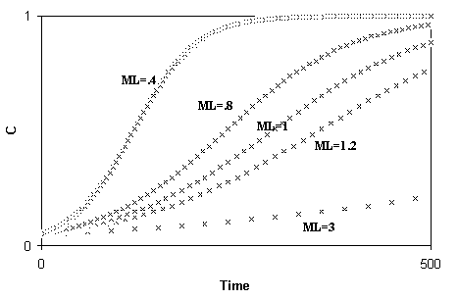

FIG. 3. Spreading of a gene according to the variation of ML (while S = k).

different terms and later (1892) disavowed it (for a review of Weismann's suggestions see Kirkwood & Cremer, 1982).
We put forward two criticisms of the hypothesis of an adaptive value of IMICAW. First, it is an argument of group selection and therefore has all the limitations of such a selective process (see Maynard Smith, 1964, 1976). In the next paragraph we will reformulate the hypothesis, in terms of individual selection, in an attempt to overcome this serious criticism. Second, IMICAW may have a quantitatively scarce or very scarce value in the reduction of the ML, namely in the increase of the turnover of generations, since very few individuals reach the right side of the survival curve. (This is not the 'old age' of Medawar, 1952, or Comfort, 1979, since in the wild the 'individuals that reach the right side of the survival curve' are not necessarily "old". The evidence of "old age" is largely a consequence of the IMICAW-shift.) This criticism is easily overcome if we use the data of natural observation, although they are approximate and fragmentary. The procedure is as follows. Starting from the data of the life table in the wild, after an appropriate smoothing of the death-rates curve, with particular attention to the lowest death-rate value, we derive the survival curve under the hypothesis that the increment of the mortality be zero after the mortality has reached its lowest value at time τ. We have computed the ML under this hypothesis (HML) and the results are summarized in Table 1 where we have indicated τ, the force of mortality at that time (λ_{min}), and the values of ML minus τ (ML_{τ} - τ) and of HML minus τ (HML_{τ} - τ) of that fraction of the population surviving at the time τ. The ratios HML / ML and (HML_{τ} - τ) / (ML_{τ} - τ) are also expressed.
Figures 4 and 5 are graphic examples of the procedure. The ratio HML / ML ranges from 1.55 to 3.21. The second ratio, which we consider to be more meaningful since the early stages of life are excluded, ranges from 2.42 to 5.09.
150 G. LIBERTINI

TABLE 1
_______________________________________________________________________________________
Source Time ML HML Ratio ML_{τ}-τ HML_{τ} – τ Ratio
Species of data unit τ λ_{min} (A) (B) B/A (C) (D) D/C
_______________________________________________________________________________________
Zebra 1 year 6 4.63 8.48 17.23 2.03 6.73 21.55 3.20
Hippopotamus 3 year 14 1.03 15.40 43.33 2.81 21.69 96.68 4.45
Elephant 2 year 16 1.95 17.27 28.85 1.67 21.08 51.95 2.42
Waterbuck 4 year 3 5.55 3.71 9.56 2.57 4.47 18.00 4.02
Warthog 1 year 8 5.90 4.79 7.43 1.55 5.92 16.93 2.85
Impala 1 year 3 5.44 6.37 16.87 2.64 4.76 18.35 3.85
Buffalo 1 year 5 4.23 5.50 12.16 2.21 6.80 23.61 3.46
Dall mountain sheep 5 year 4 3.54 7.15 23.00 3.21 5.52 28.17 5.09
Floscularia conifera 5 day 3 7.69 5.17 11.54 2.23 3.76 12.99 3.45
_______________________________________________________________________________________

Sources of data:
(1) Spinage, 1972; sex combined.
(2) Laws, 1966; sex combined.
(3) Laws, 1968; sex combined.
(4) Spinage, 1970; sex combined.
(5) Deevey, 1947; sex combined.

ADAPTIVE THEORY OF INCREASING MORTALITY 151

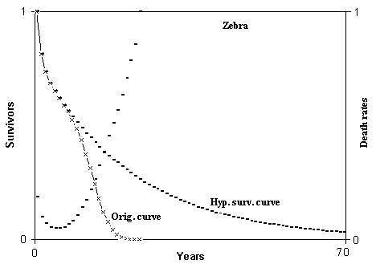

Fig. 4. Hypothetical survival curve of zebra. Abscissas from 0 to 70 years. Calculation from 0 to 350 years. Min. mortal.: at 6 years = 4.638216%. ML = 8.480926 years; HML = 17.23965 years; ratio = 2.032755. ML(6) = 6.730483 years; HML(6) = 21.55998 years; ratio = 3.203333.

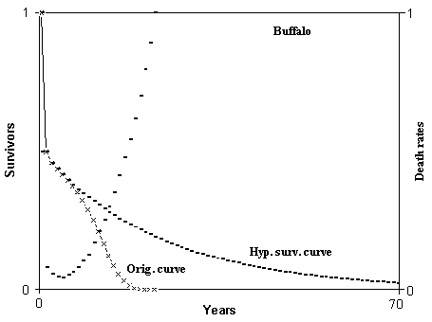

Fig. 5. Hypothetical survival curve of buffalo. Abscissas from 0 to 70 years. Calculation from 0 to 350 years. Min. mortal.: at 5 years = 4.235282%. ML = 5.503607 years; HML = 12.16345 years; ratio = 2.210086. ML(5) = 6.805135 years; HML(5) = 23.61117 years; ratio = 3.469611.

152 G. LIBERTINI

Although the results may not be precise due to the approximation of the data, they are sufficient for our purposes. The ratios, the second in particular, are clearly superior to unity and hence the greater swiftness of turnover of generations is not at all negligible. We think that Comfort's opinion on the impossibility of an adaptive value of a genetically limited life is caused by his contradictory conception of the phenomenon, as already underlined by Williams (1957). Comfort, and indeed other authors, does not distinguish between IMICAW and the phenomena related to the IMICAW-shift.

4. Evolutionary Steadiness of a Gene causing IMICAW

The frequency of an advantageous gene increases and that of a disadvantageous gene decreases. Moreover, the mutations generally alter the action of a gene so that the frequency of the gene in its active form is reduced.
We define a gene as evolutionarily stable when the effects on its frequency of the advantages become greater than the effects of disadvantages and mutations.
In the previous section, we have compared two species of different t*, while arbitrarily and tacitly assuming that the gene C, causing a smaller t*, is exempt from mutations, selective pressures and other factors that might modify its frequency within each of the two species. We have proved that between two species with different t*, ceteris paribus and under the aforesaid conditions, that species with the smaller t* is favoured. However the reasoning is only an argument of group selection and is not proof of evolutionary stableness within the species of a gene causing the IMICAW phenomenon. We now investigate this question by removing the previous assumptions. Surely, for individuals with a greater t*, there are some remarkable advantages. For example: 1) a lesser incidence on the total length of life of the more vulnerable life period, that is, growth; 2) a better exploitation of the learning abilities. Both in the case of an adaptive and of a non-adaptive meaning of IMICAW, such advantages should cause a positive correlation between body mass and t*, as well as between learning abilities and t* (Sacher, 1959).
On first thought it is difficult to justify the stableness of a gene causing IMICAW, since the advantage of a faster turnover of generations caused by IMICAW would seem valuable in a period of many generations and for the population 'in toto', whereas for the individuals non- (or with-tardy-) IMICAW, certainly there are the aforementioned advantages. It is undisputed that selection is determined by present and not by future advantages and that group selection arguments are of limited weight in this matter.
It is necessary to prove that IMICAW has an immediate advantage at every generation for the genes that are supposed to induce it. Against this hypothetical immediate advantage, we must compare the immediate advantages of the non- (or with-tardy-) IMICAW organisms. If there is no immediate advantage, then the genes determining IMICAW would decay, as is shown in Fig. 6, where t* increases since there is no advantage for the premature-IMICAW individuals.
In Fig. 6 the alleles C and C' induce a ML equal to V_{c} and V_{c'} (with V_{C} < V_{C'} = 1 unity of time), respectively. The population is constant but large and the individuals
ADAPTIVE THEORY OF INCREASING MORTALITY 153

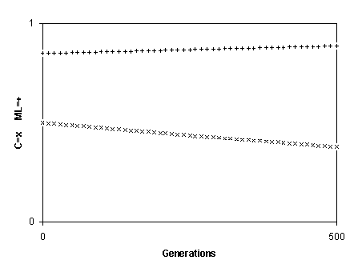
Fig. 6. Decay of a gene causing IMICAW.

are freely circulating (so dead individuals are replaced by individuals with a mean coefficient of relationship, r, not greater than the mean r of the whole population, Hamilton, 1971). The reduced ML causes a disadvantage S'. The frequency of C is given by:

C_{n+1} = C_{n}⋅ (1 – S') (4)
1 – C_{n} ⋅ S'

In Fig. 6, the arbitrarily chosen values are: C₀ = .5; S'= .001; V_{C} = .7.
I feel that the answer to the above problem must be researched in the light of what is the pivotal concept of modern sociobiology, namely the distinction as regards natural selection between the advantage for the individual and the advantage for the gene (see: Hamilton, 1971; Trivers, 1976; Wilson, 1975). If a character, determined by the gene C, is harmful for the individual I, where C is present, but its action on I is advantageous for another individual (I') genetically related, namely having a fraction r of genes identical to those of the individual I (and therefore a probability r of having C), the spreading of the gene C is subjected to two contrasting selective pressures. If the sum of the two pressures (inclusive fitness) is positive, C is favoured, though harmful for the specific individual that has the "unselfish"- gene.
Figure 7 has been obtained using the following formula:

C_{n+1} = C_{n}⋅ (1 + r ⋅ S – S') (5)
1 + C_{n} ⋅ ( r ⋅ S - S')

where: S'= disadvantage for I; S = advantage for I'; r = coefficient of relationship between I and I'. Going from top to bottom the values assigned are: C₀ = .5; S = .03; r = .5.
154 G. LIBERTINI

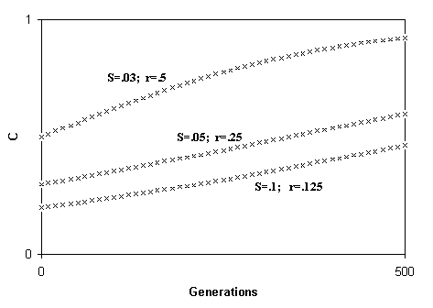

Fig. 7. Spreading of an "unselfish" gene according to the variation of S and r.

C₀ = .3; S = .05; r = .25. C₀= .2; S = .1; r = .125. For all the curves, S' = .01.
Returning to the IMICAW problem, let us estimate the inclusive fitness of a gene C which reduces t*. An essential condition, that will be discussed and verified in the next paragraph, needs to be presented at this point. An individual (I) which has died as a consequence of the action of C, is replaced by genetically related individuals (I'), having on average a fraction r (coefficient of relationship) of genes equal to those of I (preferential replacement condition). We then have:
(a) C and C' cause an ML equal to V_{C} and V_{C'} (with V_{C} < V_{C'} = 1 unity of time), respectively.
(b) If within the species m genes are spreading, favoured by a total advantage S, a reduction of ML is equivalent to a proportional increase of the advantage S (see Figs. 2 and 3), and considering all of the population on the basis of a generation time equal to 1 unity of time, the advantage S for the individuals with the genes C and C', if isolated, would be, respectively:

S_{C} = S/ V_{C}; S_{C'} = S/ V_{C'} = S. (6)

The difference between the two advantages is:

S_{C} – S_{C'} = S - S = S ⋅ ( 1 – 1) (7)
V_{C} V_{C}

That is > 0 since V_{C} < I.
(c) The disadvantage for the gene C is:
S'. (8)
ADAPTIVE THEORY OF INCREASING MORTALITY 155

(d) The gene C, that causes the premature death of the individual I, and therefore the disadvantage (8), also brings about the advantage (7) for the copies of C existing with a probability r in the substituting individuals I'.
The spreading, or decay, within a population of a gene C causing a premature t*, may now be expressed by the recursion formula:

C_{n+1} = C_{n} ⋅ [1 + r ⋅ S ⋅ (1 / V_{C} – 1) – S'] (9)
1 + C_{n} ⋅ [r ⋅ S ⋅ (1 / V_{C} –1) – S']

Figure 8 has been obtained from this formula. The values assigned are: C₀ = .1, S = .1, S' = .001, and V_{C} = .7 for all the curves, and r = .25; .125; .05; 0, going from top to bottom. Note that we have hypothesized S » S', since S sums up the advantages of the m genes that are spreading within the species. Figure 8 shows that C is favoured except where r = 0 (non-preferential replacement) where the formula (9) becomes (4). Analytically C is favoured when:

r ⋅ S ⋅ ( 1 - 1 ) > S'. (10)
V_{C}
In short, according to our theory, a gene C becomes an unselfish gene favoured by a kind of "hitch-hiker" effect (Hill & Robertson, 1966; Felsenstein, 1974; Strobeck et al., 1976).

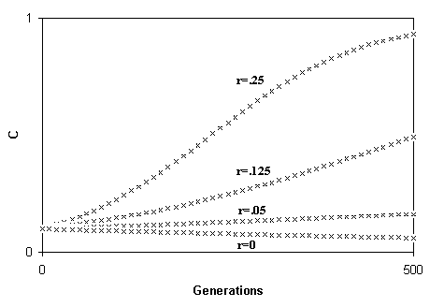

Fig. 8. Spreading of a gene causing IMICAW if the dead individual (I) is substituted by a kin (r > 0) individual (I').
156 G. LIBERTINI

5. Two Limiting Conditions

The mechanism of the advantage of the phenomenon IMICAW given in the previous paragraph is constrained by two limiting conditions:
(a) The population must be numerically constant, as a consequence of a limited living-space, so that only when an individual dies there is place for a new individual (Constant number condition).
(b) Dead individuals must be replaced by individuals with a mean r superior to the mean r of the whole population (Preferential replacement condition).
The first condition is verified, in general, with K-selected populations (see Leopold, 1961). On the contrary, this is unrealistic with r-selected species since for these species constraints on living-space for the newer individuals are secondary to reproductive potentiality, which becomes the key factor. The second condition is verified with species divided into small demes with a limited interdemic genic flow, since among the individuals of a deme, r is greater than the mean r of the whole population, and presumably a dead individual generates living-space for individuals of the same deme. Also, the second condition is verified with plants, sessile animals and with territorial species, since, in such conditions a dead individual is substituted more frequently by offspring of itself or of its neighbours, that are generally genetically related. In general, the second condition is probable with K-selected species as well.
According to the above arguments, the species that more likely have to be IMICAW are territorial or non-mobile, divided into small demes and K-selected. On the other hand, the rule for the r-selected species has to be non-IMICAW.
I believe that such previsions are in accordance with the data of natural observation. That is, only for K-selected species we will have survival curves of type I (see Pianka, 1970). Moreover a certain parallelism has to be observed between IMICAW and unselfish and social behaviours (Wilson, 1975, in particular Pianka's table as modified in chapter IV). This parallelism is not casual since in our theory a gene causing IMICAW is a kind of unselfish gene.
Finally, a parallel problem is that in a deme the first copy of a C gene causing IMICAW, or a more precocious IMICAW, cannot be advantageous since there is no copy of C in other individuals that might be benefitted by its action. The answer, is probably the same as that proposed by Boorman & Levitt (1973) for unselfish genes i.e., non-selective mechanisms are important up to a critical frequency.

6. The "Methuselah Effect"

The right-hand term of the disequation (10), the disadvantage S', is inversely proportional to the ML, since the shorter the ML, the greater the disadvantage deriving from the action of a gene C that reduces t* and therefore further on the ML as well. Since the ML is determined by the value of both A and B (the age-specific and the non-age-specific mortality, respectively), if B is large, the ML will be small, the term S' will also be large and consequently the gene C will not be advantaged in the spreading. The paradoxical result is that the species with a

ADAPTIVE THEORY OF INCREASING MORTALITY 157

high value of B, where B is inaccurately called "environmental mortality" should be non-IMICAW ("Methuselah effect"). Comfort (1979, p. 92) states:

'. . . populations of many species of fish, studied in the wild, show an age structure and a pattern of death similar to that found in birds, i. e. a high constant mortality unrelated to age and a virtually constant expectation of life . . .',

As examples of non-IMICAW species with high value of B we cite: Callionymus lyra, Leuresthes tenuis, Leucichthys kiyi, Cottus gobio, Clupea sprattus, Clupea pallasi (Beverton & Holt, 1959), the blackbird, the song thrush, the robin, the starling and the lapwing (Deevey, 1947).

7. T-Genes and IMICAW

We define a gene that express a disadvantageous action (S) only and exclusively at the time t as "t-gene". We now discuss whether IMICAW could be a consequence of the action of many t-genes. The same question is disputed for IMICAC in the next paragraph.
Let us consider a non-IMICAW population whose survival curve is obtained from the equation:

Y_{t} = Y₀ ⋅ (1 – λ)^{t} (11)

where: Y₀ = starting population; Y_{t} = survivors at time t; λ = death-rate.
If C is a t-gene, C' its neutral allele, S the damage expressed by C at time t, V the mutation rate of C' in C, where the mutation rate of C in C' is 0, then the frequency of C at the (n + l)th generation is given by:

C_{n+1} = C_{n} ⋅ (1 – S ⋅ Y_{t} – V) + V (12)
1 – C_{n} ⋅ S ⋅ Y_{t}

The equilibrium frequency of C (C_{e}) is given by:

C_{e} = V / (S ⋅ Y_{t}). (13)

Now, if we hypothesize that in the population there are m different types of t-genes that express themselves at time 1, each with a disadvantage S, the same number of t-genes with the same attributes at times 2, 3, . . ., the survivors at the time t + 1, will be:

Y_{t+1} = Y_{t} ⋅ (1 – C_{e} ⋅ S ⋅ m) = Y_{t} ⋅ (1 – V ⋅ m) (14)
Y_{t}

The equation shows that the value of S is unimportant. Moreover, since V is small, the decrement of Y_{t+1} will be notable only with small values of Y_{t}.
In Fig. 9, the original curve is given by (11) and the modified curve by equation (14). The values are: λ = .07; m = 100; V= .00001.
The modified curve shows that a very strong load of t-genes shifts only a little down the original curve and does not make it similar to that of an IMICAW population.
158 G. LIBERTINI
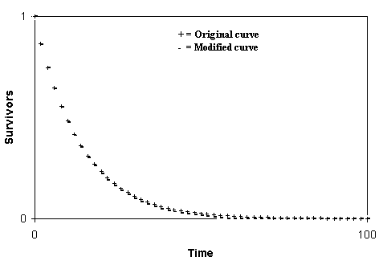

Fig. 9. Effects of t-genes on survival curve in the wild.

8. T-Genes and IMICAC

If we set the non-IMICAW population of the previous paragraph in conditions of lower mortality (λ' < λ), since the equilibrium frequency of a gene is modified only by a selective mechanism of many generations, we can consider the equilibrium frequencies in this case as equal to the values in the wild given by equation (13). But Y_{t} represents the survivors at time t in the wild and not in conditions of lower mortality. This difference notably modifies the consequence of the action of the t-genes. Figure 10 shows the same curves as Fig. 9, plus the original curve in conditions of lower mortality (λ'= .03), and this last curve with the notable downward shift caused by the action of the t-genes. This might be a theoretical ground for the explanation of the hypothesized phenomenon IMICAC.
The above argument might also be applied to the rise of mortality in the case of IMICAW-shift. But if a gene X causes IMICAW and therefore the IMICAW-shift is only the result of the delayed action of X in conditions of lower mortality, it will be difficult to distinguish between the action of X and the action of a t-gene. Since the t-gene is subject to negative selection (although weak because the individuals surviving at time t are few), it will be present only in a fraction of the population; on the contrary, X is favoured by a selective process and consequently will be present in all the population.

9. Discussion

We have avoided the term "senescence" as its common usage is not sufficiently precise for our purposes. Kirkwood & Cremer (1982) point out that "In fact, 'ageing' is used with so many different meanings in so many different contexts that it is sometimes highly confusing when used without proper qualification."
ADAPTIVE THEORY OF INCREASING MORTALITY 159

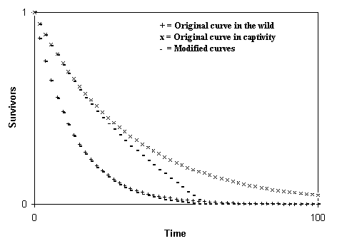

Fig. 10. Effects of t-genes on survival curves in captivity.

The definition of ageing expressed by Rockstein et al. (1977) is quite different from that of Comfort (1979). Comfort is, in fact, inconsistent, in places, as pointed out by Williams (1957). Senescence, in common usage, includes both IMICAW and IMICAC and mixes the increasing rate of age-specific mortality in the wild with the phenomena related to the IMICAW-shift, e.g. the alterations observed in captivity of individuals in the "state of senility" (Williams, 1957). Our definition of IMICAW in its actuarial simplicity (see Medawar, 1952, 1955) starts from the trivial observation of Comfort (1979): "It is rare that we can determine the vulnerability of an individual. Our estimate of it is determined statistically, upon a population." The restriction "in the wild" has a rational motivation: if we want to establish the evolutionary meaning of a function, we must first consider how it works in natural conditions since natural selection acts only in the wild.
We have used the concept of "t*" instead of that of "lifespan" because the first is clearly definable and is a parameter obtainable from natural observations, while the second is a laboratory artefact, too variable and dependant on the conditions of captivity. In this report, other theories and the data of natural observation must be interpreted, where it is possible without doubts, only according to the terms as defined in the first paragraph.
A commonly accepted theory justifies "senescence" as the consequence of the action of harmful genes expressing themselves from a certain age and, moreover, with possible beneficial actions at previous age (Haldane, 1941; Medawar, 1952; Williams, 1957; Hamilton, 1965; Emlen, 1970).
If the term "senescence" means the same as our definition of IMICAC, then Medawar et al.'s theory is plausible (as discussed in part 8). If Medawar et al.'s theory sets out to explain the IMICAW-shift and related phenomena, it is plausible, as for IMICAC, but there is an alternative / complementary explanation.
160 G. LIBERTINI

On the contrary if the theory sets out to explain what we have defined IMICAW, as with Williams (1957), this theory is disproved by the theoretical arguments expressed in part 7.
On the grounds of natural observations, we have a clearly stated prevision (Williams, 1957, p. 404):

"Low adult death rates should be associated with low rates of senescence, and high adult death rates with high rates of senescence"

that in our terms should be: species with a great value of B should have a premature IMICAW (namely a small value of t*). This is exactly the opposite of the prevision of the "Methuselah effect".
An alternative explanation for the "ageing" is the "disposable soma" theory (Kirkwood, 1977, 1981; Kirkwood & Holliday, 1979). With the same observations expressed for Medawar et al.'s theory, according to this hypothesis (Kirkwood & Cremer, 1981):

". . . a species subject to high environmental mortality will do better not to invest too heavily in each individual soma, which will therefore age relatively soon . . ."

that is, in our interpretation, the same prevision of Williams. We think that this common prevision is not sufficiently strengthened by natural observations, while the "Methuselah effect" has clear, though incomplete, confirmations. Further, we must observe that the reference to "lifespan" or to "maximum longevity" (see Williams, 1957) is particularly insidious since, as underlined in this paper, such parameters may be widely influenced both by IMICAW (a hypothesized adaptive phenomenon) and by IMICAC and IMICAW-shift (non-adaptive phenomena by definition). For example for a non-IMICAW species, the value of t* would be indeterminate (we prefer to say = ∞), and on the contrary the maximum longevity of the same species in captivity might be greater than the values observed in nature, but finite (by action of non-adaptive mechanisms such as those hypothesized by Medawar et al.), and less than the maximum longevity of an IMICAW species. This phenomenon is not in contrast with our theory of IMICAW, but might be greatly confusing if one wants to measure the "senescence" with the parameter "lifespan".
Finally we have to discuss the possible relations between IMICAW and IMICAW-shift. Since IMICAW-shift by definition is unobservable in the wild and cannot have an evolutionary meaning, it is illogical to explain, or attempt to explain, IMICAW in terms of phenomena related to the IMICAW-shift. On the contrary, if IMICAW has an evolutionary adaptive value, the phenomena related to the IMICAW-shift might be an extreme and non-adaptive consequence of the mechanisms underlying IMICAW. So it will be useful to study "old" individuals, unobservable in the wild, to understand the physiological mechanisms underlying IMICAW, but we always have to consider the existence of these "old" individuals as an artefact with no weight as regards the evolutionary meaning of IMICAW.
ADAPTIVE THEORY OF INCREASING MORTALITY 161

REFERENCES

Bell, G. (1982). The Masterpiece of Nature: The Evolution and Genetics of Sexuality. London: Croom Helm.
Beverton, R. J. & Holt, S. J. (1959). Ciba Fdn Colloq. Ageing 5, 142.
Boorman, S. A. & Levitt, P. R. (1973). Proc. Nat. Acad. Sci. U.S.A., 70, 187.
Bourliere, F. (1959). Ciba Fdn Colloq. Ageing 5, 99.
Comfort, A. (1979). The Biology of Senescence. London: Livingstone.
Deevey, E. S., Jr. (1947). Quart. Rev. Biol. 22, 283.
Emlen, J. M. (1970). Ecology 51, 588.
Felsenstein, J. (1974). Genetics 78, 737.
Haldane, J. B. S. (1941). New Paths in Genetics. New York & London: Harper.
Hamilton, W. D. (1965). J. Theoret. Biol. 12, 12.
Hamilton, W. D. (1971). In: Man and Beast: Comparative Social Behavior (Eisenberg, J. F. & Dillon, W. S., eds), pp. 57-91. Washington: Smithsonian Institution Press.
Hill, W. G. & Robertson, A. (1966). Genet. Res. 8, 269.
Kirkwood, T. B. L. (1977). Nature 270, 301.
Kirkwood, T. B. L. (1981). In: Physiological Ecology: An Evolutionary Approach to Resource Use (Townsend, C. R. & Calow, P., eds), pp. 165-189. Oxford: Blackwell.
Kirkwood, T. B. L. & Cremer, T. (1982). Hum. Genet. 60, 101.
Kirkwood, T. B. L. & Holliday, R. (1979). Proc. R. Soc. Lond. B 205, 531.
Laws, R. M. (1966). E. Afr. Wildl. J. 4, 1.
Laws, R. M. (1968). E. Afr. Wildl. J. 6, 19.
Laws, R. M. & Parker, I. S. C. (1968). Symp. Zool. Soc. Lond. 21, 319.
Leopold, A. C. (1961). Science 134, 1727.
Maynard Smith, J. (1964). Nature 201, 1145.
Maynard Smith, J. (1976). Quart. Rev. Biol. 51, 277.
Medawar, P. B. (1952). An Unsolved Problem of Biology. London: Lewis.
Medawar, P. B. (1955). Ciba Fdn Colloq. Ageing 1, 4.
Medvedev, Zh. A. (1966). Protein Biosynthesis. London: Oliver & Boyd.
Pianka, E. R. (1970). Amer. Natur. 104, 592.
Rockstein, M., Chesky, J. A. & Sussman, M. L. (1977). In: Handbook of the Biology of Ageing. Caleb, E. F. & Hayflick, L., eds), Vol. I. pp. 3-34 London: Van Nostrand Reinhold Company.
Sacher, G. A. (1959). Ciba Fdn Colloq. Ageing 5, 115.
Spinage, C. A. (1970). J. Anim. Ecol. 39, 51.
Spinage, C. A. (1972). Ecology 53, 645.
Strobeck, C., Maynard Smith, J. & Charlesworth, B. (1976). Genetics 82, 547.
Trivers, R. L. & Hare, H. (1976). Science 191, 249.
Weismann, A. (1889, 2nd edn 1891). Essays Upon Heredity and Kindred Biological Problems. Vol. I. Oxford: Clarendon Press.
Weismann, A. (1892). Idem. Vol. II.
Williams, G. C. (1957). Evolution 11, 398.
Wilson, E. 0. (1975). Sociobiology: The New Synthesis. Cambridge: Harvard University Press.
Woolhouse, H. W. (1967). In: Aspects of the Biology of Ageing, Symposia of the society for experimental biology, No. XXI, pp. 179-213. Cambridge: Cambridge University Press.
162 G. LIBERTINI

APPENDIX
For the demonstration that a smaller ML or a proportionally greater value of S have the same effects on the spreading velocity of a favourable gene we observe that:

C₁ = C₀ ⋅ (1 + S)
1 + C₀ ⋅ S

C₀ ⋅ (1 + S) ⋅ (1 + S)
C₂ = C₁ ⋅ (1 + S) = 1 + C₀ ⋅ S = C₀ ⋅ (1 + S)²
1 + C₁ ⋅ S 1 + C₀ ⋅ (1 + S) ⋅ S 1 + C₀ ⋅ S + C₀ ⋅ S ⋅ (1 + S)
1 + C₀ ⋅ S

C₃ = C₂ ⋅ (1 + S) = . . . = C₀ ⋅ (1 + S)³
1 + C₂ ⋅ S 1 + C₀ ⋅ S + C₀ ⋅ S ⋅ (1 + S) + C₀ ⋅ S ⋅ (1 + S)²

. . . . . . . . . . . . . . . . . . . . . . . . . . . . . . . . . . . . . . . . . . . . . . . . . . . . . . . . . . . . . . . .

C_{n} = C₀ ⋅ (1 + S)^{n}
1 + C₀ ⋅ S + C₀ ⋅ S ⋅ (1 + S)¹ + C₀ ⋅ S ⋅ (1 + S)² + . . . + C₀ ⋅ S ⋅ (1 + S)^{n-1}

= C₀ ⋅ (1 + S)^{n} (15)
1 + C₀ ⋅ S ⋅ [(1+ S)⁰ + (1+ S)¹ + (1+ S)² + . . . + (1 + S)^{n-1}]

Utilizing the formula of the geometric series we obtain:

C_{n} ≅ C₀ ⋅ (1 + S)^{n} = C₀ ⋅ (1 + S)^{n} (16)
1 + C₀ ⋅ S ⋅ 1 – (1 + S)^{n} 1 – C₀ ⋅ [1 – (1 + S)^{n}]
1 – (1 + S)

If n is an integer, using the Newton formula of the binomial and disregarding the terms having S with index superior to 1, which is justifiable because S has been supposed to be small, we get:

C_{n} ≅ C₀ ⋅ (1 + n ⋅ S) = C₀ ⋅ (1 + n ⋅ S) (17)
1 – C₀ ⋅ (1 – 1 – n ⋅ S) 1 + C₀ ⋅ n ⋅ S

Besides, recalling that the number of generations in a period T is inversely proportional to the ML: n = T / ML, and substituting, we obtain:

C_{n} = C_{1 u. t.} ≅ C₀ ⋅ (1 + S / ML) (18)
1 + C₀ ⋅ S / ML

where the coefficients of C are the time and not the generation, and that prove for integer values of n that smaller values of S and greater values of ML, and vice versa, have the same effects on the spreading velocity of a gene. If we consider that the equality is approximate, by interpolation we can infer that it is valid for fractional values of n, too. Also the exact formula, non-iterative, is:

C_{n} = C_{1 u. t.} = C₀ ⋅ (1 + S)^{1/ML} (19)
1 – C₀ ⋅ [1 – (1 + S)^{1/ML}]

